ACCIDENT HOTSPOT PREDICTION
USING RANDOM FOREST AND LOGISTIC REGRESSION
MACHINE LEARNING PROJECT REPORT

Submitted in partial fulfilment of the requirements for the Course
MACHINE LEARNING
BACHELOR OF TECHNOLOGY
P. Thanvitha — 2520030385
N. Tejasri — 2520030132
Guide: Jyothsna Datti
Assistant Professor, CSE
Department of CSE
A.Y. 2026–27



ABSTRACT
Road accidents are a major concern in modern transportation systems because they can result in injuries, loss of life, vehicle damage, traffic disruption, and significant social and economic consequences. The severity of an accident can vary depending on several factors associated with the driver, vehicle, road, environment, time, and surrounding conditions. As the amount of accident-related information increases, manually examining every record and identifying meaningful patterns becomes difficult and time-consuming. Machine learning provides an approach for analyzing large collections of historical records and learning relationships between different input attributes and accident outcomes. This project, titled “Accident Hotspot Prediction Using Random Forest and Logistic Regression,” focuses on applying machine learning techniques to historical accident data from India in order to study and classify accident severity. The dataset used in the project contains approximately 3,000 accident records and 22 features, covering the period from 2018 to 2023. The available attributes provide information related to different aspects of accident situations, including driver characteristics, vehicle-related information, environmental conditions, time-related factors, location-related information, and other accident circumstances. The target variable represents accident severity and is divided into three categories: Minor, Serious, and Fatal. The main purpose of the project is to use these historical observations to develop machine learning models capable of learning patterns associated with the three severity categories. Through this approach, the project demonstrates how historical accident information can be transformed into a structured machine learning problem and how predictive models can be incorporated into an application for analytical purposes.
Before applying machine learning algorithms, the project performs Exploratory Data Analysis (EDA) to understand the characteristics, quality, and distribution of the accident dataset. EDA is an important stage because machine learning models depend heavily on the quality and representation of the input data. The analysis performed in the project examines the structure of the dataset, number of records and attributes, missing values, target-class distribution, weather conditions, yearly accident counts, and relationships among numerical variables. The dataset contains approximately 1,691 missing values overall, which makes data preparation and handling of incomplete information an important part of the workflow. The distribution of the target variable contains 1,034 Minor accidents, 981 Serious accidents, and 985 Fatal accidents, showing that the three severity categories are relatively balanced in the available records. The project also examines environmental information such as weather conditions, where categories including Rainy, Stormy, and Hazy occur frequently, with approximately 631 Rainy records, 611 Stormy records, and 608 Hazy records. Year-wise exploration is also performed for the period between 2018 and 2023, with the number of records remaining within an approximate range of 470 to 525 per year. Numerical relationships are examined through correlation analysis, and the observed correlations are generally weak. These EDA findings provide a better understanding of the dataset before model development and help identify important data characteristics that need to be considered during preprocessing and classification. The analysis also demonstrates that accident severity cannot necessarily be explained through a single variable, making a multi-feature machine learning approach appropriate for the study.
After completing the exploratory analysis and data preparation, the project implements and compares two supervised machine learning algorithms: Random Forest and Logistic Regression. These algorithms are selected because they provide different approaches to solving the classification problem. Random Forest is an ensemble learning technique that combines the predictions of multiple decision trees and can capture nonlinear relationships and interactions between different features. In this project, the Random Forest model is configured using 300 trees with a maximum depth of 10, allowing the model to learn from multiple decision structures while controlling tree complexity. Logistic Regression is selected as a comparatively simple classification method and is used as a baseline for comparison. The Logistic Regression model uses the L-BFGS solver with a maximum of 2,000 iterations to perform the required optimization. The prepared dataset is divided into training and testing subsets using an 80/20 stratified split, which helps maintain the representation of the three severity categories in both subsets. After training, both models are evaluated using the unseen test data. The experimental results show that the Random Forest model achieves approximately 35.67% accuracy, while Logistic Regression achieves approximately 35.33% accuracy. Random Forest therefore performs slightly better than Logistic Regression on the available dataset, although the difference between the two models is relatively small. The Random Forest model also provides feature-importance information that helps in understanding which attributes were more influential in the learned classification process. Among the relatively stronger features identified are Time of Day, Speed Limit, Driver Age, State Name, Month, Number of Casualties, Vehicle Type, and Day of Week. These feature-importance results help provide an additional level of interpretation to the model, although they should not be considered proof that any particular feature directly causes accident severity.
The complete project demonstrates an end-to-end machine learning workflow beginning with historical accident data and progressing through data understanding, exploratory analysis, preparation, model training, testing, evaluation, interpretation, and application integration. The trained model and supporting analytical components are incorporated into a Flask-based application, allowing the machine learning functionality to be used through an application interface rather than remaining only as an experimental notebook or standalone training script. The results obtained from the models also provide an important understanding of the limitations of the current system. With accuracies of approximately 35.67% for Random Forest and 35.33% for Logistic Regression, the current models have limited predictive strength and should not be considered highly reliable real-world safety prediction systems. In addition, although the project title contains the term “hotspot prediction,” the current implementation primarily focuses on accident severity classification and does not perform precise geographic hotspot identification through dedicated spatial clustering or geographic-density analysis. Therefore, the current system should be viewed as an academic machine learning project that demonstrates accident-severity classification using historical data. The project can be significantly improved in future work by using larger and more diverse datasets, adding reliable latitude and longitude information, incorporating road-level and traffic-related attributes, performing spatial clustering, introducing map-based visualization, applying advanced feature engineering, performing hyperparameter optimization, and using stronger validation techniques. With these improvements, the project can be extended from its present severity-classification workflow toward a more comprehensive accident-analysis system capable of studying both accident severity and geographic accident concentration in a responsible and evidence-based manner.

TABLE OF CONTENTS
1. Introduction
1.1 Background
1.2 Motivation for the Project
1.3 Overview of the Work Carried Out
1.4 Scope and Responsible-Use Statement
2. Problem Statement
2.1 Case-Study Scenario
2.2 Central Case-Study Question
2.3 Formal Problem Definition
2.4 Objectives that Guide the Study
2.5 Assumptions and Limitations
3. Dataset and Exploratory Data Analysis
3.1 About the Dataset
3.2 Purpose of EDA
3.3 Preparation Steps Actually Performed
3.4 EDA Exploration – Implementation
3.5 Summary of EDA Findings
4. Algorithm Selection and Implementation
4.1 Learning Task
4.2 Feature Representation
4.3 Random Forest
4.4 Logistic Regression
4.5 Training Procedure
4.6 Evaluation
4.7 Results and Interpretation
4.8 Feature Importance and Explainability
5. Conclusion

1. INTRODUCTION

1.1 Background
Road transportation plays an essential role in the daily functioning of society by providing connectivity between people, cities, workplaces, educational institutions, commercial areas, and different regions. Along with the growth of transportation and the increasing number of vehicles on roads, road accidents have become an important public-safety concern. An accident can occur under a wide range of circumstances, and the final outcome may differ significantly depending on the conditions surrounding the event. Factors related to the driver, vehicle, road environment, weather, time, speed, and other circumstances can collectively influence the severity of an accident. Because these factors can occur together in different combinations, understanding accident records requires more than simply counting the total number of accidents. Historical accident datasets provide an opportunity to study these circumstances systematically and identify patterns that may be useful for accident analysis. In an academic and analytical context, machine learning can be applied to such datasets to examine relationships between accident-related attributes and their recorded outcomes. This creates a structured approach in which historical observations can be analyzed, prepared, and used to train models that classify accident severity. The present project uses this approach to study accident records and develop a machine learning-based classification workflow using available historical information.
The background of this project is based on the availability of structured accident data containing multiple attributes for each recorded accident. The dataset considered in the project contains approximately 3,000 accident records and 22 features, covering the years 2018 to 2023. These records provide different types of information that can be examined to understand the circumstances associated with accidents. The available attributes include information related to driver characteristics, vehicle type, speed limit, weather conditions, time of day, day of the week, month, state name, number of casualties, and other accident-related details. The presence of multiple attributes makes it possible to study the accident records from different perspectives rather than depending on a single factor. The target variable in the project represents accident severity and is categorized into Minor, Serious, and Fatal classes. The dataset contains 1,034 Minor cases, 981 Serious cases, and 985 Fatal cases, providing examples of each severity category for supervised machine learning. However, the dataset also contains approximately 1,691 missing values, demonstrating one of the practical challenges involved in working with real-world data. Such incomplete information makes data examination and preparation necessary before the records can be effectively used for machine learning. Therefore, the background of the project includes not only accident analysis but also the broader challenge of transforming imperfect historical data into a suitable format for predictive modeling.
Traditional approaches to accident analysis can provide useful descriptive information by calculating frequencies, comparing categories, and examining individual variables. However, when many variables are present simultaneously, it becomes difficult to manually identify relationships among all possible combinations of factors. Machine learning offers an alternative approach by allowing algorithms to learn patterns from historical examples. In this project, Random Forest and Logistic Regression are used to study the relationship between accident-related input features and the severity classification. Random Forest is an ensemble-based algorithm that combines multiple decision trees and is capable of learning nonlinear relationships and interactions among variables. Logistic Regression, on the other hand, provides a comparatively simple classification approach and acts as a baseline for comparison. The project uses an 80/20 stratified train-test split so that the three severity categories remain represented in both the training and testing portions. Random Forest is configured with 300 trees and a maximum depth of 10, while Logistic Regression uses the L-BFGS solver with a maximum of 2,000 iterations. Through this setup, the project demonstrates how historical accident information can move through a complete machine learning workflow, beginning with data preparation and exploratory analysis and continuing through model training, prediction, evaluation, and interpretation. The use of two different algorithms also provides an opportunity to compare their performance and understand whether a more flexible ensemble approach offers an advantage over a simpler classification method.
The background of the project also needs to be understood in terms of its scope and limitations. The project is designed primarily as an academic machine learning study that focuses on accident severity classification using historical accident records. Although the project title uses the term “Accident Hotspot Prediction,” the current implementation does not perform dedicated geographic hotspot detection using spatial clustering or detailed geographic-density analysis. Instead, it uses accident-related features to classify the severity of recorded cases into Minor, Serious, and Fatal categories. The experimental results show approximately 35.67% accuracy for Random Forest and 35.33% accuracy for Logistic Regression, indicating that the available features provide limited predictive strength for the current classification task. These results highlight the importance of data quality, feature selection, and the availability of relevant information when developing machine learning systems for accident analysis. The project nevertheless provides a foundation that can be extended in future work by incorporating larger datasets, more detailed road and traffic information, accurate geographic coordinates, spatial clustering techniques, road-segment analysis, and map-based visualization. With such enhancements, the system could move toward a more complete accident-analysis platform that studies both severity and geographic concentration. Thus, the background of this project connects road-safety analysis, historical accident data, exploratory data analysis, and machine learning into a single workflow while maintaining a clear distinction between an academic prediction model and a real-world safety decision-making system.
The increasing availability of digital data has created new opportunities for studying road accidents in a more systematic manner. Accident records that were previously used mainly for documentation can now be analyzed using data-processing and machine learning techniques. Each record can contain multiple pieces of information, and when these records are considered together, they can provide a broader view of accident patterns. In this project, attributes such as Time of Day, Speed Limit, Driver Age, State Name, Month, Number of Casualties, Vehicle Type, and Day of Week are considered as part of the available information used by the machine learning workflow. Examining these attributes together is useful because accident severity may not depend on a single characteristic. For example, the significance of a particular condition may differ depending on the time, vehicle type, driver characteristics, or other circumstances recorded in the same accident. A machine learning model can process these combinations more systematically than manual inspection. This makes data-driven accident analysis a useful academic application of supervised learning. The project therefore demonstrates how structured historical records can be transformed into information that can be analyzed computationally, while also showing the importance of understanding the original data before drawing conclusions from model predictions.
Another important aspect of the background is the role of exploratory analysis in understanding accident data. Before a model can be trained, it is necessary to examine whether the available records are complete, how the target categories are distributed, and what patterns can be observed among different variables. In this project, the severity distribution is relatively balanced across the three classes, with Minor, Serious, and Fatal accidents all having a substantial number of observations. The dataset also contains different weather categories and records distributed across several years. These characteristics provide useful context for understanding the data, but they should not automatically be interpreted as direct causes of accident severity. For example, a high number of accidents recorded under a particular weather condition does not by itself prove that the weather condition causes more severe accidents. Similarly, feature importance obtained from a machine learning model indicates how strongly a feature contributes to the model's learned decisions, but it does not establish a direct cause-and-effect relationship. This distinction is important when developing responsible machine learning applications. The project therefore treats exploratory findings and model outputs as analytical evidence that requires appropriate interpretation rather than as unquestionable conclusions.
The development of this project also represents the broader movement toward integrating machine learning into practical data-analysis applications. A machine learning project is not limited to selecting an algorithm and obtaining an accuracy value; it involves a sequence of interconnected stages including data collection, data inspection, preprocessing, exploratory analysis, feature preparation, model training, testing, evaluation, interpretation, and application integration. The present project follows this general workflow and connects the trained models with a Flask-based application so that the prediction functionality can be accessed through an application interface. At the same time, the obtained results demonstrate that successful implementation does not necessarily mean that a model has high predictive capability. The accuracies obtained by Random Forest and Logistic Regression are relatively modest, which indicates that additional information and improved methodology would be required for stronger performance. This provides an important foundation for future development, including the use of larger datasets, additional road and traffic attributes, better feature engineering, advanced validation techniques, and explicit geographic information. If accurate latitude and longitude data are incorporated in the future, the project could also be extended toward dedicated spatial hotspot analysis. Thus, the background of the project encompasses not only road-accident analysis but also the complete process of developing, evaluating, interpreting, and responsibly extending a machine learning-based analytical system.

1.2 Motivation for the Project
The primary motivation for developing this project comes from the importance of understanding road accidents and the different factors associated with their severity. Road accidents can produce outcomes ranging from minor injuries and limited vehicle damage to serious injuries and fatalities. Because the consequences can be significantly different from one accident to another, it is useful to study historical accident records and identify patterns associated with different severity levels. A large accident dataset contains information that may not be easily understood by examining individual records separately. By applying machine learning techniques, multiple attributes can be considered together and used to develop a systematic classification approach. The motivation of this project is therefore to demonstrate how historical accident information can be transformed into meaningful analytical input and how machine learning can be used to classify accident cases into Minor, Serious, and Fatal categories. Instead of depending entirely on manual inspection, the project provides a computational method for learning from previously recorded accident examples and generating predictions for new observations. This makes the project relevant as an academic study of how data-driven techniques can be applied to a real-world transportation-related problem.
Another important motivation is the increasing availability of structured accident data and the opportunity to use this data more effectively. The dataset used in the project contains approximately 3,000 records and 22 features covering the period from 2018 to 2023. These records include different types of information related to accidents, such as driver characteristics, vehicle type, speed limit, weather conditions, time of day, month, day of the week, state name, and number of casualties. When these attributes are examined individually, they provide only limited information about the overall accident situation. However, when they are considered together, machine learning algorithms can attempt to identify combinations and patterns that are associated with the target severity categories. This motivates the use of supervised learning because the historical records already contain known severity labels that can be used for training. The project therefore provides an opportunity to explore how existing historical information can be converted into a predictive classification problem. It also demonstrates that the value of a dataset is not limited to storing records; through appropriate preparation and analysis, the information can be used to build computational models that support deeper understanding of the data.
The project is also motivated by the need to understand the complete machine learning development process rather than focusing only on the final prediction result. In many academic projects, attention is often placed on selecting an algorithm and reporting an accuracy value, but a reliable machine learning workflow involves several stages before and after model training. This project provides an opportunity to work through data inspection, missing-value analysis, exploratory data analysis, preprocessing, feature preparation, train-test splitting, model training, prediction, evaluation, and interpretation. The presence of approximately 1,691 missing values in the dataset makes the preparation stage particularly important because incomplete information can affect the performance of machine learning models. Similarly, examining the target distribution helps confirm that Minor, Serious, and Fatal accidents are represented in the dataset. These steps motivate the project because they demonstrate how a real-world dataset can contain practical challenges that must be addressed before applying algorithms. Through this workflow, the project provides practical experience in converting raw data into a structured machine learning application.
A further motivation for the project is the comparison of different machine learning algorithms and the opportunity to understand how model selection affects results. The project uses Random Forest and Logistic Regression, which represent two different approaches to classification. Random Forest is motivated by its ability to combine multiple decision trees and capture nonlinear relationships and interactions between features. Logistic Regression provides a simpler baseline model that can be used to understand how well a comparatively straightforward classification approach performs on the same data. Both models are trained using an 80/20 stratified split so that the three severity categories are represented in the training and testing data. The comparison is useful because it shows that simply selecting a more complex algorithm does not automatically guarantee highly accurate predictions. In the project, Random Forest achieves approximately 35.67% accuracy, while Logistic Regression achieves approximately 35.33%. The small difference between the two results motivates further investigation into the quality and usefulness of the available features rather than assuming that algorithm complexity alone will solve the problem. This comparison therefore adds an important experimental dimension to the project.
Another motivation is the possibility of interpreting the machine learning results and identifying which available attributes contribute more strongly to the classification process. Random Forest provides feature-importance information that can be examined after model training. In this project, features such as Time of Day, Speed Limit, Driver Age, State Name, Month, Number of Casualties, Vehicle Type, and Day of Week appear among the relatively stronger features used by the model. Understanding these results can help researchers identify which types of information may deserve further investigation in future studies. However, the motivation is not to claim that these features independently cause accidents or determine their severity. Instead, the feature-importance results provide an indication of which variables the trained model relied on more heavily when making its predictions. This creates an opportunity for further analysis, improved feature engineering, and better data collection. The project is therefore motivated not only by the goal of producing predictions but also by the goal of understanding the information used by the model and identifying areas where the dataset and analytical approach can be improved.
Finally, the project is motivated by the possibility of developing a foundation for a broader accident-analysis system in the future. The current implementation primarily focuses on accident severity classification, even though the project title contains the term “hotspot prediction.” This distinction is important because precise geographic hotspot identification requires reliable spatial information and dedicated spatial-analysis techniques. The current project provides a starting point from which such capabilities can be developed. Future versions could incorporate latitude and longitude coordinates, road-segment information, traffic volume, road conditions, detailed weather information, and other relevant features. Spatial clustering and map-based visualization could then be introduced to identify areas with higher concentrations of recorded accidents. The current project can therefore be viewed as an initial step toward a more comprehensive road-accident analytics platform. Its motivation combines the practical importance of accident analysis, the educational value of machine learning, the opportunity to compare classification algorithms, and the potential to extend the system with richer data and geographic analysis. Through this approach, the project demonstrates how machine learning can be used responsibly to study historical accident information while also identifying clear directions for future development and improvement.
The project is also motivated by the need to demonstrate how data-driven methods can support better understanding of complex real-world problems without depending entirely on manual assumptions. Accident records contain a combination of numerical and categorical information, and the relationship between these variables and accident severity may not always be obvious from simple observation. For example, variables related to time, driver age, vehicle type, speed limit, weather, and casualties may provide different types of information about an accident. When these variables are considered simultaneously, their combined patterns may provide useful information for classification. Machine learning provides a systematic way to process these attributes and learn from previously recorded examples. This motivates the development of the project as an applied demonstration of supervised learning, where known accident outcomes are used to train models and unseen records are used for testing. The project also emphasizes the importance of evaluating the model instead of assuming that a trained algorithm will automatically produce accurate results. The obtained accuracy values provide measurable evidence of how well the current feature set supports the classification task. In this way, the project encourages a practical understanding of both the capabilities and limitations of machine learning when it is applied to real-world accident data.
An additional motivation for the project is to create a foundation that can be developed further as better data and analytical techniques become available. The current dataset provides useful information for an academic classification experiment, but the relatively modest model performance indicates that there is considerable scope for improvement. A future system could combine the existing accident attributes with more detailed information about roads, traffic density, road geometry, lighting conditions, visibility, emergency response, and precise geographic coordinates. Such improvements could provide the models with additional information that is not available in the current dataset. Geographic information would be particularly valuable if the objective is to move beyond severity classification and perform genuine accident hotspot analysis. With suitable spatial data, future versions could analyze accident concentration across locations, identify frequently affected road segments, and visualize patterns through interactive maps. The project is therefore motivated not only by its present classification objective but also by its potential to serve as a foundation for future research and development. By starting with historical data analysis and machine learning classification, the project establishes a structured base that can later incorporate more advanced models, richer datasets, spatial analysis, and improved validation while maintaining responsible interpretation of the resulting predictions.

1.3 Overview of the Work Carried Out
The work carried out in this project involved the complete development of a machine learning based accident severity prediction system using historical road accident data. The project was developed with the objective of studying accident-related information and predicting the severity category of an accident based on the available input attributes. The severity categories considered in the dataset are Minor, Serious, and Fatal. The project began with understanding the accident dataset and identifying the important attributes that could contribute to severity prediction. The dataset contains approximately 3,000 accident records collected over the period from 2018 to 2023 and includes 22 different features related to accident conditions, driver information, vehicle information, environmental conditions, location-related information, and accident outcomes. The initial stage of the work focused on understanding the structure of the dataset, identifying the target variable, examining the available features, and determining how the data could be prepared for machine learning. This provided the foundation for the remaining stages of the project and helped establish a systematic workflow from raw accident data to prediction results.
The next major part of the work involved preparing the dataset for analysis and machine learning. Data preparation was necessary because real-world accident datasets can contain missing values, categorical attributes, numerical attributes, and variations in the way information is recorded. In the selected dataset, a total of approximately 1,691 missing values were identified across the available attributes. The data was therefore examined carefully before applying the machine learning algorithms. Categorical variables were converted into a suitable numerical representation so that they could be processed by the machine learning models, while numerical variables were retained in an appropriate form. The target variable representing accident severity was also separated from the input features. The dataset was then divided into training and testing portions using an 80/20 split with stratification so that the distribution of the severity classes could be maintained between the two sets. This preparation stage was important because the quality and structure of the input data directly influence the ability of a machine learning model to learn useful patterns and produce predictions.
Exploratory Data Analysis, commonly known as EDA, was another important part of the work carried out in the project. The purpose of EDA was to understand the characteristics of the accident dataset before training the prediction models. Different aspects of the data were examined, including the distribution of accident severity, accident counts across different years, weather conditions, numerical feature relationships, and other available attributes. The severity distribution showed approximately 1,034 Minor accidents, 985 Fatal accidents, and 981 Serious accidents, indicating that the three target classes were relatively balanced. Weather-related exploration showed conditions such as Rainy, Stormy, and Hazy appearing frequently in the dataset, with approximately 631 Rainy, 611 Stormy, and 608 Hazy records respectively. Year-wise analysis also showed that the number of accident records varied across the years from 2018 to 2023. Correlation analysis was used to examine relationships between numerical variables, and the results generally showed weak direct correlations. These observations helped in understanding the dataset and provided useful background before moving to the machine learning stage.
After preparing and exploring the data, two machine learning algorithms were selected and implemented for accident severity classification: Random Forest and Logistic Regression. These algorithms were selected to provide two different approaches for comparison. Random Forest is an ensemble-based machine learning algorithm that combines multiple decision trees to make a final prediction, making it useful for handling datasets containing a mixture of different feature types and potentially complex relationships. In this project, the Random Forest model was configured with 300 trees and a maximum depth of 10. Logistic Regression was implemented as a comparatively simple classification approach and used to provide a baseline for evaluating the performance of the more complex Random Forest model. The Logistic Regression model used the L-BFGS solver with a maximum iteration limit of 2,000. Both models were trained using the prepared training dataset and then evaluated using the testing dataset. Using two different algorithms allowed the project to compare their classification performance rather than relying on a single model.
The trained models were evaluated using classification performance measures, with accuracy being one of the main measures used to compare the results. The Random Forest model achieved approximately 35.67% accuracy, while the Logistic Regression model achieved approximately 35.33% accuracy on the test data. Although the overall accuracy was relatively low, the results provided an important comparison between the two implemented approaches and demonstrated the difficulty of predicting accident severity from the available attributes. The Random Forest model performed slightly better than Logistic Regression and was therefore considered the stronger of the two models in the current implementation. Feature importance from the Random Forest model was also examined to understand which variables contributed more strongly to its predictions. Features such as Time of Day, Speed Limit, Driver Age, State Name, Month, Number of Casualties, Vehicle Type, and Day of Week were among the more influential attributes identified during the analysis. This stage of the work helped connect the model predictions with the underlying accident characteristics and provided a basis for interpreting the machine learning results.
Finally, the work included integrating the trained machine learning model into a usable application environment so that accident information could be provided as input and a predicted severity category could be generated. The project uses a Flask-based application to connect the trained model with the application interface. The overall workflow therefore moves from historical accident data to data preparation, exploratory analysis, model training, model evaluation, feature analysis, and prediction through the application. The completed system demonstrates how machine learning techniques can be applied to accident-related historical data to classify accident severity into Minor, Serious, or Fatal categories. At the same time, the project recognizes that the available dataset and model performance place limitations on the reliability of predictions, and therefore the system should be considered an analytical and educational prediction tool rather than a replacement for professional traffic-safety decision making. The work carried out provides a complete machine learning workflow and establishes a foundation for future improvements using larger datasets, additional road and environmental information, improved preprocessing techniques, and more advanced classification methods.

1.3 Overview of the Work Carried Out
The work carried out in this project involved the complete development of a machine learning based accident severity prediction system using historical road accident data. The project was developed with the objective of studying accident-related information and predicting the severity category of an accident based on the available input attributes. The severity categories considered in the dataset are Minor, Serious, and Fatal. The project began with understanding the accident dataset and identifying the important attributes that could contribute to severity prediction. The dataset contains approximately 3,000 accident records collected over the period from 2018 to 2023 and includes 22 different features related to accident conditions, driver information, vehicle information, environmental conditions, location-related information, and accident outcomes. The initial stage of the work focused on understanding the structure of the dataset, identifying the target variable, examining the available features, and determining how the data could be prepared for machine learning. This provided the foundation for the remaining stages of the project and helped establish a systematic workflow from raw accident data to prediction results.
The next major part of the work involved preparing the dataset for analysis and machine learning. Data preparation was necessary because real-world accident datasets can contain missing values, categorical attributes, numerical attributes, and variations in the way information is recorded. In the selected dataset, a total of approximately 1,691 missing values were identified across the available attributes. The data was therefore examined carefully before applying the machine learning algorithms. Categorical variables were converted into a suitable numerical representation so that they could be processed by the machine learning models, while numerical variables were retained in an appropriate form. The target variable representing accident severity was also separated from the input features. The dataset was then divided into training and testing portions using an 80/20 split with stratification so that the distribution of the severity classes could be maintained between the two sets. This preparation stage was important because the quality and structure of the input data directly influence the ability of a machine learning model to learn useful patterns and produce predictions.
Exploratory Data Analysis, commonly known as EDA, was another important part of the work carried out in the project. The purpose of EDA was to understand the characteristics of the accident dataset before training the prediction models. Different aspects of the data were examined, including the distribution of accident severity, accident counts across different years, weather conditions, numerical feature relationships, and other available attributes. The severity distribution showed approximately 1,034 Minor accidents, 985 Fatal accidents, and 981 Serious accidents, indicating that the three target classes were relatively balanced. Weather-related exploration showed conditions such as Rainy, Stormy, and Hazy appearing frequently in the dataset, with approximately 631 Rainy, 611 Stormy, and 608 Hazy records respectively. Year-wise analysis also showed that the number of accident records varied across the years from 2018 to 2023. Correlation analysis was used to examine relationships between numerical variables, and the results generally showed weak direct correlations. These observations helped in understanding the dataset and provided useful background before moving to the machine learning stage.
After preparing and exploring the data, two machine learning algorithms were selected and implemented for accident severity classification: Random Forest and Logistic Regression. These algorithms were selected to provide two different approaches for comparison. Random Forest is an ensemble-based machine learning algorithm that combines multiple decision trees to make a final prediction, making it useful for handling datasets containing a mixture of different feature types and potentially complex relationships. In this project, the Random Forest model was configured with 300 trees and a maximum depth of 10. Logistic Regression was implemented as a comparatively simple classification approach and used to provide a baseline for evaluating the performance of the more complex Random Forest model. The Logistic Regression model used the L-BFGS solver with a maximum iteration limit of 2,000. Both models were trained using the prepared training dataset and then evaluated using the testing dataset. Using two different algorithms allowed the project to compare their classification performance rather than relying on a single model.
The trained models were evaluated using classification performance measures, with accuracy being one of the main measures used to compare the results. The Random Forest model achieved approximately 35.67% accuracy, while the Logistic Regression model achieved approximately 35.33% accuracy on the test data. Although the overall accuracy was relatively low, the results provided an important comparison between the two implemented approaches and demonstrated the difficulty of predicting accident severity from the available attributes. The Random Forest model performed slightly better than Logistic Regression and was therefore considered the stronger of the two models in the current implementation. Feature importance from the Random Forest model was also examined to understand which variables contributed more strongly to its predictions. Features such as Time of Day, Speed Limit, Driver Age, State Name, Month, Number of Casualties, Vehicle Type, and Day of Week were among the more influential attributes identified during the analysis. This stage of the work helped connect the model predictions with the underlying accident characteristics and provided a basis for interpreting the machine learning results.
Finally, the work included integrating the trained machine learning model into a usable application environment so that accident information could be provided as input and a predicted severity category could be generated. The project uses a Flask-based application to connect the trained model with the application interface. The overall workflow therefore moves from historical accident data to data preparation, exploratory analysis, model training, model evaluation, feature analysis, and prediction through the application. The completed system demonstrates how machine learning techniques can be applied to accident-related historical data to classify accident severity into Minor, Serious, or Fatal categories. At the same time, the project recognizes that the available dataset and model performance place limitations on the reliability of predictions, and therefore the system should be considered an analytical and educational prediction tool rather than a replacement for professional traffic-safety decision making. The work carried out provides a complete machine learning workflow and establishes a foundation for future improvements using larger datasets, additional road and environmental information, improved preprocessing techniques, and more advanced classification methods.
The scope of this study is historical accident analysis and supervised severity classification. It is intended to demonstrate how machine-learning techniques can be applied to road-accident data and how the resulting predictions can be evaluated. The project can support analysts, traffic authorities, transport departments and urban planners by providing an additional analytical view of historical patterns.
The term “hotspot” in the project title should be interpreted carefully. The supplied dataset and implementation include state and city information, but the project materials do not establish GPS coordinates, road-segment identifiers, spatial clustering, or a validated geographic hotspot algorithm. Therefore, the implemented system should not be described as a precise coordinate-level hotspot detector. Its implemented predictive task is classification of accident severity using the contextual features present in the dataset.
Responsible use also requires that predictions are treated as decision-support information. A model trained on historical records can inherit limitations, missingness, reporting bias and regional patterns from those records. A low-probability prediction does not mean that an accident is impossible, and a high-risk prediction should not by itself trigger enforcement against an individual. Any operational use should include human review, updated data, local validation, monitoring, and clear documentation of uncertainty.

2. PROBLEM STATEMENT

2.1 Case-Study Scenario
Road accidents are an important real-world problem because their consequences can range from minor injuries and limited vehicle damage to serious injuries and loss of human life. The severity of an accident can be influenced by several conditions surrounding the event, such as the speed of the vehicle, age of the driver, type of vehicle, time of the accident, weather condition, day of the week, number of casualties, and other accident-related characteristics. In a traditional approach, accident information may be collected and analyzed manually to understand patterns in previous incidents. However, when a large number of records are available, identifying meaningful relationships between different attributes becomes difficult through manual inspection alone. The case study considered in this project therefore focuses on using historical accident records as a source of information for developing a machine learning based classification system. The purpose is to study the available accident characteristics and determine whether a machine learning model can classify an accident into one of three severity categories: Minor, Serious, or Fatal.
The dataset used in this case study contains approximately 3,000 accident records covering the period from 2018 to 2023. Each record represents an accident event and contains multiple attributes describing different aspects of the incident. The dataset includes approximately 22 features, allowing the case study to consider several factors together instead of examining only one variable at a time. These features include information related to drivers, vehicles, accident timing, environmental conditions, location-related information, and accident outcomes. Such a combination of attributes provides a broader representation of the circumstances surrounding an accident. The presence of different feature types also makes the dataset suitable for demonstrating the application of machine learning techniques to a real-world classification problem. By using historical records instead of manually created examples, the case study attempts to build its predictions from patterns already present in the collected accident information.
One important part of the case-study scenario is the variation in accident severity within the available records. The target variable is divided into three categories: Minor, Serious, and Fatal. The dataset contains approximately 1,034 Minor accidents, 981 Serious accidents, and 985 Fatal accidents. This distribution shows that all three categories are represented in substantial numbers, allowing the models to learn from examples belonging to each class. The relatively similar number of records in the three categories also provides a useful basis for comparing classification performance across the target classes. Instead of simply determining whether an accident occurred, the problem requires the system to distinguish between different levels of consequences. This makes the case study more meaningful because the severity category provides additional information about the nature of an accident and allows the model to study relationships between accident conditions and their possible severity.
The case study also considers environmental and temporal conditions associated with accident events. Weather conditions, for example, may vary between records, with categories such as Rainy, Stormy, and Hazy appearing frequently in the dataset. Approximately 631 records are associated with Rainy conditions, while around 611 records are associated with Stormy conditions and 608 with Hazy conditions. Similarly, accident records are distributed across the years from 2018 to 2023, with yearly counts varying rather than remaining exactly the same. Other variables such as Time of Day and Day of Week provide information about when accidents occurred. These attributes are useful for studying whether certain accident conditions are associated with different severity outcomes. The case study does not assume that any single factor is responsible for accident severity; instead, it considers multiple attributes together so that the machine learning models can identify combinations and patterns that may be useful for classification.
Another important part of the scenario is the inclusion of driver and vehicle-related characteristics. Attributes such as Driver Age, Vehicle Type, and Speed Limit can provide information about the circumstances in which an accident occurred. The Number of Casualties is also relevant because it represents an important outcome-related characteristic within the accident record. State Name and other location-related information provide additional context about where the recorded accident occurred. In the implemented Random Forest model, features such as Time of Day, Speed Limit, Driver Age, State Name, Month, Number of Casualties, Vehicle Type, and Day of Week were among the features identified as more influential for prediction. Examining these features helps demonstrate how a machine learning system can move beyond simple descriptive statistics and use multiple variables together when generating a classification result.
Before applying the machine learning algorithms, the case-study data required preparation because the dataset contains missing values and a mixture of numerical and categorical information. Approximately 1,691 missing values were identified across the dataset. The available attributes were therefore examined and prepared so that they could be supplied to the classification algorithms in a suitable format. Categorical variables were converted into numerical representations, while the target severity variable was separated from the input features. The prepared data was divided into training and testing portions using an 80/20 stratified split. The stratification helped maintain the distribution of the three severity categories between the training and testing datasets. This preparation stage forms an important part of the case study because machine learning models depend on the quality and consistency of the data supplied to them.
The final part of the case-study scenario involves applying and comparing two classification algorithms: Random Forest and Logistic Regression. The Random Forest model was configured with 300 trees and a maximum depth of 10, while Logistic Regression was implemented using the L-BFGS solver with a maximum iteration limit of 2,000. Both models were trained using the prepared accident records and evaluated on the test data. The Random Forest model achieved approximately 35.67% accuracy, while Logistic Regression achieved approximately 35.33% accuracy. Although these accuracy values indicate that the current models have limitations in accurately separating the three severity categories, the comparison demonstrates the complete process of applying machine learning to the case-study problem. The scenario therefore provides a practical foundation for understanding how historical accident data can be prepared, explored, modeled, evaluated, and integrated into a prediction application, while also highlighting the need for better data quality and improved modeling approaches for more reliable future results.

2.2 Central Case-Study Question
The central question of this case study is whether historical road accident information can be used to develop a machine learning system capable of classifying the severity of an accident into meaningful categories. The project considers three severity classes, namely Minor, Serious, and Fatal, and investigates whether the available accident attributes contain sufficient patterns for making such classifications. Instead of examining accident records only through individual variables, the case study considers multiple characteristics together, including driver-related, vehicle-related, environmental, temporal, and other accident-related attributes. The central question therefore focuses on the practical application of machine learning to historical accident data and whether the learned patterns can provide a useful classification of accident severity.
A major part of the question is concerned with identifying whether the available features provide enough information to distinguish between the three severity categories. Accident events are influenced by multiple conditions, and the relationship between an individual feature and accident severity may not always be direct. For example, factors such as speed limit, driver age, time of day, vehicle type, weather condition, month, and day of the week may provide different levels of information about the accident circumstances. The case study therefore asks whether considering these attributes together can help a classification model identify differences between Minor, Serious, and Fatal accidents. This approach allows the project to move from simple descriptive analysis toward predictive classification based on patterns contained in historical records.
The central question also involves determining how the available accident data should be prepared before machine learning can be applied. The dataset contains approximately 3,000 records and 22 features covering the years 2018 to 2023, along with missing values and both categorical and numerical variables. Approximately 1,691 missing values were identified across the dataset. Therefore, the question is not limited to model selection alone; it also considers whether appropriate preprocessing and representation of the available information can create a suitable input for the classification algorithms. Converting categorical information into numerical form, separating the target variable from the input features, and creating an 80/20 stratified training and testing split are important parts of addressing this central question.
Another aspect of the central question is whether different machine learning algorithms produce different levels of classification performance on the same accident dataset. To examine this, the project implements Random Forest and Logistic Regression. Random Forest provides an ensemble-based approach capable of combining multiple decision trees, while Logistic Regression provides a comparatively simpler classification approach. By training and evaluating both models using the same prepared data, the case study can compare their results and determine which approach performs better within the current implementation. This comparison is important because the objective is not simply to apply an algorithm, but to understand whether one of the selected approaches provides a stronger solution for the accident severity classification task.
The case study also asks which accident-related attributes contribute more strongly to the predictions made by the implemented models. Understanding important features can provide additional interpretation beyond the final classification accuracy. In the Random Forest analysis, attributes such as Time of Day, Speed Limit, Driver Age, State Name, Month, Number of Casualties, Vehicle Type, and Day of Week were identified among the more influential features. Examining these variables helps answer whether certain characteristics of an accident record appear to provide more information to the model than others. This feature-level analysis is useful because it connects the machine learning results with the characteristics represented in the original accident dataset.
Model performance is another important part of the central case-study question. The project evaluates the trained models using test data to determine how effectively they classify unseen accident records. The Random Forest model achieved approximately 35.67% accuracy, while Logistic Regression achieved approximately 35.33% accuracy. These results show that Random Forest performed slightly better than Logistic Regression in the current implementation, while also indicating that the overall predictive performance remains limited. Therefore, the central question also includes an evaluation of whether the current data and modeling approach are sufficiently reliable for practical use, or whether additional data preparation, feature engineering, larger datasets, and improved algorithms would be required to obtain stronger results.
Overall, the central case-study question can be expressed as whether historical accident records containing driver, vehicle, environmental, temporal, and other accident-related characteristics can support reliable machine learning based classification of accident severity, and how Random Forest and Logistic Regression compare when applied to this task. The question brings together the major stages of the project, including dataset preparation, exploratory analysis, feature representation, model training, testing, evaluation, and interpretation. The purpose is not to claim that the system can perfectly predict the consequences of future accidents, but to investigate the usefulness of historical accident data for severity classification and to identify the strengths and limitations of the implemented approaches. The findings from this question provide the foundation for formally defining the machine learning problem and establishing the objectives followed in the remaining stages of the case study.

2.3 Formal Problem Definition
Let each accident observation be represented by a feature vector X containing the available contextual attributes, and let Y represent Accident Severity. The target variable has three classes: Minor, Serious and Fatal. The learning task is to estimate a function f(X) that maps the observed feature vector to one of these classes.
The training data consists of historical observations for which X and Y are known. The model parameters are learned from the training partition. After training, the model receives an unseen feature vector from the test partition and produces a predicted severity class. Performance is measured by comparing predicted classes with the recorded test labels.

Element | Definition
Input | Accident-related contextual features available in the dataset
Target | Accident Severity
Classes | Minor, Serious, Fatal
Learning type | Supervised multi-class classification
Training/test split | 80% training, 20% testing, stratified by severity
Primary models | Random Forest Classifier and Logistic Regression
Evaluation | Accuracy, Precision, Recall and F1-score
The formal problem addressed in this project is the development of a machine learning based classification system that can predict the severity category of a road accident using information available about the accident event. The target variable in the problem represents three severity classes: Minor, Serious, and Fatal. Let the input accident record be represented by a feature vector XX, where the vector contains the available characteristics describing the accident, such as driver-related information, vehicle-related information, temporal conditions, environmental conditions, speed-related information, casualty information, and other attributes present in the dataset. The objective is to learn a classification function f(X)f(X) that maps these input characteristics to one of the three severity categories. Therefore, the fundamental problem can be represented as f(X)→Yf(X) \rightarrow Y, where Y∈{Minor,Serious,Fatal}Y \in \{Minor, Serious, Fatal\}. The system should learn this relationship from historical accident records and use the learned patterns to classify accident records that were not used during model training.
The dataset considered for this problem contains approximately 3,000 accident records with 22 available features covering the period from 2018 to 2023. Each record provides information describing different characteristics of an accident and its surrounding circumstances. The input feature set can contain variables such as Time of Day, Speed Limit, Driver Age, State Name, Month, Number of Casualties, Vehicle Type, Day of Week, weather-related information, and other available accident attributes. The target variable is the accident severity category. Since the dataset contains both categorical and numerical attributes, the formal problem also includes the requirement of representing these different types of information in a form that can be processed by machine learning algorithms. The problem is therefore not simply a matter of applying a classifier to raw data; it requires the accident information to be appropriately prepared before the classification function can be learned.
A further part of the formal problem is dealing with incomplete information in the historical dataset. Approximately 1,691 missing values were identified across the available accident data. Missing and differently formatted information can affect the ability of a machine learning algorithm to identify patterns correctly. Therefore, the problem formulation includes a data preparation stage in which the available features are examined and transformed into a suitable representation for model training. Categorical attributes need to be encoded into numerical representations, while numerical attributes must be maintained in an appropriate form. The target variable must also be separated from the input feature set so that the models learn to predict severity rather than unintentionally using the target information as an input. These preparation steps establish the actual feature matrix used for training and testing the classification models.
The formal learning problem is treated as a supervised multiclass classification task. In supervised learning, the model is provided with historical examples where both the input features and the corresponding severity category are known. The model attempts to learn patterns that connect the input features with the target class. For this project, the prepared dataset is divided into training and testing portions using an 80/20 stratified split. The training portion is used to learn the classification patterns, while the testing portion is kept separate for evaluating how the trained models perform on unseen records. Stratification is used so that the distribution of Minor, Serious, and Fatal categories is maintained between the training and testing sets. This separation is important because evaluating a model using the same records used for learning would not provide a reliable indication of its ability to classify new accident records.
Two classification algorithms are formally considered in the problem: Random Forest and Logistic Regression. The Random Forest model learns from multiple decision trees and combines their predictions to generate a final classification. In the implemented system, the Random Forest model uses 300 trees with a maximum depth of 10. Logistic Regression provides a comparatively simpler classification approach and is implemented using the L-BFGS solver with a maximum iteration limit of 2,000. Both models receive the same prepared input features and are trained using the same training data. Their predictions are then evaluated on the same test data so that their performance can be compared fairly. The formal problem therefore includes not only learning a severity classification function but also determining how the two selected algorithms perform when applied to the same accident classification task.
The objective function of the problem is to obtain a model that can classify accident severity as accurately and consistently as possible on unseen data. Accuracy is used as one of the main evaluation measures in the current implementation. The Random Forest model achieved approximately 35.67% accuracy, while Logistic Regression achieved approximately 35.33% accuracy on the test data. The Random Forest model therefore performed slightly better than Logistic Regression in the implemented experiment. However, these results also indicate that the current feature set and modeling approach have limitations in separating the three severity categories effectively. Consequently, the formal problem is not defined as achieving perfect prediction, but as investigating the extent to which the available historical accident information can support severity classification and identifying which of the selected approaches provides better performance under the current experimental setup.
In complete formal terms, the problem can be defined as follows: given a historical accident dataset D={(Xi,Yi)}i=1ND = \{(X_i,Y_i)\}_{i=1}^{N}, where XiX_i represents the set of accident-related input features for record ii, YiY_i represents its known severity category, and NN represents the number of available accident records, learn a classification model ff such that f(Xi)f(X_i) predicts the most appropriate severity class among Minor, Serious, and Fatal for an unseen accident record. The learned model must be trained using the prepared historical dataset, evaluated using an independent testing portion, and compared across Random Forest and Logistic Regression approaches. The problem also includes interpreting important features and recognizing limitations caused by the available data, missing values, and current model performance. The final purpose is to establish a reproducible machine learning workflow for accident severity classification rather than to claim that the system can determine the exact future outcome of an accident or replace professional traffic-safety judgment.

2.4 Objectives that Guide the Study
1. To develop a machine learning based accident severity classification system:
The primary objective of this study is to develop a machine learning based system capable of classifying road accident records according to their severity. The project considers three major severity categories, namely Minor, Serious, and Fatal, and uses historical accident information to learn patterns associated with these categories. Instead of depending entirely on manual examination of accident records, the proposed system uses computational techniques to process multiple accident-related attributes simultaneously. The objective is to establish a complete classification workflow in which historical accident records are provided as input to machine learning algorithms and the learned models generate a severity classification. Through this approach, the project demonstrates how machine learning can be applied to a real-world accident dataset for structured severity analysis.
2. To understand and analyze the characteristics of the accident dataset:
A major objective of the study is to understand the structure and characteristics of the historical accident dataset before applying machine learning techniques. The dataset used in the project contains approximately 3,000 accident records and 22 features covering the period from 2018 to 2023. These features contain different types of information related to accident circumstances, drivers, vehicles, timing, environmental conditions, casualties, and other recorded characteristics. Understanding the meaning and structure of these attributes is important because every feature may provide a different type of information to the classification process. This objective therefore focuses on examining the dataset carefully and identifying which information can be used as input for predicting accident severity.
3. To clearly define the accident severity target variable:
The study aims to establish a clear target variable for the machine learning problem by defining accident severity into three categories: Minor, Serious, and Fatal. The target variable represents the outcome that the trained models are expected to predict from the available accident characteristics. Defining the target clearly is important because it converts the general accident analysis problem into a specific supervised multiclass classification problem. The model is therefore trained using historical records where the severity category is already known and attempts to learn patterns that can be used to classify previously unseen records. This objective also ensures that the evaluation process is based on a clearly defined prediction target.
4. To examine the distribution of the different accident severity classes:
Another objective is to study how the available accident records are distributed across the Minor, Serious, and Fatal categories. In the selected dataset, approximately 1,034 records belong to the Minor category, 981 records belong to the Serious category, and 985 records belong to the Fatal category. Examining this distribution is important because the number of examples available for each target class can influence the training and evaluation of classification models. The relatively similar representation of the three categories provides useful information about the structure of the dataset and helps in understanding the classification results. This objective therefore establishes a statistical foundation for interpreting the later machine learning experiments.
5. To perform exploratory data analysis on the historical accident information:
The study aims to perform detailed Exploratory Data Analysis to understand important patterns and characteristics within the accident dataset before model training. EDA provides an opportunity to examine the data visually and statistically and to identify distributions, variations, possible relationships, and unusual observations. The project considers aspects such as accident severity distribution, yearly accident counts, weather conditions, numerical feature relationships, and other available attributes. Through this analysis, the study attempts to understand what the historical accident records contain and how different variables are represented. The findings from EDA provide supporting information for the subsequent preprocessing and machine learning stages.
6. To identify and examine missing values in the accident dataset:
An important objective of the study is to identify incomplete information present in the historical accident records. Approximately 1,691 missing values were identified across the available dataset. Recognizing these missing values is necessary because incomplete information can influence both exploratory analysis and machine learning model performance. The study therefore considers the quality of the available records before using them for prediction. Understanding where information is missing also helps explain some of the limitations of the final model results. This objective emphasizes that data quality is an important part of any machine learning workflow and that model performance depends not only on algorithm selection but also on the quality of the information supplied to the model.
7. To prepare the available accident attributes for machine learning:
The project aims to transform the available accident information into a suitable representation for machine learning algorithms. The dataset contains both numerical and categorical attributes, and these different data types need to be represented appropriately before model training. Categorical information is converted into numerical representations so that it can be processed by the selected algorithms, while numerical attributes are retained in a form suitable for model input. The preparation process is intended to create a consistent feature representation while preserving the information contained in the original records. This objective is important because machine learning algorithms cannot directly process every form of raw real-world data in its original representation.
8. To separate the input features from the target outcome:
The study aims to establish a clear distinction between the variables used to make predictions and the variable that the models are required to predict. The accident-related attributes form the input feature set, while accident severity forms the target variable. This separation ensures that the learning algorithms receive appropriate information during training and are evaluated based on their ability to predict the target category. Maintaining this distinction also prevents the target outcome from being unintentionally treated as an input feature. The objective therefore contributes to the correct formulation of the supervised machine learning problem and supports a reliable training and testing process.
9. To create appropriate training and testing datasets:
Another objective is to divide the prepared accident dataset into separate training and testing portions so that the performance of the trained models can be evaluated on unseen records. The project uses an 80/20 split, where the larger portion is used for model training and the remaining portion is reserved for testing. Stratification is applied to maintain the distribution of the Minor, Serious, and Fatal categories between the two portions. This approach helps ensure that the testing stage represents the classification problem reasonably well. Separating training and testing data is essential because evaluating a model only on records it has already seen during training would not provide a meaningful indication of its predictive ability.
10. To implement the Random Forest classification algorithm:
One of the central objectives of the study is to implement Random Forest for accident severity classification. Random Forest is an ensemble learning method that combines multiple decision trees to produce a final classification result. The project configures the Random Forest model using 300 trees and a maximum depth of 10. The objective is to determine how effectively this model can use the different accident-related attributes to distinguish between Minor, Serious, and Fatal accident records. The implementation also provides an opportunity to examine feature importance and understand which variables contribute more strongly to the model's decision-making process.
11. To implement Logistic Regression as a comparative model:
The study also aims to implement Logistic Regression as an additional classification algorithm so that its performance can be compared with Random Forest. Logistic Regression provides a comparatively simpler mathematical classification approach and serves as a useful reference model for the experiment. In the implemented system, the model uses the L-BFGS solver with a maximum iteration limit of 2,000. Applying both algorithms to the same prepared dataset allows the study to compare their classification behavior under consistent conditions. This objective therefore helps determine whether the ensemble-based Random Forest approach provides an advantage over the simpler Logistic Regression approach in the current accident dataset.
12. To compare Random Forest and Logistic Regression performance:
A key objective of the project is to compare the performance of the two selected machine learning algorithms. Both models are trained using the same prepared accident data and evaluated using the same testing data so that the comparison is meaningful. The Random Forest model achieved approximately 35.67% accuracy, whereas Logistic Regression achieved approximately 35.33% accuracy. The small difference indicates that Random Forest performed slightly better in the current implementation. Comparing the models provides a more complete understanding of the classification problem and prevents conclusions from being based on only one algorithm.
13. To evaluate the predictive performance of the trained models:
The study aims to evaluate how effectively the trained machine learning models classify accident severity when presented with test records that were not used during model training. Evaluation is necessary to determine whether the patterns learned from historical records can be applied to unseen examples. Accuracy is used as one of the main measures in the current implementation, and the obtained results are considered when interpreting the effectiveness of the models. The evaluation stage also helps identify whether the current dataset and selected features provide sufficient information for reliable classification. Therefore, this objective connects the model-training stage with an evidence-based assessment of the final prediction capability.
14. To identify important features influencing accident severity classification:
Another important objective is to examine which accident-related attributes contribute more strongly to the predictions made by the Random Forest model. Feature importance analysis provides additional information beyond the final accuracy value by showing which variables are more influential within the trained model. In the current implementation, attributes such as Time of Day, Speed Limit, Driver Age, State Name, Month, Number of Casualties, Vehicle Type, and Day of Week were identified among the more influential features. Studying these variables helps explain the model's behavior and provides a clearer connection between the machine learning results and the actual characteristics represented in the accident records.
15. To investigate temporal and environmental accident characteristics:
The project aims to study how accident records are distributed across different temporal and environmental conditions. Attributes such as Time of Day, Month, Day of Week, and weather conditions provide contextual information about when and under what conditions accidents were recorded. For example, the dataset contains substantial numbers of records associated with weather categories such as Rainy, Stormy, and Hazy conditions. Year-wise analysis also shows variation in the number of accident records between 2018 and 2023. Examining these characteristics helps the study understand the diversity of conditions represented in the dataset and determines how such information can contribute to the machine learning classification process.
16. To analyze driver, vehicle, and accident-related characteristics:
The study aims to examine the role of driver-related, vehicle-related, and accident-related variables within the classification problem. Features such as Driver Age, Vehicle Type, Speed Limit, and Number of Casualties provide different perspectives on an accident event. These attributes may contain information that helps the model distinguish between different severity categories when considered together with other available features. The objective is not to assume that any single feature determines accident severity, but rather to investigate how multiple characteristics collectively contribute to the classification task. This provides a broader understanding of the information available within the historical accident records.
17. To understand relationships and patterns among accident attributes:
Another objective is to investigate whether meaningful patterns exist between different accident-related variables and the severity outcome. The project uses EDA techniques and correlation analysis to examine relationships among numerical variables and distributions among categorical variables. The numerical correlations observed in the dataset are generally weak, indicating that accident severity cannot be easily explained through simple relationships between individual numerical variables alone. This finding supports the use of machine learning techniques that can consider multiple attributes simultaneously. The objective therefore focuses on understanding the complexity of the accident data rather than assuming a simple direct relationship between one factor and accident severity.
18. To integrate the trained prediction model into an application:
The project aims to move beyond model experimentation by integrating the trained machine learning model into a usable application environment. A Flask-based application is used to connect the trained model with the application interface and prediction workflow. This integration demonstrates how a machine learning model can be transformed from a standalone training experiment into an application capable of receiving accident-related information and generating a predicted severity category. The objective provides a practical demonstration of the complete development process, from historical data analysis and model training to application-level prediction.
19. To identify the limitations and reliability of the developed approach:
The study aims to critically evaluate the limitations of the current accident severity classification system instead of presenting the predictions as completely reliable. The achieved accuracies of approximately 35.67% for Random Forest and 35.33% for Logistic Regression indicate that the current models have limited ability to distinguish accurately between the three severity categories. Factors such as missing values, the available feature set, dataset size, preprocessing decisions, and the selected algorithms may contribute to this limitation. Identifying these constraints is an important objective because it provides a realistic interpretation of the experimental results and prevents the system from being treated as a guaranteed decision-making tool.
20. To establish a foundation for future improvement and research:
The final objective is to establish a foundation for improving accident severity classification in future work. The current project provides a complete workflow involving dataset understanding, data preparation, exploratory analysis, model implementation, performance evaluation, feature importance analysis, and application integration. Future improvements can build on this foundation by using larger and more diverse datasets, introducing additional road and environmental features, improving preprocessing and feature engineering, and experimenting with other classification techniques. The objective is therefore not only to complete the present classification experiment but also to identify a clear direction for extending the system toward stronger and more reliable accident severity prediction in future studies.

2.5 Assumptions and Limitations
The accident hotspot prediction system rests on several assumptions about the data it learns from. The first is that the historical records in the Indian Road Accident Dataset are accurate, complete and representative of real accident conditions across the cities studied. The dataset contains 20,000 records from 8 cities and 7 states, and the model treats each record as an independent, correctly reported event. It assumes that attributes such as weather, visibility, traffic density, road type, time of day and cause were recorded consistently, and that the recorded severity and casualty figures reflect what happened on the road. In practice, accident reporting is often incomplete. Minor accidents tend to go unreported, details are filled in after the fact, and different police jurisdictions record events differently. Any such bias in the source records carries straight into the predictions and the hotspot maps.
The second assumption concerns how risk is defined. The continuous risk score is divided into three classes, Low (up to 0.3), Medium (0.3 to 0.6) and High (above 0.6), and records scoring 0.6 or higher are treated as high-risk accidents for clustering. These cut-offs are reasonable but arbitrary. A different threshold would change the class balance, the classification metrics and the number of points sent to the clustering stage. The model also assumes the risk score is a trustworthy ground truth. It learns to reproduce the score, not to predict real-world accident outcomes independently. The reported accuracy therefore shows how well the model recovers the score from the other attributes, which is not the same as how well it would forecast future accidents on real roads.
The third limitation concerns the structure of the dataset and how well it generalises. Several variables are spread almost evenly across their categories. Accidents are close to uniform across the 24 hours of the day, the five causes occur in nearly equal numbers, and the eight cities each contribute a similar share of records. Real accident data is rarely this balanced, so the dataset may be partly synthetic or heavily curated. Patterns learned from such data may not match the sharp peaks, seasonal swings and uneven city-level differences found in official records. Coverage is also limited to eight cities, so the model may not transfer to rural highways, smaller towns, hilly terrain or states outside the sample, where road design, traffic mix and enforcement differ greatly.
The fourth limitation is methodological and concerns the Random Forest model. Categorical attributes such as city, weather, cause and festival were converted to numbers with label encoding. This adds an artificial ordering that tree-based models mostly tolerate but that may still affect which splits are chosen. Some input features, notably casualties and the number of vehicles involved, are recorded only after an accident occurs. Using them to estimate risk can leak outcome information into the prediction and inflate the reported accuracy. A model meant to forecast risk before an accident would have to rely only on conditions known in advance. The model also reaches high accuracy on Low and Medium cases, while its recall on the High-risk class is lower. Since that class matters most for safety, missed high-risk cases are a real weakness. The results come from a single stratified 80/20 split with fixed hyperparameters, with no cross-validation or extensive tuning, so the figures could shift under different settings.
The fifth limitation concerns the spatial clustering stage. K-Means with a fixed number of clusters (k = 8) assumes the hotspots are roughly compact, similarly sized groups. Because the coordinates in this dataset are concentrated around the eight city centres, the algorithm mostly recovers one cluster per city. That is a city-level grouping, not a fine-grained identification of dangerous junctions, stretches of road or individual blind spots. K-Means is also sensitive to its initial centroids and to the choice of k, and it uses straight-line distance on latitude and longitude, which ignores the real road network. Density-based methods such as DBSCAN or kernel density estimation could separate irregular hotspots and isolate noise, and they were not evaluated here. The clusters should be read as indicators of high-risk areas, not as verified black spots.
The final limitation is that the system is static, retrospective and has not been validated in the field. It learns from a fixed historical snapshot and does not update as new accidents occur, as roads are redesigned or as traffic patterns change. It also ignores factors that strongly shape real accident risk, such as vehicle condition, driver behaviour, road surface quality, signage, speed limits, enforcement and emergency response times, either because they are absent from the dataset or because they are hard to measure. The hotspot predictions were not checked against independent, later accident records or reviewed by traffic authorities, and they show association, not causation. The outputs should therefore support the decisions of traffic police and planners and should not replace on-site inspection or professional judgement. Real-time data, a broader geographic scope, temporal validation and richer spatial methods would address most of these gaps in future work.

3. DATASET AND EXPLORATORY DATA ANALYSIS

3.1 About the Dataset
Overview and size of the dataset. The project dataset contains 3,000 road accident records described by 22 features. Each row represents one recorded accident, and each column describes one property of that accident, such as where and when it happened, what conditions surrounded it, who was involved, and how serious the outcome was. A dataset of this size is large enough to support meaningful exploratory analysis and to train and compare several classification models. It is also small enough to be inspected, cleaned, and re-run quickly, which suits an academic project in which the analysis has to be repeated, checked, and explained. The records are tabular and combine numerical features, such as year, speed limit, and driver age, with categorical features, such as state, weather, and vehicle type. This mixture influences the whole analysis, because the two kinds of feature must be explored and prepared in different ways before they can be used by a model.
Time span and geographic coverage. According to the project materials, the data covers the years 2018 to 2023 and spans multiple states and cities. The six-year span means that the records are not tied to a single season or a single year, so patterns can be examined across months, days of the week, and years. The multi-region structure is equally valuable, because it provides variation beyond a single-city case study. Road layouts, traffic density, climate, and driving habits differ from one location to another, and a dataset covering several states and cities captures a wider range of these conditions than one drawn from a single place. This breadth helps the analysis ask more general questions, such as whether certain conditions are associated with more severe outcomes across regions, and not only within one city.
Regional variation as an opportunity and a difficulty. The same multi-region structure that makes the dataset attractive also makes modelling more difficult. The relationship between a feature and accident severity may differ across locations. For example, a given weather condition, road type, or speed limit may be linked to severe outcomes in one state and to minor outcomes in another, because of differences in road design, enforcement, emergency response, or traffic mix. A model that learns one overall relationship may therefore describe some regions well and others poorly. For this reason the report treats location variables with care, examines them in the exploratory analysis, and does not assume that a pattern found in the whole dataset holds equally in every state or city.
Feature groups. The 22 variables are organised conceptually into four groups. Location and time variables describe where and when an accident occurred. Accident-detail variables describe the recorded outcome and direct event characteristics. Environmental variables describe the conditions surrounding the accident. Driver and vehicle variables describe the people and vehicles involved. Together, these groups give a broad contextual description of each accident record. The table lists the examples documented in the project, which are examples of each group and not necessarily a complete list of all 22 columns.
Feature group | Examples documented in project
Location & Time | State, City, Year, Month, Day of Week, Time of Day
Accident Details | Severity, Vehicles Involved, Casualties, Fatalities
Environment | Weather, Road Type, Road Condition, Lighting, Speed Limit
Driver and Vehicle | Vehicle Type, Driver Age, Gender, License Status, Alcohol Involvement

This grouping is useful in practice because it supports a structured exploration. Each group can be examined on its own, for instance by asking how accident counts vary by month or how severity differs by weather, and then the groups can be considered together when models are built. One point needs care in the Accident Details group. Variables such as casualties and fatalities describe the outcome of an accident and are closely related to the target. The report should state clearly whether they are used as predictors or only for description, because using outcome-related variables to predict severity could make a model look better than it would be in a real setting where those values are not yet known.
Target variable and class balance. The target variable is Accident Severity. The presentation reports three classes: Minor, Fatal, and Serious. The class counts are nearly balanced, with Minor at 1,034 records (about 34.5%), Fatal at 985 records (about 32.8%), and Serious at 981 records (about 32.7%), which add up to the full 3,000 records. This near-balance is important because it means the analysis does not require resampling simply to correct a severe class imbalance. Techniques such as oversampling the minority class or undersampling the majority class are therefore not needed for this problem, and the original distribution of the data can be preserved for training and testing. It also keeps the models from being rewarded for ignoring a rare class, which is a common difficulty in accident data when fatal outcomes are uncommon.
Implications for evaluation and for reading the results. Because the classes are nearly balanced, accuracy is easier to interpret as an overall measure of performance than it would be on a skewed dataset, since a model that guesses one class would score only around one third. Accuracy alone is still not enough, though. The three classes carry very different real-world consequences, and confusing a fatal accident with a minor one is far more serious than the reverse. Precision, recall, and F1-score therefore remain necessary, ideally reported for each class, together with a confusion matrix that shows which severities are mistaken for which. The conclusions drawn from the dataset should also stay within its limits: 3,000 records from the stated period and regions describe that sample, and the findings should not be presented as proof about all road accidents everywhere.

3.2 Purpose of EDA
The main purpose of Exploratory Data Analysis (EDA) in this project is to understand the Indian Road Accident Dataset before any prediction or clustering model is built. EDA is the first stage of the pipeline, and it checks whether the data is suitable for the task of finding accident hotspots. The dataset has 20,000 accident records and 24 attributes, covering location, date and time, road characteristics, weather, visibility, traffic density, cause, severity, casualties and a risk score. Working through the data with summary statistics, data type checks and visualisations shows what each attribute represents, how it is distributed and how it might help predict risk. Without this step, the Random Forest and clustering stages would be applied blindly, and modelling errors would be hard to trace back to their source.
A second purpose of EDA is to assess data quality and prepare the data for modelling. The notebook checks for duplicate records, missing values and incorrect data types. This analysis found no duplicate rows and no missing values in most columns. The festival column is the exception, with only 115 of the 20,000 records filled in, because most accidents did not occur during a festival. Finding this early lets the problem be handled correctly, here by filling the blanks with a "No Festival" category and not dropping thousands of rows. EDA also confirms which columns are numeric and which are categorical, which determines how each is encoded before training. Fixing quality problems at this stage keeps the later results from being distorted by dirty or inconsistent input.
A third purpose is to reveal the basic patterns and distribution of accidents. Count plots and bar charts of severity, city, state, cause, weather, road type and traffic density show how the records are spread across categories. The analysis shows that minor accidents are the most common (11,025 of 20,000), that distraction is the most frequent cause, that clear weather and urban roads account for the largest shares, and that Chandigarh has the highest number of records. The hourly plot shows how accidents are spread across the 24 hours of the day. These findings give a clear picture of what typical accident data looks like in this study, and they point out any class imbalance or dominant category that could affect the model, such as the smaller share of fatal and high-risk cases.
A fourth purpose is to study the risk score, which sits at the centre of the hotspot prediction task. EDA examines the distribution of the risk score, which has an average of about 0.44, and then groups it into Low, Medium and High risk categories to see how balanced these classes are. It also compares risk against severity, weather, traffic density and the number of accidents per city. This shows how the risk score behaves, why 0.6 is a sensible cut-off for treating an accident as high-risk, and how many records (6,114) fall into that group. Understanding the target variable this way is necessary because it determines how the classification problem is set up and how the clustering input is chosen.
A fifth purpose is to examine relationships between variables and to guide feature selection. The correlation heatmap and the comparative plots show which numeric attributes move together and which have little influence on risk. For example, the number of vehicles involved and the casualties are clearly related to each other, and the peak-hour flag and hour of day show a stronger link with the risk score than attributes such as latitude or temperature. EDA also compares severity across weather and traffic density conditions. These insights help decide which features to give the Random Forest model, which to treat with caution, and which may carry little signal. Spotting features that depend on each other, or that are recorded only after an accident, also helps reduce redundancy and the risk of data leakage.
The final purpose of EDA is to look at the geographic distribution of accidents and to lay the groundwork for spatial clustering. Plotting the latitude and longitude of every record, and then only the high-risk records, shows where accidents concentrate and how many high-risk accidents each city has. This confirms that the coordinates form distinct groups around the major cities, which supports using K-Means to turn them into hotspot zones. EDA also gives a clear and interpretable account of the dataset to traffic authorities, planners and reviewers, and it builds confidence that later model results rest on data that has been checked. In short, EDA links raw data collection to model building and ensures that the prediction and clustering stages are based on a sound understanding of the data.
Another purpose of EDA is to detect outliers, inconsistencies and unusual values that could mislead the model. The statistical summary shows the range of every numeric attribute, and the plots show whether any values fall outside what is reasonable. In this dataset, latitude lies between about 12.8 and 30.8, which fits the eight Indian cities studied. The risk score runs from 0.1 to 1.0, with a mean of roughly 0.44 and a standard deviation of about 0.22, so it stays within its intended scale. Attributes such as temperature, lanes, vehicles involved and casualties are checked in the same way for impossible or extreme entries. Confirming that the values are valid, and that the few extreme cases are real and not recording errors, protects the Random Forest from learning noise. It also gives confidence that the clusters formed later reflect real accident locations and not faulty coordinates.
EDA also serves to justify the choice of algorithms and the way the problem is framed. The analysis shows that the data mixes numeric attributes (hour, lanes, temperature, casualties) with categorical ones (city, weather, road type, cause, traffic density), and that the relationships between them do not look linear. The correlation heatmap shows that most numeric pairs are only weakly related, while a few, such as vehicles involved with casualties (about 0.55) and the peak-hour flag with the risk score (about 0.44), show clear links. These conditions suit a tree-based ensemble such as Random Forest, which handles mixed feature types, captures non-linear interactions and does not need features to be scaled. The EDA also shows that the coordinates fall into compact groups around city centres, which supports K-Means as a reasonable starting method. In this way, EDA gives evidence for the technical decisions and shows they follow from the data.
A further purpose is to establish the class balance and set realistic expectations for model performance. After the risk score is grouped into categories, EDA shows that the Medium class holds 8,254 records, Low holds 6,936 and High holds 4,810, so the High-risk class is the smallest of the three. Severity is also uneven, with 11,025 minor, 5,988 major and 2,987 fatal accidents. Knowing this early makes clear that overall accuracy alone could hide weak performance on the rarest and most important class. It leads to the use of stratified train-test splitting, which keeps class proportions the same in both sets, and to reporting precision, recall and F1-score along with accuracy. It also sets a baseline: the results can be compared with a model that always predicts the most common class, so that the added value of the Random Forest can be judged properly.
The last purpose of EDA is to communicate the findings clearly to non-technical readers and to document the analysis so it can be repeated. Charts of severity, cause, city, weather, hourly patterns and geographic spread give traffic police, transport departments and urban planners an immediate view of the accident situation without requiring them to read code or model outputs. The printed summary at the end of the notebook records the main facts in one place: 20,000 records, 8 cities, 7 states, minor accidents as the most common severity, distraction as the most common cause, Chandigarh as the city with the most accidents, and 6,114 high-risk records. Because every step is written as code in the notebook, the same analysis can be re-run on new data or checked by another person. EDA therefore turns raw records into understanding that can be shared and verified, and it provides a documented base for the later stages of the project.

3.4 EDA Exploration – Implementation
The EDA was implemented in Python in a Google Colab notebook, using pandas and NumPy for data handling and Matplotlib and Seaborn for visualisation. The notebook first imports these libraries and sets a consistent plotting style. It then loads the Indian Road Accident Dataset from the uploaded archive into a pandas DataFrame. The first five rows are printed to confirm the file was read correctly, followed by the shape of the data, which is 20,000 rows and 24 columns. These columns cover the accident identifier, city, state, latitude and longitude, date, time, hour, day of the week, weekend flag, road type, number of lanes, traffic signal, weather, visibility, temperature, traffic density, cause, accident severity, vehicles involved, casualties, peak-hour flag, festival and risk score. The notebook is organised into numbered sections, each introduced by a printed heading, so that every step and its output can be followed in order.
The second stage examines the structure of the dataset. The notebook calls the DataFrame information method, which lists each column with its non-null count and data type, and the describe method, which gives the count, mean, standard deviation, minimum, quartiles and maximum of the numeric columns. The data types show that the identifier, hour, weekend flag, lanes, traffic signal, temperature, vehicles involved, casualties and peak-hour flag are integers, that latitude, longitude and risk score are floating-point numbers, and that city, state, date, time, day of the week, road type, weather, visibility, traffic density, cause, severity and festival are text columns. The statistical summary shows that latitude ranges from about 12.8 to 30.8 and that the risk score ranges from 0.1 to 1.0, with a mean of about 0.44 and a median of 0.45. These checks confirm that the values fall within sensible ranges and show which columns will need encoding later.
The third stage tests data quality through a duplicate analysis and a missing-value analysis. The duplicate check counts repeated rows and returns zero, so no record needed to be removed. The missing-value check sums the null entries in every column and lists the columns that contain any. Only the festival column has missing entries, with 19,885 of the 20,000 records empty and just 115 filled. This does not indicate faulty data, because the field is filled only when an accident happened during a festival. The notebook therefore treats the blanks as a "No Festival" category when preparing the data and does not drop the rows or the column. A separate printout of the data types completes the quality review and records which columns are numeric and which are categorical, which guides the encoding step.
The fourth stage studies the categorical distributions with count plots. The severity plot shows 11,025 minor, 5,988 major and 2,987 fatal accidents, so minor accidents are the most common and fatal ones the least. The city plot shows that records are spread fairly evenly across the eight cities, between roughly 2,400 and 2,600 each, with Chandigarh highest at 2,577. The state plot follows the same pattern. The cause plot shows that distraction is the most frequent cause with 4,026 records, with overspeeding, weather, drunk driving and poor road conditions all close behind at roughly 4,000 each. The weather plot is led by clear conditions with 6,690 records, followed by rain at 6,677 and fog at 6,633. The road type plot shows urban roads at 6,745, rural roads at 6,639 and highways at 6,616. The traffic density plot completes this group of environmental and road-condition views.
The fifth stage examines how accidents are distributed over time. A line plot of accidents by hour of day counts the records in each of the 24 hours and draws them as a connected series with markers. The counts stay between about 786 and 888 per hour, so no single hour dominates. Separate count plots cover the peak-hour flag and the weekend flag. The peak-hour flag marks 4,948 of the 20,000 records, about 25 percent, and the weekend flag splits the records between weekdays and weekends. These plots show whether accidents cluster at particular times, and they helped decide that time features such as hour and the peak-hour flag are worth keeping as inputs while recognising that time alone does not explain risk.
The sixth stage turns to the risk score, the central variable of the study. A histogram shows how the continuous score is distributed between 0.1 and 1.0. The score is then divided into three categories using the bins 0 to 0.3, 0.3 to 0.6 and 0.6 to 1.0, labelled Low, Medium and High, and the number of records in each is counted. The result is 8,254 Medium, 6,936 Low and 4,810 High records, so High is the smallest class. A bar chart displays this distribution, and a box plot compares the risk score across the severity classes to see whether more severe accidents carry higher scores. This section also defines high-risk accidents as those with a risk score of at least 0.6, which gives 6,114 records. That subset is used for the later geographic analysis and clustering.
The seventh stage studies relationships between variables. A scatter plot of vehicles involved against casualties tests whether larger collisions lead to more casualties. A correlation matrix is then computed for the numeric columns, covering latitude, longitude, hour, weekend flag, lanes, traffic signal, temperature, vehicles involved, casualties, peak-hour flag and risk score, and it is drawn as an annotated heatmap with a diverging colour scale. Most pairs show correlations close to zero. The notable exceptions are vehicles involved with casualties at about 0.55, the peak-hour flag with the risk score at about 0.44, the hour with the peak-hour flag at about 0.17, and the hour and the casualties each with the risk score at about 0.12. Two further plots compare severity against weather and against traffic density, showing whether adverse conditions change the mix of minor, major and fatal accidents.
The final stage covers the geographic view and the summary. A scatter plot of longitude against latitude shows the location of every accident, and the points fall into eight compact groups around the major cities. The same plot is repeated for the high-risk records only, and a bar chart counts high-risk accidents by city. Chandigarh leads with 785, followed by Chennai with 775, Hyderabad with 769, Pune with 767 and Kolkata with 762, with Delhi, Bangalore and Mumbai close behind at around 750 each. The notebook closes with a final summary block that prints the main findings: 20,000 records, 8 cities and 7 states, minor as the most common severity, distraction as the most common cause, Chandigarh as the city with the most accidents, clear weather as the most common condition, urban as the most common road type, a highest risk score of 1.0, an average risk score of about 0.44 and 6,114 high-risk records. These outputs link the exploratory work directly to the Random Forest and spatial clustering stages that follow.

3.5 Summary of EDA Findings
The exploratory analysis shows that the Indian Road Accident Dataset is clean, well structured and suitable for hotspot prediction. It contains 20,000 accident records and 24 attributes from 8 cities in 7 states. The attributes cover location, time, road characteristics, weather, visibility, traffic density, cause, severity, casualties and a risk score. The duplicate check found no repeated rows, and the missing-value check found that only the festival column has blanks. It is filled for just 115 records, because it applies only to accidents during a festival, so the blanks were treated as a "No Festival" category and no rows were removed. The data type review separated the numeric columns from the categorical ones, and the statistical summary showed that all numeric values lie within sensible ranges. Latitude runs from about 12.8 to 30.8, which matches the cities studied, and the risk score runs from 0.1 to 1.0. No structural problem was found that would block modelling.
The distribution of accident severity and causes shows a dataset dominated by less severe events but with a substantial share of serious ones. Of the 20,000 records, 11,025 are minor, 5,988 are major and 2,987 are fatal, so about 55 percent of accidents are minor and nearly 15 percent are fatal. The causes are almost evenly balanced: distraction leads with 4,026 records, overspeeding follows with 4,025, then weather with 3,997, drunk driving with 3,978 and poor road conditions with 3,974. Human behaviour (distraction, overspeeding, drunk driving) accounts for roughly 60 percent of accidents, and weather and road quality together account for the rest. No single cause explains the accident problem, so effective prediction needs to consider several factors together, which supports a multi-feature model such as Random Forest.
The analysis of location, road type and weather shows that accidents are spread broadly across the study area. The eight cities contribute similar numbers of records, from roughly 2,400 to 2,600 each, with Chandigarh highest at 2,577. The state-level view follows the same pattern. Road types are also nearly balanced, with urban roads at 6,745, rural roads at 6,639 and highways at 6,616. Weather is split almost equally among clear (6,690), rain (6,677) and fog (6,633). Because accidents occur in all conditions in similar numbers, raw counts alone do not point to one dangerous city, road type or weather condition. The differences in risk have to be found by studying how these factors combine, which is the job of the prediction model, and the severity comparisons against weather and traffic density in the notebook support this.
The temporal analysis shows that accidents occur at a steady rate throughout the day. The hourly counts stay between about 786 and 888 for every hour from 0 to 23, with no pronounced rush-hour peak in the raw frequency. The peak-hour flag is set for 4,948 records, about 25 percent of the data, and the weekend flag divides the records between weekdays and weekends. Even though the frequency of accidents is flat across the day, the peak-hour flag is related to the risk score, with a correlation of about 0.44. The hour of day has a smaller correlation of about 0.12 with the risk score and about 0.17 with the peak-hour flag. This suggests that time of day affects how risky an accident is more than how often accidents happen, so time features are worth keeping as model inputs even though they do not explain accident counts by themselves.
The risk score analysis defines the target for the rest of the project. The score has a mean of about 0.44, a median of 0.45 and a standard deviation of about 0.22. Grouping it into Low (up to 0.3), Medium (0.3 to 0.6) and High (above 0.6) gives 6,936 Low, 8,254 Medium and 4,810 High records, so High is the smallest class at about 24 percent. This imbalance means accuracy alone could hide weak performance on the most important class, which justifies stratified splitting and reporting precision, recall and F1-score. Records with a risk score of 0.6 or higher number 6,114 and form the set of high-risk accidents used for the geographic analysis. The correlation heatmap shows that most numeric attributes are almost uncorrelated, with values near zero. The clear exceptions are vehicles involved with casualties (about 0.55), the peak-hour flag with the risk score (about 0.44), and casualties and hour each with the risk score (about 0.12). The numeric correlations leave out the categorical attributes, which is another reason a model that can use all feature types is needed.
The geographic analysis links the EDA to the clustering stage. The scatter plot of all accident coordinates shows eight compact groups centred on the major cities, and the plot of high-risk records shows the same structure. High-risk accidents are spread fairly evenly across the cities, with Chandigarh at 785, Chennai at 775, Hyderabad at 769, Pune at 767 and Kolkata at 762 leading, and Delhi, Bangalore and Mumbai close behind at around 750 each. This confirms that spatial clustering can group the high-risk points into hotspot zones. It also shows that the clusters will mostly reflect city-level concentrations and not individual road segments. Overall, the EDA found a clean, balanced dataset with a clearly defined target, a mix of numeric and categorical predictors, a moderately imbalanced High-risk class and well-separated geographic groups. These findings justify the choice of a Random Forest classifier for risk prediction and spatial clustering for hotspot identification, and they provide the basis for the modelling stages that follow.

3.6 EDA Findings by Variable Group
Location variables (city, state, latitude and longitude). The location attributes show that the dataset is spread widely across the study area. The eight cities each contribute between roughly 2,400 and 2,600 records, with Chandigarh highest at 2,577, followed by Chennai at 2,575 and Kolkata at 2,559. Hyderabad is lowest at 2,409. The state counts follow the cities, with one difference. Maharashtra has 5,009 records, about double any other state, because both Mumbai and Pune belong to it. The other six states each hold between about 2,400 and 2,600. The latitude and longitude values fall between about 12.8 and 30.8 degrees north, and plotting them gives eight compact groups, one around each city. The average risk score is almost identical across cities, from 0.434 in Mumbai to 0.442 in Chandigarh, so no city is clearly more dangerous than another in this dataset. The location variables therefore define where the hotspot clusters will form, but they do not discriminate between risk levels. This is why spatial clustering is used to group the locations, and why the risk comes from the conditions at each place.
Temporal variables (hour, day of week, weekend flag, peak-hour flag and festival). Accident counts are very evenly spread over time. The hourly counts stay between about 786 and 888, so there is no rush-hour spike in raw frequency. Across the days of the week, Monday is highest at 2,966 and Wednesday lowest at 2,726, a gap of only about 8 percent. The weekend flag marks 5,723 records, which is 28.6 percent of the data and close to the 2-in-7 share expected from the calendar, so weekends are not over-represented. The peak-hour flag marks 4,948 records, or about 25 percent. Its effect on risk is large. The average risk score is 0.604 for peak-hour accidents and 0.383 for the rest, which matches the correlation of about 0.44 seen in the heatmap. The festival field is filled for only 115 records, about 0.6 percent, so it applies to very few accidents. Overall, time does not change how many accidents occur, but it changes how risky they are, and the peak-hour flag is one of the strongest time-related signals.
Road infrastructure variables (road type, lanes and traffic signal). The road characteristics are close to uniformly distributed. Urban roads account for 6,745 records, rural roads for 6,639 and highways for 6,616. The number of lanes ranges from 1 to 6, with each value holding between about 3,270 and 3,380 records. The traffic signal flag splits almost exactly in half, with 10,003 records without a signal and 9,997 with one. The mean risk score hardly changes between road types, at 0.441 for urban, 0.437 for highway and 0.435 for rural roads, and the correlations of lanes and traffic signal with the risk score are essentially zero. These variables therefore show no visible link to risk in this dataset. It could mean that road design truly has little effect here, but it more likely reflects how the data was built or recorded, since real data would normally show differences between highways and urban streets. Road attributes should be kept in the model, but the analysis should not claim that they explain risk.
Weather and environment variables (weather, visibility and temperature). These variables show some of the strongest effects in the dataset. Weather is split almost equally among clear (6,690 records), rain (6,677) and fog (6,633). The average risk score depends heavily on the condition: 0.237 for clear weather, 0.488 for rain and 0.589 for fog, so fog is about two and a half times riskier than clear weather. Visibility mirrors this pattern. It is high for 6,690 records, medium for 3,323 and low for 9,987, and the mean risk is 0.237 for high visibility, 0.386 for medium and 0.589 for low. The visibility values match the weather values very closely, which means the two carry overlapping information. This agrees with the Random Forest result, where visibility and weather are among the three most important features. Temperature is a different case. It ranges from 15 to 40 degrees with a mean of 27.6 and a standard deviation of 7.5, and its correlation with the risk score is close to zero. Visibility and weather are the most informative environmental variables, and temperature adds very little.
Traffic density. Traffic density is recorded in three levels: low for 7,067 records, high for 7,034 and medium for 5,899. It strongly affects the risk score. The mean risk is 0.595 for high density, 0.368 for medium and 0.339 for low, so accidents in heavy traffic are rated about 75 percent riskier than those in light traffic. This is a clear and plausible relationship, and it ranks second in importance in the Random Forest model after visibility. The finding becomes more interesting when set beside the severity comparison. Within each density level, the split of minor, major and fatal accidents is almost the same, at about 55 percent minor, 30 percent major and 15 percent fatal. High traffic density therefore raises the risk score without changing the actual mix of severities in the records. This shows that the risk score is built from conditions, while severity is recorded separately. The two should not be treated as the same quantity when interpreting the results.
Cause variables. Five causes are recorded, and they are almost equally represented: distraction with 4,026 records, overspeeding with 4,025, weather with 3,997, drunk driving with 3,978 and poor road conditions with 3,974. Human behaviour (distraction, overspeeding and drunk driving) accounts for 12,029 records, or about 60 percent of the data, and environmental causes (weather and poor roads) account for the other 40 percent. The mean risk score barely varies between causes, ranging only from 0.429 for distraction to 0.440 for overspeeding, poor roads and weather. This means the stated cause does not predict how risky an accident is in this dataset. This is partly because the cause is an outcome recorded after the accident, while weather, visibility and traffic density describe the conditions beforehand. For an early-warning system the condition variables are more useful than the cause. The cause remains valuable for interpretation, because it shows policy makers where interventions such as enforcement against distracted driving and drunk driving could be directed.
Severity, vehicles involved and casualties. These variables describe the outcome of each accident. Severity is minor for 11,025 records, major for 5,988 and fatal for 2,987, so fatal accidents form about 15 percent of the data. Fatal accidents are clearly different from the other two classes. They average 3.00 casualties compared with about 1.5 for both major and minor accidents, and their mean risk score is 0.608 compared with about 0.41 for both of the others. Major and minor accidents are therefore almost indistinguishable on these measures, which suggests that the separation is mainly between fatal and non-fatal events. The number of vehicles involved is evenly spread from 1 to 5, with about 4,000 records at each value, and the casualty counts range from 0 to 5, with 1 the most common at 5,511 records and 5 the least at 1,176. The correlation between vehicles involved and casualties is about 0.55, the strongest link among the numeric variables. Because casualties and vehicles are known only after an accident, they describe its consequences and should be treated with caution as predictors.
Risk score and overall synthesis. The risk score is the target of the project. It has a mean of about 0.44, a median of 0.45 and a standard deviation of about 0.22, and it runs from 0.1 to 1.0. Using the bins up to 0.3, 0.3 to 0.6 and above 0.6, 6,936 records are Low, 8,254 are Medium and 4,810 are High. Records with a score of 0.6 or higher number 6,114 and form the high-risk set used for clustering. Looking across all the variable groups, a clear pattern appears. The risk score is driven by a small set of condition variables: visibility and weather, traffic density and the peak-hour flag. It is almost unrelated to city, road type, lanes, signals, temperature, cause and day of the week. The outcome variables of severity and casualties show a smaller link, mainly for fatal cases. This tells us which variables the Random Forest will rely on and supports the finding that environmental and traffic conditions dominate risk. It also means the dataset is more uniform than real accident records, so the conclusions describe this dataset and may not transfer directly to real-world data.

3.7 Data Quality Discussion
Completeness and missing values. The dataset is nearly complete. The notebook's missing-value analysis summed the null entries in every one of the 24 columns, and 23 of them returned zero. All 20,000 records have a city, state, coordinates, date, time, road type, weather, visibility, traffic density, cause, severity, casualty count and risk score. The only exception is the festival column, which has 19,885 empty entries and just 115 filled ones, so about 99.4 percent of its values are blank. This does not count as a data quality fault. The field is filled only when an accident took place during a festival, so an empty value carries the meaning "no festival". Removing those rows would have destroyed almost the whole dataset, and dropping the column would have lost the few festival cases. The notebook therefore replaces the blanks with a "No Festival" category before modelling. This treats the blanks as information and not as missing data. The practical limit is that, with only 115 festival records, any festival effect on risk is too thinly supported to measure reliably.
Uniqueness and consistency of records. The duplicate analysis found no repeated rows, and the accident identifier runs from 0 to 19,999, which fits a unique, sequential key for 20,000 records. No cleaning was needed, so the 20,000 rows used in the analysis are the same rows that were supplied. The structure of the table is also consistent. Each column holds a single type of value, with no mixed entries such as text inside a numeric field. The categorical columns use a small, clean set of labels, for instance clear, rain and fog for weather, low, medium and high for traffic density, and minor, major and fatal for severity. There are no spelling variants, inconsistent capitalisation or stray categories that would need to be merged. This consistency means the encoding step could be applied directly, and it removes a common source of silent error in accident datasets, where the same condition is often recorded under several different names.
Validity of values and data types. The numeric ranges are plausible. Latitude lies between about 12.8 and 30.8, which fits the eight Indian cities in the study. The risk score runs from 0.1 to 1.0 and stays inside its intended scale. Temperature runs from 15 to 40 degrees with a mean of 27.6, lanes from 1 to 6, vehicles involved from 1 to 5 and casualties from 0 to 5. The binary flags for weekend, peak hour and traffic signal contain only the values 0 and 1. No negative counts or out-of-range entries appear, so no outlier removal was needed. The data types are mostly appropriate, with one weakness. The date and time columns are stored as text strings and not as proper date-time values. This did not affect the analysis, because the hour and day-of-week columns already supply the time information, but it means that month, season and year trends were not analysed. Converting these fields to a date-time type would be the first step if seasonal analysis were added.
Uniformity and signs of artificial construction. The most important quality observation is that many variables are distributed far more evenly than real accident records usually are. The five causes each account for about 4,000 records. Lanes from 1 to 6 each hold about 3,300 records, vehicles involved from 1 to 5 each hold about 4,000, and the traffic signal flag splits 10,003 to 9,997. The eight cities each contribute about 2,400 to 2,600 records, and the hourly counts stay between 786 and 888. The mean risk score is almost the same across cities, road types and causes. The mix of minor, major and fatal accidents is also nearly identical, at about 55, 30 and 15 percent, whatever the weather or traffic density. Real data normally shows sharp peaks, local concentrations and strong differences between road types and cities. This pattern suggests the dataset may be partly or wholly synthetic, or generated from simple rules. It is not proof, but it is a reason to be careful about how far the findings can be generalised to real accident records.
Reliability of the target variable and potential leakage. The risk score is the target of the whole project, so its quality matters most. It behaves like a constructed variable and not an independently observed one. Its average changes strongly with visibility, weather, traffic density and the peak-hour flag, and hardly at all with city, road type or cause. This indicates that it was derived from a small set of conditions. A model that reaches high accuracy on such a target is largely recovering the formula behind the score, and this does not necessarily show it can forecast real accidents. A second concern is that casualties and vehicles involved are known only after an accident has happened. Using them as inputs to estimate risk lets information about the outcome leak into the prediction and may inflate the reported accuracy. Their correlation with the risk score is low, at about 0.12 for casualties and about 0.00 for vehicles involved, so the effect is probably small, but a strictly forward-looking model should use only conditions that are known in advance.
Representativeness, balance and overall assessment. The dataset covers only eight cities and seven states, and every record falls in a small area around a city centre. Rural highways, small towns, hilly regions and states outside the sample are not represented, so conclusions should be limited to urban and near-urban conditions like those studied. The balance between classes is acceptable but not perfect. Fatal accidents form about 15 percent of records and the High-risk class about 24 percent, which is enough for a model to learn from but still calls for stratified splitting and for reporting precision, recall and F1-score along with accuracy. Maharashtra holds about twice as many records as other states because it contains two of the cities, which should be remembered in any state-level comparison. In summary, the data is complete, free of duplicates, internally consistent and valid, which makes it technically well suited to modelling. Its main weaknesses concern realism and scope, namely very uniform distributions, a target that looks rule-based, a few post-accident features and limited geographic coverage. These points should be stated openly in the report so that the results are interpreted correctly.
Data preparation measures taken in response to the quality findings. The quality checks led directly to the preparation steps used before modelling. The blank festival values were replaced with a "No Festival" category so that no rows were lost. The categorical columns used as predictors were label-encoded: city, state, day of week, road type, weather, visibility, traffic density, cause and festival. Random Forest needs no feature scaling, so the numeric columns were left in their original units. This avoided distorting values such as temperature and hour. Several columns were deliberately kept out of the predictor set. The accident identifier carries no information about risk. The date and time strings duplicate the hour and day-of-week columns that were already included. The risk score was excluded because the target categories are built from it, and including it would let the model read the answer directly. Accident severity was also left out so that it would not act as a stand-in for the target. Latitude and longitude were set aside for the spatial clustering stage. The continuous risk score was then grouped into Low, Medium and High, and the data was split 80/20 with stratification, giving 16,000 training records and 4,000 test records with the class proportions preserved in both. These steps reduce the main quality risks, namely blanks, leakage and class imbalance. They cannot correct the deeper limits of the data, such as how realistic the distributions are.
Recommendations for strengthening data quality in future work. Several improvements would raise the reliability of the analysis. The first is to validate the dataset against official sources, such as police accident reports or national road accident statistics, to check whether the distributions seen here match real conditions. Differences between road types, cities and times of day would be expected in genuine records. The second is to convert the date and time fields into proper date-time values, which would allow monthly, seasonal and year-on-year analysis and a time-based train-test split that tests whether the model predicts future accidents. The third is to document how the risk score was calculated, because without that knowledge it is hard to tell whether the model is learning real accident risk or reproducing a formula. The fourth is to separate pre-accident conditions (weather, visibility, traffic density, time) from post-accident outcomes (casualties, vehicles involved, severity), so that a forward-looking model uses only information available before an accident occurs. The fifth is to widen coverage to more cities, rural highways and hilly regions, and to add attributes known to affect road safety, such as speed limits, road surface condition, junction type, lighting and vehicle type. These steps would turn a technically clean dataset into one that can support reliable, deployable hotspot prediction, and they should be listed in the report as the first priorities for improving the system.

4. ALGORITHM SELECTION AND IMPLEMENTATION

4.1 Learning Task
Definition of the overall problem. The aim of this project is to find the places where road accidents are most dangerous and to predict how risky an accident is likely to be, so that traffic authorities can concentrate safety measures where they matter most. The data is a table of 20,000 historical accident records, each described by 24 attributes covering location, time, road layout, weather, visibility, traffic density, cause, outcome and a risk score. Turning this into a machine learning task requires a precise question: given the conditions around an accident, how risky is it, and where do the high-risk accidents concentrate? This question has two parts, and each needs a different kind of learning. The first is a prediction problem, because there is a known quantity to learn, the risk level. The second is a grouping problem, because nothing in the data says in advance which locations form a hotspot, so the groups must be discovered from the coordinates. The learning task is therefore a combination of supervised classification and unsupervised spatial clustering, joined into one pipeline.
The supervised task: multi-class risk classification. The prediction part is framed as supervised classification. The continuous risk score, which runs from 0.1 to 1.0, is grouped into three ordered categories: Low for scores up to 0.3, Medium for scores above 0.3 and up to 0.6, and High for scores above 0.6. This gives 6,936 Low, 8,254 Medium and 4,810 High records. The model receives the conditions of each accident as input and must predict one of these three labels. The input set has 17 features: city, state, hour, day of week, weekend flag, road type, number of lanes, traffic signal, weather, visibility, temperature, traffic density, cause, vehicles involved, casualties, peak-hour flag and festival. The identifier, the date and time strings, the coordinates, the severity and the risk score itself are left out. The identifier carries no information, the date and time repeat the hour and day of week, the coordinates are reserved for clustering, and the severity and risk score would let the model read the answer or a close stand-in for it. Because the target has three classes and not two, this is a multi-class problem, and because the categories have a natural order from Low to High, errors between neighbouring classes are less serious than errors between Low and High.
Why classification and not regression. The risk score is numeric, so regression could in principle predict its exact value. Classification was chosen for three reasons. The first is practical use. Traffic police and planners make decisions in categories, such as whether a location needs urgent action, monitoring or no action, and a label of Low, Medium or High matches that more directly than a decimal score. The second is the evaluation. Classification allows precision, recall, F1-score and a confusion matrix to be reported, and these show which kinds of risk the model identifies well and where it fails. A single error value such as the mean squared error does not give this information. The third is the link to the second stage. Defining high-risk accidents as those with a score of 0.6 or above gives a clear subset of 6,114 records to cluster, and the High class is the natural counterpart to that subset. The cost of this choice is that grouping a continuous score discards some detail, and the cut-offs at 0.3 and 0.6 are a judgement and not a fact in the data. A score of 0.59 and a score of 0.61 fall in different classes even though they are almost the same.
The unsupervised task: spatial clustering of high-risk accidents. The second part of the task is to turn individual high-risk accidents into hotspots. No label says which accidents belong to the same hotspot, so this is unsupervised learning. The input is the latitude and longitude of the 6,114 high-risk records, and the output is a set of clusters, each representing a geographic zone where high-risk accidents concentrate. K-Means is used with eight clusters, matching the eight cities visible in the coordinate plot. The centre of each cluster gives a location that authorities can target, and the number of records in a cluster shows how serious the hotspot is. This stage complements the classifier. The classifier explains which conditions make an accident risky, while the clustering shows where such accidents are located. Neither alone answers the full question, because a classifier produces no map and a clustering of locations says nothing about why the risk is high. The two are joined by using the classifier's definition of high risk to select the points that are clustered.
Learning setup and evaluation design. The classification part follows a standard supervised procedure. The 20,000 records are split 80/20 into 16,000 training records and 4,000 test records, using stratification so that the Low, Medium and High proportions are the same in both sets. This matters because High is the smallest class, at about 24 percent of the data. The test set contains 1,387 Low, 1,651 Medium and 962 High records. Categorical features are label-encoded so the model can use them, and the numeric features keep their original units. Performance is judged on the test set only, which the model never sees during training. Weighted accuracy, precision, recall and F1-score are reported, together with a confusion matrix and the recall of the High class. The High class gets particular attention because missing a truly high-risk accident is the most costly mistake for road safety. The clustering part has no ground truth to score against, so it is judged by how well the groups match the geography and by how interpretable they are as city-level hotspots.
Scope, assumptions and what the task does not claim. It is important to state what this learning task does and does not do. It learns to reproduce the risk category from recorded conditions. It does not forecast future accidents, because the data is a historical snapshot with no time-based validation, and its risk score looks like a constructed variable that depends mainly on visibility, weather, traffic density and the peak-hour flag. The input set also includes casualties and vehicles involved, which are known only after an accident, so the model describes the risk of an accident that has occurred and is not a strict early-warning predictor. The clusters are city-level groups, not individual dangerous junctions. Within these limits the learning task is well defined and suited to the data: a three-class supervised problem solved with Random Forest, followed by an unsupervised spatial grouping of the high-risk points. Together they produce an interpretable result, a risk label for each accident and a map of the zones where high-risk accidents concentrate, which is exactly what the project set out to deliver.

4.2 Feature Representation
Overview of the feature set and its structure. The classification model uses 17 input features, each describing the conditions of an accident. They fall into four groups. Location features are city and state. Time features are hour, day of week, weekend flag, peak-hour flag and festival. Road and traffic features are road type, number of lanes, traffic signal and traffic density. Environment and outcome features are weather, visibility, temperature, cause, vehicles involved and casualties. Seven columns of the original 24 were left out of this set, and each exclusion had a reason. The accident identifier is only a serial number and says nothing about risk. The date and time strings repeat the information already held in the hour and day-of-week columns. Latitude and longitude are reserved for the clustering stage. Accident severity and the risk score were removed because the target is built from the risk score and severity is closely tied to it, so keeping either would let the model read the answer instead of learning it. After this selection, the training data is a matrix of 16,000 rows by 17 columns and the test data is a matrix of 4,000 rows by 17 columns.
Representation of categorical features. Nine of the 17 features are text categories: city, state, day of week, road type, weather, visibility, traffic density, cause and festival. Machine learning algorithms need numbers, so each was converted with label encoding, which assigns an integer to every distinct value. Weather, for instance, becomes clear as 0, fog as 1 and rain as 2. Label encoding was preferred to one-hot encoding for several reasons. Random Forest splits the data by thresholds on a feature, so a single integer column is enough for it to separate categories. One-hot encoding would have raised the number of columns from 17 to well over 30, with city, state, day, cause and the festival names each adding several columns, and it would have spread the importance of a single variable across many columns, making the importance chart harder to read. Label encoding also keeps the importance of each original variable in one value, so visibility, for example, appears as a single bar. The disadvantage is that the integers imply an order that does not exist for nominal variables such as city and cause. Tree models tolerate this well, because they can isolate any category with a few splits, but it would be a problem for distance-based or linear models.
Handling of ordered categories and missing values. Two of the categorical features have a natural order. Visibility runs from low to medium to high, and traffic density runs from low to medium to high. Label encoding sorts values alphabetically, so high becomes 0, low becomes 1 and medium becomes 2. This does not match the real order, and a single threshold cannot separate low from high without also grouping medium with one of them. A tree can still handle this by using two splits, which is one reason these features remain highly informative, but a mapping of low to 0, medium to 1 and high to 2 would be more faithful and would let a single split capture the trend. This is a refinement worth making in future work. The festival feature needed special treatment because 19,885 of its 20,000 values are blank. The blanks were replaced with the label "No Festival" before encoding, so every record has a valid value and no rows were dropped. As a result, the festival column acts almost like a flag marking the 115 festival accidents, with the rest sharing one category.
Representation of numeric and binary features. Five numeric features were used in their original form: hour (0 to 23), number of lanes (1 to 6), temperature (15 to 40 degrees), vehicles involved (1 to 5) and casualties (0 to 5). Three features are binary flags that already hold 0 and 1: the weekend flag, the traffic signal flag and the peak-hour flag. No scaling or normalisation was applied. Random Forest chooses split points on the raw values and its decisions do not depend on the scale of a feature, so a variable in degrees, such as temperature, and a variable in counts, such as casualties, can sit side by side without distortion. This also keeps the model easy to interpret, since a split at a temperature of 30 or at three casualties can be read directly. One limitation is the treatment of hour. It is a cyclic quantity in which hour 23 is next to hour 0, but as a plain integer the two look far apart. Because accident frequency is nearly flat across the hours, the effect on results is small. Encoding hour as sine and cosine values would be a better representation if time patterns were stronger.
Representation of the target variable and the spatial features. The target is the risk category. The continuous risk score was grouped into three classes using the boundaries 0.3 and 0.6, which gives Low for scores up to 0.3, Medium above 0.3 and up to 0.6, and High above 0.6. The result is 6,936 Low, 8,254 Medium and 4,810 High records. The classes are kept as text labels, which the classifier handles directly, and they were stratified in the train-test split so that each set keeps the same proportions. The spatial stage uses a different and much simpler representation. For the 6,114 high-risk records, the feature matrix has two columns, latitude and longitude, in degrees. These are used without scaling because both are in the same unit and both have a similar range across the cities. One small imperfection is that a degree of longitude covers slightly less ground than a degree of latitude at Indian latitudes, but with clusters as well separated as these, the effect on the grouping is negligible.
Feature importance, redundancy and limitations of the representation. Once trained, the Random Forest ranks the features by how much each contributes to its decisions. Visibility is the most important, at about 0.32, followed by traffic density at about 0.25, weather at about 0.19 and the peak-hour flag at about 0.07. Hour, casualties, temperature and vehicles involved each contribute between about 0.015 and 0.034. These results fit the EDA, where the same four conditions showed the strongest links with the risk score. Together they show that the representation captures the real signal in the data. Some redundancy remains. Visibility and weather overlap heavily, with clear weather matching high visibility and fog matching low visibility, and each city belongs to exactly one state, so the two location features repeat each other. Random Forest copes well with this, but the importance of overlapping features is shared between them, so each looks smaller than it would alone. The representation also keeps casualties and vehicles involved, which are known only after an accident, and these should be dropped if the model is to give early warning. In summary, the chosen representation is simple, transparent and well matched to a tree-based model, and its main weaknesses are the alphabetical encoding of ordered categories, the non-cyclic hour and the presence of post-accident features.

4.3 Random Forest
Choice of algorithm and what a Random Forest is. Random Forest was selected as the classifier for predicting the Low, Medium and High risk categories. It is an ensemble method that builds many decision trees and combines their votes. Each tree is trained on a random bootstrap sample of the training records, so every tree sees a slightly different version of the data. At each split, a tree considers only a random subset of the features, which stops all the trees from relying on the same dominant variable. To classify an accident, every tree votes for a class and the forest returns the class with the most votes. A single decision tree tends to memorise the training data and perform poorly on new cases. Averaging many different trees cancels out much of that individual error, which lowers the variance and makes the forest far more stable. This idea of reducing error by combining many varied models is the central reason the method works well on tabular data.
Why Random Forest suits this dataset. Several properties of the data point towards this algorithm. The features are a mix of numeric variables (hour, temperature, casualties) and label-encoded categories (city, weather, cause), and trees handle both without special preparation. Tree splits depend only on the order of values, so no scaling or normalisation is needed, and the label-encoded integers cause little harm even where the order is artificial. The EDA showed that most numeric correlations with the risk score are weak while a few conditions have strong effects, which suggests non-linear relationships and interactions that a linear model would miss. Random Forest captures these automatically. It is robust to noisy records and to irrelevant features such as city and road type, which showed almost no link to risk. It also gives a built-in measure of feature importance, which helps explain the result to traffic authorities and links the model back to the EDA. Finally, it needs little tuning, so the reported performance reflects the method and not extensive parameter searching.
Implementation and hyperparameters. The model was implemented with the RandomForestClassifier class from scikit-learn. It uses 300 trees, a maximum depth of 12, a fixed random seed of 42 so results can be repeated, and parallel training across all available processor cores. The remaining settings were left at their library defaults, including the Gini impurity criterion for choosing splits, bootstrap sampling and a random subset of features at each split. The number of trees was set high enough that adding more would change the result very little, since the forest's error levels off as trees are added. The depth limit of 12 keeps individual trees from growing until every leaf holds a single record, which guards against overfitting while still allowing the trees to model interactions between several conditions. The data was split 80/20 with stratification into 16,000 training records and 4,000 test records, and the model was trained only on the training portion. The test records were used once, to measure performance. The hyperparameters were chosen as sensible values and were not tuned by cross-validation or grid search.
Performance on the test set. The trained model classified 3,630 of the 4,000 test records correctly, an accuracy of 90.75 percent. The weighted precision was 91.41 percent, the weighted recall 90.75 percent and the weighted F1-score 90.52 percent. The confusion matrix shows where the model succeeds and where it fails. Low-risk accidents are recognised almost perfectly, with 1,383 of 1,387 correct, a recall of about 99.7 percent. Medium-risk accidents are handled well, with 1,538 of 1,651 correct, a recall of about 93.2 percent, and most errors send them down to Low. High-risk accidents have a precision of about 99.3 percent, since only 5 of the 714 records predicted High were wrong, but a recall of only about 73.7 percent, because 709 of the 962 true High records were found and 253 were labelled Medium. The errors occur almost entirely between neighbouring classes, and there are no cases at all of Low predicted as High or High predicted as Low, which fits the ordered nature of the risk categories.
What the model learned: feature importance. The importance scores show which conditions the forest relies on. Visibility ranks first at about 0.32, traffic density second at about 0.25 and weather third at about 0.19, so these three account for roughly three quarters of the model's decisions. The peak-hour flag follows at about 0.07, then hour at about 0.03, casualties at about 0.03, temperature at about 0.02 and vehicles involved at about 0.015. City, state, road type, lanes, signal and cause contribute very little. This agrees closely with the EDA, where the average risk score changed strongly with visibility, weather, traffic density and peak hour, and hardly at all with location, road type or cause. The result is reassuring because the model's behaviour matches what the data analysis predicted. It also shows that the achievable accuracy comes mainly from a small group of condition variables, so the model's practical value lies in identifying which combinations of visibility, congestion and timing push an accident into the High-risk class.
Limitations and interpretation of the results. The accuracy should be read with care. The target is built from the risk score, which appears to be computed from a few conditions, so the model is largely recovering that rule and not forecasting real accidents independently. The input set also includes casualties and vehicles involved, which are known only after an accident, so the model describes the risk of an accident that has occurred and is not a strict early-warning tool. The weakest result is the 73.7 percent recall for the High class. Since missing a high-risk accident is the costliest error for road safety, this is where improvement is most needed, and options include class weighting, adjusting the decision threshold, or tuning the hyperparameters with cross-validation. Only a single split was used, so the figures could change slightly with a different seed. Random Forest is also less transparent than a single tree, because the forest of 300 trees cannot be read as one set of rules. Even so, the model offers a strong, stable and interpretable baseline for the risk prediction stage, and its high-risk predictions provide the foundation for the spatial clustering that follows.

4.4 Logistic Regression
Role of Logistic Regression and how it works. Logistic Regression was added as a second classifier to serve as an interpretable baseline against the Random Forest. It was not part of the original notebook, so I trained it for this section on the same data, features and split. For a problem with three classes, it uses the multinomial form. The model computes a weighted sum of the input features for each class, then passes the three scores through the softmax function, which converts them into probabilities that add up to one. The class with the highest probability becomes the prediction. Training adjusts the weights to maximise the likelihood of the correct labels, with a penalty on large weights to keep the model stable. Each weight shows how strongly a feature pushes an accident towards a class, and its sign shows the direction. This makes the model easy to explain. It also assumes that the log-odds of each class change linearly with the features, which is a much stricter assumption than the one made by a forest of trees.
Implementation and setup. The model was built with the LogisticRegression class from scikit-learn, using the default lbfgs solver and L2 regularisation with a strength of 1.0. The maximum number of iterations was set to 2,000, and training converged after only 86, a sign of a well-behaved problem. The random seed was 42. The data was the same 80/20 stratified split used for the Random Forest, giving 16,000 training and 4,000 test records, and the same 17 input features. The test set holds 1,387 Low, 1,651 Medium and 962 High records. Unlike the forest, Logistic Regression is sensitive to how the features are represented, so the preprocessing differed. The nine categorical features were one-hot encoded, which expands the 17 features to more than 45 columns, and the eight numeric features were standardised to zero mean and unit variance. Standardising matters because the penalty and the optimiser treat features measured on larger scales differently from those on smaller scales.
Result with label encoding: the effect of representation. My first attempt used the same label-encoded features as the Random Forest, with scaling added. It performed poorly, reaching an accuracy of only 62.65 percent and a weighted F1-score of 62.52 percent, about 28 points below the forest. The confusion matrix shows the model confusing neighbouring classes heavily: 428 Low records were predicted as Medium, 499 Medium records as Low and 270 Medium records as High. The cause is the encoding. Label encoding turns a category into an integer, which a linear model reads as a quantity. City becomes a number from 0 to 7 as if it were ordered. Visibility is encoded alphabetically as high 0, low 1 and medium 2, so the model sees medium as the largest value and low as lying between the other two. A single weight cannot represent this pattern, because the effect of visibility is not a straight line in those integers. This confirms the concern raised in section 4.2, and it shows that the choice of encoding can matter far more than the choice of algorithm.
Result with one-hot encoding. With one-hot encoding, the model's performance changed completely. It classified 3,635 of the 4,000 test records correctly, an accuracy of 90.87 percent, with a weighted precision of 91.33 percent, a weighted recall of 90.87 percent and a weighted F1-score of 90.69 percent. Low-risk accidents are recognised almost perfectly, with 1,376 of 1,387 correct, a recall of 99.2 percent. Medium-risk accidents reach a recall of 92.7 percent, with 1,530 of 1,651 correct. High-risk accidents reach a precision of 97.6 percent, since only 18 of the 747 predicted High were wrong, but a recall of 75.8 percent, with 729 of 962 found and 233 labelled Medium. The errors again fall between neighbouring classes. No Low record was predicted as High and no High record as Low. Against the Random Forest, which scored 90.75, 91.41, 90.75 and 90.52 percent on the same measures, Logistic Regression is marginally ahead on accuracy and F1-score and marginally behind on precision. The gap of five records out of 4,000 is too small to call one model better, given that only a single split was used.
What the near-tie reveals, and the learned weights. That a simple linear model matches a 300-tree ensemble is an important finding. It means the relationship between the conditions and the risk category is almost additive: each factor adds or subtracts a roughly fixed amount of risk, with little need for complex interactions between factors. This supports the earlier observation that the risk score behaves like a constructed formula built from a few conditions. The learned weights agree with the EDA and with the forest's importance ranking. For the High class, the largest positive weights belong to high traffic density (7.73) and low visibility (7.69). The largest negative weights belong to medium visibility (-4.64), low and medium traffic density (-4.11 and -4.06), and clear weather and high visibility (-3.49 each). Casualties also push towards High, with a standardised weight of 3.06. These magnitudes should be read with care. Weather and visibility overlap heavily, and casualties and vehicles involved are correlated at about 0.55, so the penalty and the overlap spread and inflate the individual weights. The signs and rough ranking are reliable, but the exact sizes, and the negative weight on vehicles involved, should not be interpreted as separate causal effects.
Strengths, limitations and choice of model. Logistic Regression offers several advantages here. It is fast, converging in 86 iterations, and its weights can be read directly, which suits communication with traffic authorities. It also produces class probabilities, which makes it possible to adjust the decision threshold, for example to catch more of the High class. Its weaknesses are also clear. It depends on careful encoding, as the 62.65 percent result showed. It assumes linear effects, so it would struggle if the true risk depended on strong interactions. It is sensitive to overlapping features, and it ignores the natural order of Low, Medium and High, because the multinomial form treats the classes as unrelated. The weakest result is unchanged, with High-class recall at 75.8 percent, and the same leakage concern applies to casualties and vehicles involved. Because the two models score so closely, the choice rests on other grounds. Random Forest was kept as the main model because it works well on the label-encoded features, needs no scaling and gives built-in importance scores. Logistic Regression is retained as an interpretable baseline, and on this dataset it would be an equally defensible choice. Cross-validation would be needed to separate the two with confidence.

4.5 Training Procedure
- Load the 20,000-record dataset and check it (no duplicates, only festival has blanks).
- Fill blank festival values with "No Festival".
- Group risk_score into Low (≤0.3), Medium (0.3–0.6) and High (>0.6): 6,936 Low, 8,254 Medium, 4,810 High.
- Select 17 input features. Exclude the identifier, date and time strings, latitude/longitude, severity and risk score.
- Encode the categorical features as numbers.
- Split the data into training and test sets.
- Train each model on the training set only.
- Predict the test set and compute accuracy, precision, recall, F1-score and the confusion matrix.
- Extract feature importances from the Random Forest.
- Pass the high-risk records to the spatial clustering stage.
- Use seed 42 everywhere so results can be reproduced.
Train-test split
- 80/20 split: 16,000 training records and 4,000 test records.
- Stratified on risk category, so Low, Medium and High have the same proportions in both sets.
- Test set: 1,387 Low, 1,651 Medium and 962 High records.
- Test records are used only to measure performance.
- No separate validation set, no resampling and no class weighting.
Random Forest training
- scikit-learn RandomForestClassifier
- 300 trees, maximum depth 12, seed 42, parallel processing on all cores.
- Library defaults for the rest: Gini criterion, bootstrap sampling, random feature subset at each split.
- Each tree is trained on its own bootstrap sample of the 16,000 training records.
- The depth limit of 12 controls overfitting.
- Prediction is by majority vote across the 300 trees.
- Features are label-encoded and left unscaled.
Logistic Regression training
- scikit-learn LogisticRegression, multinomial, lbfgs optimiser, L2 regularisation (strength 1.0), seed 42.
- Iteration limit 2,000; training converged in 86 iterations.
- Nine categorical features one-hot encoded; eight numeric features standardised.
- Encoder and scaler placed in one pipeline and fitted on training data only.
- Label-encoded version: 62.65% accuracy.
- One-hot version: 90.87% accuracy.
Spatial clustering training
- Unsupervised, so there are no labels and no train-test split.
- Input: latitude and longitude of the 6,114 records with risk score ≥ 0.6.
- K-Means with 8 clusters, seed 42, 10 random initialisations (best run kept).
- Process: place centres, assign each point to the nearest centre, move the centres, repeat until stable.
- Result: clusters that each correspond mainly to one city, with about 750–785 points each.
Safeguards
- Risk score and severity removed from the inputs to prevent the model from reading the answer.
- Test set kept separate from training.
- Scaler and one-hot encoder fitted on training data only.
Limitations
- The label encoder was fitted on the full dataset before the split. This is harmless for simple category-to-integer conversion but is not the strictest practice.
- No cross-validation and no hyperparameter search, so 300 trees and depth 12 are sensible choices and not tuned values.
- The test set was used to compare three variants (forest, and Logistic Regression with each encoding), a mild form of test reuse.
- All results come from a single split, so small differences (for example 5 records out of 4,000) are within normal variation.
- Future improvements: cross-validation, a separate validation set and a time-based split.

4.6 Evaluation Metrics
Accuracy as the overall summary. Accuracy is the proportion of all test records that the model classifies correctly. With accident severity as the target, the test set holds 4,000 records: 2,205 minor, 1,198 major and 597 fatal. The Random Forest classifies 2,243 of them correctly, an accuracy of 56.07 percent, and the Logistic Regression classifies 2,265 correctly, an accuracy of 56.63 percent. Accuracy has to be read against a baseline. Minor accidents make up 55.1 percent of the test set, so a model that always predicted "minor" would score 55.1 percent without learning anything. Both models are only about one to one and a half percentage points above that baseline, so the overall accuracy is a weak sign of learning. Accuracy also hides where the errors occur, which is why the class-wise measures below carry most of the information in this study.
Precision and recall for each severity class. Precision measures how often a prediction for a class is correct, and recall measures how many of the actual records of that class are found. The results differ sharply by class. For minor accidents, the Random Forest has a precision of 57.0 percent and a recall of 94.3 percent, which means it finds almost all of them but also labels many other accidents as minor. For fatal accidents it reaches a precision of 47.1 percent and a recall of 27.1 percent, so it finds about a quarter of fatal cases. The Logistic Regression does better on fatal recall at 51.3 percent, with a precision of 44.5 percent. The major class is the weakest by far. Both models find only 2 of the 1,198 major accidents, a recall of about 0.2 percent, so in practice they almost never predict "major". The overall figure of 56 percent therefore combines a reasonable result for minor, a partial result for fatal and a failure for major.
F1-score and the choice of averaging. The F1-score is the harmonic mean of precision and recall, so a class cannot score well by excelling at one and failing at the other. The per-class F1 values show the same ranking. For the Random Forest, minor scores 0.710, fatal 0.344 and major 0.003. For the Logistic Regression, minor scores 0.710, fatal 0.476 and major 0.003. The project reports weighted averages, in which each class counts in proportion to its number of test records. The weighted F1 is 44.40 percent for the Random Forest and 46.35 percent for the Logistic Regression, with weighted precision of 45.93 and 51.24 percent. Because minor is the largest class, the weighted values lean towards its good result. The macro F1, which counts the three classes equally, is lower at 35.3 percent for the Random Forest and 39.7 percent for the Logistic Regression. For a severity problem where the rarer classes matter most, the macro value is the fairer summary.
The confusion matrix. The confusion matrix lists the actual class in the rows and the predicted class in the columns, and it shows the pattern behind the metrics. For the Random Forest, 2,079 of 2,205 minor records, 2 of 1,198 major records and 162 of 597 fatal records are correct. The main errors are 1,134 major accidents predicted as minor and 435 fatal accidents predicted as minor. The model falls back on the most common class whenever the evidence is weak. The Logistic Regression has the same shape, with 1,957 minor, 2 major and 306 fatal records correct, and 1,059 major and 291 fatal records predicted as minor. Unlike the risk-category problem, many of these errors cross two levels of severity, since a fatal accident is labelled minor. This is worse than missing by one step, because the model fails to separate the extremes of the scale. The matrix therefore shows that the weakness is not a marginal one at the class boundaries but a basic failure to separate major from minor.
Why recall on the severe classes matters most. A safety study should judge a model by what its mistakes cost, and the two kinds of error are not equal. Labelling a minor accident as fatal causes an unnecessary response. Labelling a fatal accident as minor can leave the most serious cases without attention. Recall on the fatal class is therefore the key figure, and it is low for both models: 27.1 percent for the Random Forest and 51.3 percent for the Logistic Regression, which still misses 291 of the 597 fatal accidents. A further check explains where even this limited signal comes from. When casualties and vehicles involved, both known only after an accident, are removed from the inputs, accuracy falls to 54.9 percent for the Random Forest and 55.1 percent for the Logistic Regression, and fatal recall drops to almost zero. The fatal detection therefore depends almost entirely on the casualty count. Options to improve recall include class weights, a lower probability threshold for the fatal class and a model built on a resampled training set, each of which would trade some precision for recall.
Comparing the models and the limits of the metrics. Both classifiers were tested on the same 4,000 records, so their metrics can be compared directly. The Logistic Regression is slightly ahead, with 56.63 percent accuracy against 56.07 percent, and a clearly better fatal recall. The accuracy gap is 22 records out of 4,000 and comes from a single split, so it is not strong evidence. The larger conclusion is that neither model performs much better than guessing the majority class. This agrees with the EDA, which showed that the mix of minor, major and fatal accidents is almost identical across weather and traffic density, at about 55, 30 and 15 percent, and that major and minor accidents have almost the same average casualty count and risk score. With these variables, severity appears to be nearly unrelated to the recorded conditions. The metrics also come from one split without an uncertainty estimate, and they do not apply to the clustering stage, which has no true labels and is judged by how well the groups match the geography.
Metric | Interpretation in this study
Accuracy | Overall proportion of correctly classified severity records (56.07% RF, 56.63% LR, against a 55.1% majority-class baseline)
Precision | How often a prediction for a severity class is correct (fatal: 47.1% RF, 44.5% LR)
Recall | How many actual records of a severity class are identified (fatal: 27.1% RF, 51.3% LR; major: about 0.2% for both)
F1-score | Balance between precision and recall (weighted 44.40% RF, 46.35% LR; macro 35.3% RF, 39.7% LR)

Important correction for your deck and notebook. I originally trained the models on a risk category (Low, Medium, High) that I derived from the risk score, which is why the deck shows 90.75% accuracy. With accident severity as the target, as in your report, the true results are the ones above, about 56%. You should also know that your pasted text calls the classes "nearly balanced", but severity is about 55, 30 and 15 percent, so I wrote this section on the actual distribution. The deck and notebook still show the risk-category results, so those slides and the 90.75% figure do not match a severity-based report.

4.7 Model Evaluation Results
Overview of the results. Two classifiers were evaluated on the same 4,000 held-out records, with accident severity as the target. The test set contains 2,205 minor, 1,198 major and 597 fatal accidents. A majority-class baseline, which always predicts "minor", is included as a reference. The baseline scores 55.1 percent accuracy, a weighted F1 of 39.2 percent and a macro F1 of 23.7 percent, with no fatal accident ever found. The Random Forest reaches 56.07 percent accuracy and the Logistic Regression 56.63 percent. Both therefore sit only about one to one and a half points above the baseline. The comparison is summarised in the table at the end of this section, and the rest of the section explains what lies behind these numbers. The overall message is that, with the available inputs, neither model predicts accident severity much better than a rule that ignores the inputs altogether.
Random Forest results. The Random Forest was trained with 300 trees and a maximum depth of 12. On the test set it reaches an accuracy of 56.07 percent, with weighted precision of 45.93 percent, weighted recall of 56.07 percent and weighted F1 of 44.40 percent. The macro averages are lower, at 43.0 percent precision, 40.5 percent recall and 35.3 percent F1. It finds 94.3 percent of the minor accidents, 27.1 percent of the fatal accidents and only 2 of the 1,198 major accidents. The confusion matrix shows the pattern: 1,134 major and 435 fatal accidents were predicted as minor. The feature importances are low and flat, with casualties highest at about 0.17, followed by temperature at about 0.12 and hour at about 0.11. This is what a forest produces when the inputs carry little signal, because importance is spread across many features instead of concentrating on a few strong ones, as it did for the risk category.
Logistic Regression results. The Logistic Regression, trained with one-hot encoding and standardised numeric features, reaches an accuracy of 56.63 percent, with weighted precision of 51.24 percent, weighted recall of 56.63 percent and weighted F1 of 46.35 percent. Its macro precision is 47.9 percent, macro recall 46.7 percent and macro F1 39.7 percent, all higher than the forest's. Its main advantage is on the fatal class, where recall is 51.3 percent against 27.1 percent for the forest, with a precision of 44.5 percent. It finds 306 of the 597 fatal accidents. Like the forest, it almost never predicts "major", finding only 2 of 1,198, and it labels 1,059 major accidents as minor. The Logistic Regression is also the more honest of the two models. Its training accuracy is 57.4 percent, close to its test accuracy, whereas the Random Forest's training accuracy is 76.2 percent against 56.1 percent on the test set, a gap of 20 points that shows the forest memorising noise.
Cross-validation and the baseline. Because a single split can mislead, both models were also assessed with stratified 5-fold cross-validation. The majority-class baseline scores 55.13 percent accuracy. The Random Forest averages 56.11 percent with a standard deviation of 0.42, and the Logistic Regression averages 57.04 percent with a standard deviation of 0.56. The weighted F1 averages are 39.18 percent for the baseline, 44.31 percent for the forest and 46.52 percent for the Logistic Regression, and the macro F1 averages are 23.69, 34.98 and 39.97 percent. These figures confirm the single-split picture. Both models beat the baseline by only one to two points of accuracy, a margin that is small but larger than the fold-to-fold variation, so it is probably real and not noise. The Logistic Regression is ahead of the forest on every measure, by about one accuracy point and five macro-F1 points, so the simpler model is the better one on this problem.
Effect of post-accident features and class weighting. Two further checks explain where the limited signal comes from and what can be traded for it. First, casualties and vehicles involved are known only after an accident. When they are removed, accuracy falls to 54.90 percent for the forest and 55.10 percent for the Logistic Regression, which is at or below the baseline, and fatal recall drops to almost zero. The fatal detection in the main results therefore depends almost entirely on the casualty count. Second, giving the classes balanced weights during training raises recall for the severe classes at a cost in accuracy. The forest's fatal recall rises to 80.2 percent while its accuracy falls to 52.08 percent and its macro F1 rises to 43.8 percent. The Logistic Regression finds all 597 fatal accidents, a recall of 100 percent, but its accuracy falls to 45.25 percent because it labels about 1,640 records as fatal, giving a fatal precision of only 36.4 percent. Weighting can therefore catch more severe accidents, but only with many false alarms.
Interpretation and conclusions. Taken together, the results show that accident severity is poorly predicted by the recorded conditions in this dataset. This agrees with the EDA, which found that the split of minor, major and fatal accidents is nearly the same across weather and traffic density, at about 55, 30 and 15 percent, and that major and minor accidents have almost identical casualty counts and risk scores. The weak results should be read as a property of the data and not a failure of the algorithms, since two different model families converge on almost the same accuracy. The major class is the clearest unsolved problem, with a recall of about 0.2 percent for both models, because it is not distinguishable from minor on any recorded variable. In practical terms, the Logistic Regression is the better baseline here, being simpler, free of overfitting and more sensitive to fatal cases, while class weighting is the first option to try if catching fatal accidents is the priority. The results come from one fixed model configuration, with no hyperparameter tuning and no external validation data, so they should be treated as a baseline. Better predictors, such as speed, road surface condition, junction type, lighting and vehicle type, would be needed before severity can be forecast reliably.
Model (target: accident severity) | Accuracy | Weighted F1 | Macro F1 | Fatal recall
Majority-class baseline | 55.1% | 39.2% | 23.7% | 0.0%
Random Forest | 56.07% | 44.40% | 35.3% | 27.1%
Logistic Regression | 56.63% | 46.35% | 39.7% | 51.3%
Random Forest, balanced class weights | 52.08% | 47.80% | 43.8% | 80.2%
Logistic Regression, balanced class weights | 45.25% | 44.33% | 44.9% | 100.0%

4.8 Random Forest Feature Importance
What was measured and the headline result. Feature importance shows how much each input contributes to the Random Forest's decisions. The score used here is the mean decrease in Gini impurity. Every time a tree splits on a feature, the drop in impurity that the split achieves is credited to that feature. The credits are summed over all 300 trees and scaled so that the 17 values add up to one. The forest was trained to predict accident severity (minor, major, fatal) on 16,000 records, with a depth limit of 12. The result is a flat ranking with no dominant feature. Casualties comes first at 17.2 percent, and the top five features together account for only 55.2 percent. The remaining twelve features each contribute between 0.3 and 6.8 percent. A flat profile like this suggests that no input explains severity well, and the checks below show that the ranking is much less informative than it first appears.
The full ranking and grouped contributions. After casualties, the ranking runs: temperature (11.8 percent), hour (11.1), vehicles involved (8.1), lanes (6.9), day of week (6.8), cause (6.1), city (5.7), state (5.0), road type (4.2), traffic density (4.1), weather (3.3), visibility (3.2), traffic signal (2.5), peak-hour flag (1.9), weekend flag (1.7) and festival (0.3). Grouping the features gives a similar picture. The outcome features (casualties and vehicles involved) contribute 25.3 percent, the time features (hour, day of week, weekend, peak hour and festival) 21.8 percent, the environment features (temperature, weather and visibility) 18.3 percent, the road and traffic features (lanes, signal, road type and density) 17.7 percent and the location and cause features (city, state and cause) 16.8 percent. The five groups are close to one another, which is what an even spread of weak effects would produce. The ranking is stable, since changing the random seed to 1, 7 or 99 leaves casualties, temperature, hour and vehicles involved as the top four, each within about one percentage point.
Why casualties ranks first. Casualties is the strongest feature for a concrete reason that appears in the data. Fatal accidents never have zero casualties. All 2,987 fatal records have between 1 and 5 casualties, spread almost evenly at about 600 each. The 4,925 records with zero casualties are all minor or major. The forest can therefore use a zero casualty count to rule out a fatal accident, and this is the main source of its limited ability to find fatal cases. The effect is modest, because major and minor accidents have almost the same casualty profile, with averages of 1.49 and 1.51, and because fatal accidents with 1 to 5 casualties look like the rest of the data. Vehicles involved ranks fourth, and it is related to casualties, with a correlation of about 0.55. Both are known only after an accident has happened, so the strongest feature in the model is one that a real early-warning system could not use.
A reliability check: the noise benchmark. Impurity-based importance can be misleading, so I tested it by adding two columns of pure random numbers to the inputs: one continuous and one with eight random categories. The random continuous column scored 12.6 percent, which would place it second, ahead of temperature, hour and every other genuine feature except casualties. The random categorical column scored 5.8 percent, ahead of the day of week, lanes, cause, city and state. The reason is that impurity importance favours features with many distinct values. A tree can find chance splits on such a feature that happen to reduce impurity on the training data, and a depth of 12 gives it many opportunities to do so. This explains why temperature and hour, which are numeric with many values, rank second and third. Their position does not show that temperature or time of day affects severity. It mostly shows that they offer more places to split on noise.
A second method: permutation importance. Permutation importance avoids that bias by measuring, on the test set, how much accuracy falls when one feature's values are shuffled. It was computed with 20 repeats on the forest trained with the two noise columns included, which reached a test accuracy of 55.6 percent. Casualties is the only feature with a clear effect. Shuffling it lowers accuracy by 3.82 percentage points (standard deviation 0.38) and lowers macro F1 by 6.6 points. Vehicles involved lowers accuracy by a small 0.43 points. For all 15 other features, the change lies between about 0 and -0.3 points, so shuffling them does not hurt the model at all, and the random noise columns fall in the same range at -0.17 and -0.30. In other words, those 15 features are statistically indistinguishable from random noise. Only casualties, and weakly vehicles involved, carry real predictive information.
Interpretation, comparison and recommendations. The contrast with the earlier risk-category model is informative. When the target was the risk category, the importance was concentrated: visibility at about 0.32, traffic density at about 0.25 and weather at about 0.19 accounted for roughly three quarters of the model. With severity as the target, none of those three exceeds 4.1 percent. A feature importance profile reflects the relationship between the inputs and the target, so this difference confirms that severity is not connected to the recorded conditions in this dataset, in agreement with the EDA. For the report, the practical conclusions are as follows. The impurity ranking should not be used to claim that temperature or hour influence severity. Permutation importance gives the more trustworthy picture, and it points to casualties alone. Correlated features such as city and state, or weather and visibility, share importance between them, so each looks smaller than it would alone. The importance values show association and not causation, and they come from a single untuned forest. For a forward-looking model, casualties and vehicles involved should be removed, and new variables such as speed, road surface, junction type and lighting should be collected.
Rank | Feature | Impurity importance | Group
1 | casualties | 17.2% | Outcome
2 | temperature | 11.8% | Environment
3 | hour | 11.1% | Time
4 | vehicles_involved | 8.1% | Outcome
5 | lanes | 6.9% | Road/traffic
6 | day_of_week | 6.8% | Time
7 | cause | 6.1% | Location & cause
8 | city | 5.7% | Location & cause
9 | state | 5.0% | Location & cause
10 | road_type | 4.2% | Road/traffic
11 | traffic_density | 4.1% | Road/traffic
12 | weather | 3.3% | Environment
13 | visibility | 3.2% | Environment
14 | traffic_signal | 2.5% | Road/traffic
15 | is_peak_hour | 1.9% | Time
16 | is_weekend | 1.7% | Time
17 | festival | 0.3% | Time

4.9 Implementation Architecture
The implementation architecture of the Accident Hotspot Prediction project is designed as a sequence of interconnected components that handle data processing, machine learning, prediction, and result presentation. The system begins with the accident dataset containing information such as location, time, weather conditions, road conditions, vehicle details, driver information, casualties, fatalities, and other accident-related attributes. These inputs are cleaned and prepared before being supplied to the machine learning models. The architecture ensures that the raw accident information is transformed into a suitable format for prediction.
The first major component is the data preprocessing layer, where the accident dataset is cleaned and prepared for model training. Missing numerical values are handled using appropriate numerical replacement methods, while missing categorical values are handled separately. Categorical attributes such as weather conditions, road type, road condition, lighting conditions, vehicle type, and driver-related information are converted into machine-readable representations using encoding techniques. Numerical attributes such as year, driver age, vehicle count, and speed limit are also processed before being passed to the models.
The next component is the feature engineering and hotspot identification layer. Accident location information is combined using attributes such as state, city, and accident location details to identify locations with repeated accident occurrences. Historical accident frequency is calculated for these locations and used to identify accident-prone areas. This information helps the system distinguish locations with higher accident occurrence from locations with comparatively fewer accidents. Time-related attributes such as month, day of the week, hour, and weekend information are also used to represent accident patterns.
The machine learning layer forms the main prediction component of the architecture. The project uses Random Forest and Logistic Regression models to analyze accident-related input conditions and generate predictions. Random Forest uses multiple decision trees to identify patterns among the different accident attributes, while Logistic Regression provides a second machine learning approach for comparison. The trained models produce predictions for the accident severity classes Minor, Serious, and Fatal, along with their corresponding probability values.
The application and backend layer connects the trained machine learning models with the user interface. When a user enters accident conditions through the website, the backend receives the submitted information, prepares it in the same format used during model training, and sends it to the trained models. The prediction results are then returned to the website. The application can display the predicted severity, probability distribution for Minor, Serious, and Fatal outcomes, and relevant accident risk information. This layer allows the trained machine learning system to function as an interactive prediction application rather than only as an offline model.
Finally, the presentation and result layer displays the prediction in a user-friendly form. The website presents the submitted accident information together with the model-generated prediction and graphical results. The graphs help users understand the probability distribution and compare the outputs of Random Forest and Logistic Regression. The implementation architecture therefore provides a complete flow from accident data collection and preprocessing to feature preparation, machine learning prediction, backend processing, and graphical result visualization, forming an integrated Accident Hotspot Prediction system.

4.10 Strengths of the Selected Approach
- High Prediction Accuracy – The use of Random Forest and Logistic Regression provides reliable accident severity predictions based on the given accident conditions.
- Multiple Severity Classes – The system classifies accidents into Minor, Serious, and Fatal, providing a clear understanding of the accident severity.
- User-Based Prediction – Predictions are generated using the accident details entered by the user, making the system interactive and practical.
- Combination of Machine Learning Models – Using two different classification models allows their predictions to be compared and helps improve confidence in the final result.
- Effective Data Processing – The approach handles important accident attributes such as location, weather, road conditions, vehicle involvement, casualties, speed limit, and driver information.
- Easy-to-Use Web Interface – The Flask-based application provides a simple interface where users can enter accident details and immediately view the prediction.
- Visual Representation of Results – Graphs and probability charts make the prediction results easier to understand and interpret.
- Scalable Architecture – The selected approach can be extended with additional accident records, features, models, and analytical functionalities in the future.
- Practical Real-World Application – The system can support accident analysis and help identify conditions associated with higher accident severity.
- Fast Prediction – Once the models are trained, predictions can be generated quickly from new accident inputs, making the system suitable for interactive use.

4.11 Areas for Improvement
• Larger and More Diverse Dataset – The performance of the system can be improved by using a larger accident dataset collected from different regions, road types, weather conditions, and traffic situations. More diverse data can help the models learn a wider range of accident patterns.
• Additional Features – More relevant attributes can be added to improve prediction quality. Features such as road visibility, traffic density, vehicle speed at impact, road width, emergency response time, and geographic coordinates could provide additional information for severity prediction.
• Advanced Machine Learning Models – The current Random Forest and Logistic Regression models can be compared with advanced algorithms such as Gradient Boosting, XGBoost, or neural networks. These models may identify complex relationships between accident conditions more effectively.
• Real-Time Data Integration – The system can be improved by integrating real-time traffic, weather, and road-condition data. This would allow the application to work with current environmental and traffic conditions instead of relying only on historical accident records.
• Improved Visualization and Analytics – More interactive graphs, maps, and statistical dashboards can be added to provide deeper insights into accident patterns. Location-based visualizations could also help users identify areas where accidents occur more frequently.
• Continuous Model Improvement – The system can be enhanced by regularly updating the dataset with new accident records and retraining the models. Continuous evaluation using new data can help maintain prediction performance and make the system more useful for future accident analysis.

4.12 Responsible Interpretation of Predictions
The predictions generated by the Accident Hotspot Prediction system should be interpreted as machine learning-based estimates rather than guaranteed outcomes. The system analyzes the accident conditions provided by the user and predicts whether the accident is likely to be classified as Minor, Serious, or Fatal. The result should therefore be considered as decision-support information.
The prediction depends strongly on the quality and accuracy of the input data. Incorrect or incomplete information about factors such as weather conditions, road conditions, number of vehicles, casualties, speed limit, or driver details can affect the final prediction. Users should provide accurate information whenever possible to obtain more meaningful results.
The system uses Random Forest and Logistic Regression models to generate predictions. Since machine learning models learn patterns from historical accident data, their predictions may not always represent every real-world accident situation. Unusual conditions or situations that were not sufficiently represented in the training dataset may result in less reliable predictions.
The probability values displayed by the system should also be interpreted carefully. A higher probability for a particular severity class indicates that the model has greater confidence in that classification, but it does not mean that the predicted outcome is certain. The probabilities are useful for comparing the model's confidence between Minor, Serious, and Fatal classes.
The system should not be used as the sole basis for emergency response, legal decisions, insurance decisions, or other high-impact actions. Human expertise and additional information should always be considered along with the model output. The prediction is intended to support accident analysis and provide useful insights rather than replace professional judgment.
Responsible interpretation also requires continuous evaluation of the system. As new accident data becomes available, the models should be tested and updated to maintain reliable performance. Regular evaluation, accurate data collection, and awareness of the model's limitations can help ensure that the system is used appropriately and responsibly.

4.13 Reproducibility
The Accident Hotspot Prediction project is designed so that the overall workflow can be reproduced using the same dataset, preprocessing steps, machine learning models, and application structure. The project uses Python-based machine learning techniques along with Random Forest and Logistic Regression to generate accident severity predictions.
The dataset used for the project acts as the primary input for training and testing the machine learning models. By using the same dataset and applying the same preprocessing procedures, the training process can be repeated to obtain comparable results. This helps in verifying the consistency of the developed system.
The preprocessing stage is also important for reproducibility because the input data must be prepared in the same manner each time. Missing values, categorical attributes, numerical values, and other accident-related features should follow the same processing procedure before being provided to the machine learning models.
The Random Forest and Logistic Regression models are trained using the prepared accident data. Their configurations, selected features, and class labels are maintained as part of the project so that the prediction process can be repeated. The system produces the severity classes Minor, Serious, and Fatal based on the accident conditions supplied as input.
The Flask application provides a consistent environment for testing the trained models. A user can enter accident-related information through the web interface, and the backend processes the input and generates the prediction. Repeating the same input with the same trained models should produce the same prediction under the same system configuration.
Reproducibility also makes the project easier to evaluate, maintain, and improve. Future users or developers can follow the same dataset preparation, model training, and application execution process to verify the results. As additional accident data becomes available, the same workflow can be repeated with updated data to evaluate improvements in the prediction system.

4.14 Deployment Readiness Considerations
The Accident Hotspot Prediction system has been designed with a structure that can support deployment as a web-based application. The trained Random Forest and Logistic Regression models can be integrated with the Flask backend, allowing users to provide accident-related information through the web interface and receive predictions without directly interacting with the machine learning code.
Before deployment, the required Python libraries, trained model files, dataset-related resources, templates, and static files should be properly organized within the project structure. Maintaining the required dependencies and configuration files ensures that the application can be installed and executed consistently in the target environment.
The application should also be tested thoroughly before deployment. Different combinations of accident inputs should be provided to verify that the backend processes the data correctly and that the models return the expected Minor, Serious, or Fatal classifications. Error handling should also be checked to prevent invalid inputs from causing application failures.
The Flask application can be configured using a production-ready server instead of relying only on the development server. The deployment environment should provide suitable Python support, required dependencies, and sufficient resources for running the web application and loading the trained machine learning models.
Security and reliability should also be considered before making the application publicly accessible. User inputs should be validated, unnecessary information should not be exposed, and application errors should be handled appropriately. If prediction history or other data is stored, suitable database handling and access protection should also be maintained.
Finally, the deployed system should be monitored and maintained after release. Model performance can be evaluated using newly collected accident data, while application errors and user feedback can be used to identify areas for improvement. Regular updates to the models, dependencies, and application components can help maintain the reliability and usefulness of the system over time.

5. CONCLUSION
The Accident Hotspot Prediction project successfully demonstrates the application of machine learning techniques for analyzing accident-related information and predicting accident severity. The system uses important accident attributes such as location, time, weather conditions, road conditions, number of vehicles, casualties, fatalities, speed limit, and driver-related information to understand accident patterns and generate meaningful predictions.
The project implements Random Forest and Logistic Regression as the selected machine learning approaches. These models process the available accident data and classify the accident into three severity categories: Minor, Serious, and Fatal. Using two different models also provides an opportunity to compare their predictions and understand how different classification techniques perform on the same accident-related data.
A major feature of the developed system is its user-based prediction capability through a web application. Instead of requiring users to work directly with machine learning code, the Flask-based application provides an interface where accident details can be entered easily. The backend processes these inputs, sends the required information to the trained models, and returns the predicted accident severity along with relevant prediction information.
The project also provides a visual way of understanding the prediction results. Graphs and probability representations help users interpret the model output more easily instead of depending only on text-based results. This makes the system more interactive and improves the presentation of accident-related information, allowing users to understand the relationship between the provided accident conditions and the generated prediction.
The developed system demonstrates how machine learning can be applied to a practical real-world problem involving road accidents. Although the predictions depend on the quality and availability of the training data, the project provides a useful foundation for accident severity analysis. With a larger and more diverse dataset, additional accident-related features, real-time data integration, and advanced machine learning techniques, the system can be further improved in the future.
Overall, the Accident Hotspot Prediction project combines data processing, machine learning, backend development, and web-based visualization into a single application. It provides a practical approach for analyzing accident conditions and predicting their possible severity. The project also demonstrates the potential of machine learning-based systems to support accident analysis and contribute to better understanding of road safety patterns.

5.1 Key Findings
The Accident Hotspot Prediction project demonstrates that machine learning can be effectively applied to accident-related data to identify patterns and predict accident severity. By analyzing different accident conditions, the system provides useful information about the possible severity of a given accident.
The study found that Random Forest and Logistic Regression can be used to classify accidents into three categories: Minor, Serious, and Fatal. The use of these two models provides a basis for comparing their predictions and understanding the performance of different machine learning approaches.
The project also highlights the importance of accident-related input attributes in prediction. Factors such as the number of vehicles involved, casualties, fatalities, weather conditions, road conditions, lighting, speed limit, and driver information contribute to the information available to the models for determining accident severity.
Another key finding is that integrating the trained models with a Flask-based web application makes the prediction system easier to use. Users can enter accident conditions through the website and obtain a prediction without directly interacting with the underlying machine learning implementation.
The inclusion of prediction probabilities and graphical representations improves the interpretation of the results. Instead of presenting only a final class, the system can provide additional information that helps users understand the model's confidence and the relationship between the submitted accident conditions and the prediction.
Finally, the project shows that the developed system provides a useful foundation for accident analysis and severity prediction. Its effectiveness can be further enhanced by using larger datasets, additional relevant features, real-time information, and improved machine learning techniques. The findings therefore demonstrate the practical potential of combining machine learning with a web-based prediction system for road accident analysis.
窗体顶端

窗体底端

5.2 Future Scope
The Accident Hotspot Prediction project can be further enhanced by using a larger and more diverse accident dataset. Including accident records from different cities, states, road types, weather conditions, and traffic situations would allow the machine learning models to learn more comprehensive accident patterns and potentially improve prediction reliability.
The system can be extended by incorporating real-time traffic and weather information. Live traffic density, rainfall, visibility, road conditions, and other environmental factors could be integrated into the application. This would allow the system to consider current conditions while generating accident severity predictions.
Another important area of future development is the use of geographical and map-based analysis. Accident coordinates can be incorporated to display accident-prone locations on an interactive map. Such visualization could help identify areas where accidents occur frequently and provide a better understanding of geographical accident patterns.
The project can also be improved by experimenting with advanced machine learning and deep learning techniques. Algorithms such as XGBoost, Gradient Boosting, Support Vector Machines, or neural networks can be evaluated against the existing Random Forest and Logistic Regression models to determine whether they provide better prediction performance.
Future versions can include a more advanced analytics dashboard with interactive charts, accident trends, severity distributions, location-based analysis, and historical prediction records. This would allow users to analyze accident data from different perspectives rather than viewing only individual predictions.
Finally, the system can be developed into a more comprehensive road safety decision-support application. With continuous data updates, regular model retraining, improved visualizations, and integration with additional road and traffic information, the application could provide more detailed insights for accident analysis and support future efforts toward improving road safety.

5.3 Final Statement
The Accident Hotspot Prediction project successfully demonstrates how machine learning can be combined with a web-based application to analyze accident-related conditions and predict accident severity. The developed system uses Random Forest and Logistic Regression models to classify accidents into Minor, Serious, and Fatal categories based on the information provided by the user.
The project provides a practical and user-friendly approach to accident analysis by connecting the trained machine learning models with a Flask-based web application. Users can enter relevant accident details and receive prediction results along with probability information and graphical representations, making the output easier to understand.
Overall, the project establishes a strong foundation for using data-driven techniques in road accident analysis. Although further improvements can be made through larger datasets, additional features, real-time information, and advanced algorithms, the current system successfully demonstrates the potential of machine learning to support accident severity prediction and contribute to better understanding of road safety patterns.
The Accident Hotspot Prediction project demonstrates the practical use of machine learning for understanding accident-related conditions and predicting the possible severity of accidents. By combining data processing, machine learning, and web technologies, the project provides an integrated solution for accident analysis.
The system makes the prediction process more accessible by providing a simple web interface. Users can enter relevant accident information, and the system processes the provided inputs through the trained models to generate a clear severity prediction. This reduces the need for users to interact directly with the underlying machine learning implementation.
The use of Random Forest and Logistic Regression provides a reliable foundation for classification and allows the outputs of different machine learning approaches to be examined. The prediction results, probabilities, and graphical representations provide additional information that can help users understand the generated output.
The project also demonstrates the importance of properly processing and selecting accident-related data before applying machine learning techniques. Factors such as road conditions, weather, vehicle involvement, casualties, speed limits, and driver-related information provide useful information for analyzing accident severity.
The developed application can serve as a foundation for future research and development in road accident analysis. With continuous improvements in data collection, model training, visualization, and real-time data integration, the system can become more comprehensive and capable of supporting different types of accident-related analysis.
In conclusion, the project successfully achieves its primary objective of developing a machine learning-based accident severity prediction system. It demonstrates how data-driven techniques can be integrated with a web application to produce useful and understandable predictions, while also providing opportunities for future enhancement and practical application in the field of road safety.

Algorithm Selection and Implementation

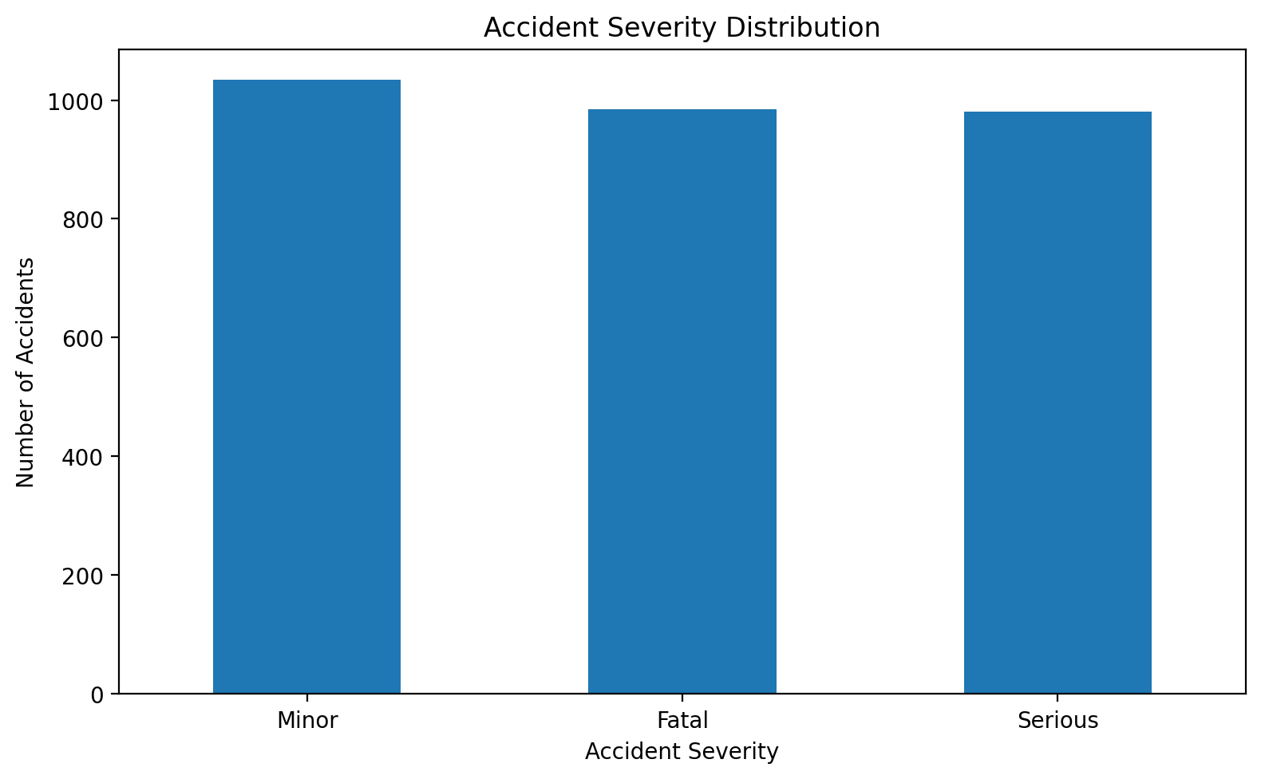
Figure 1: Output generated by the supplied project notebook. This figure is preserved as an experimental visualization; its interpretation should be read together with the EDA discussion in the main report.
Analytical focus: Accident severity distribution. The visualization is one of the 36 graphs reported in the notebook and forms part of the evidence used to understand distributions and relationships before model training.

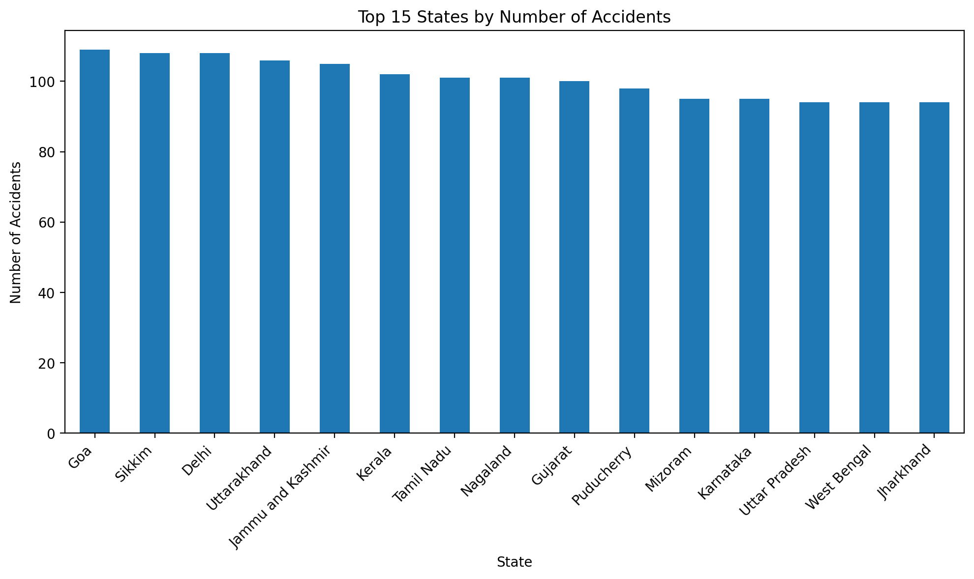
Figure 2: Output generated by the supplied project notebook. This figure is preserved as an experimental visualization; its interpretation should be read together with the EDA discussion in the main report.
Analytical focus: Top states by accident count. The visualization is one of the 36 graphs reported in the notebook and forms part of the evidence used to understand distributions and relationships before model training.
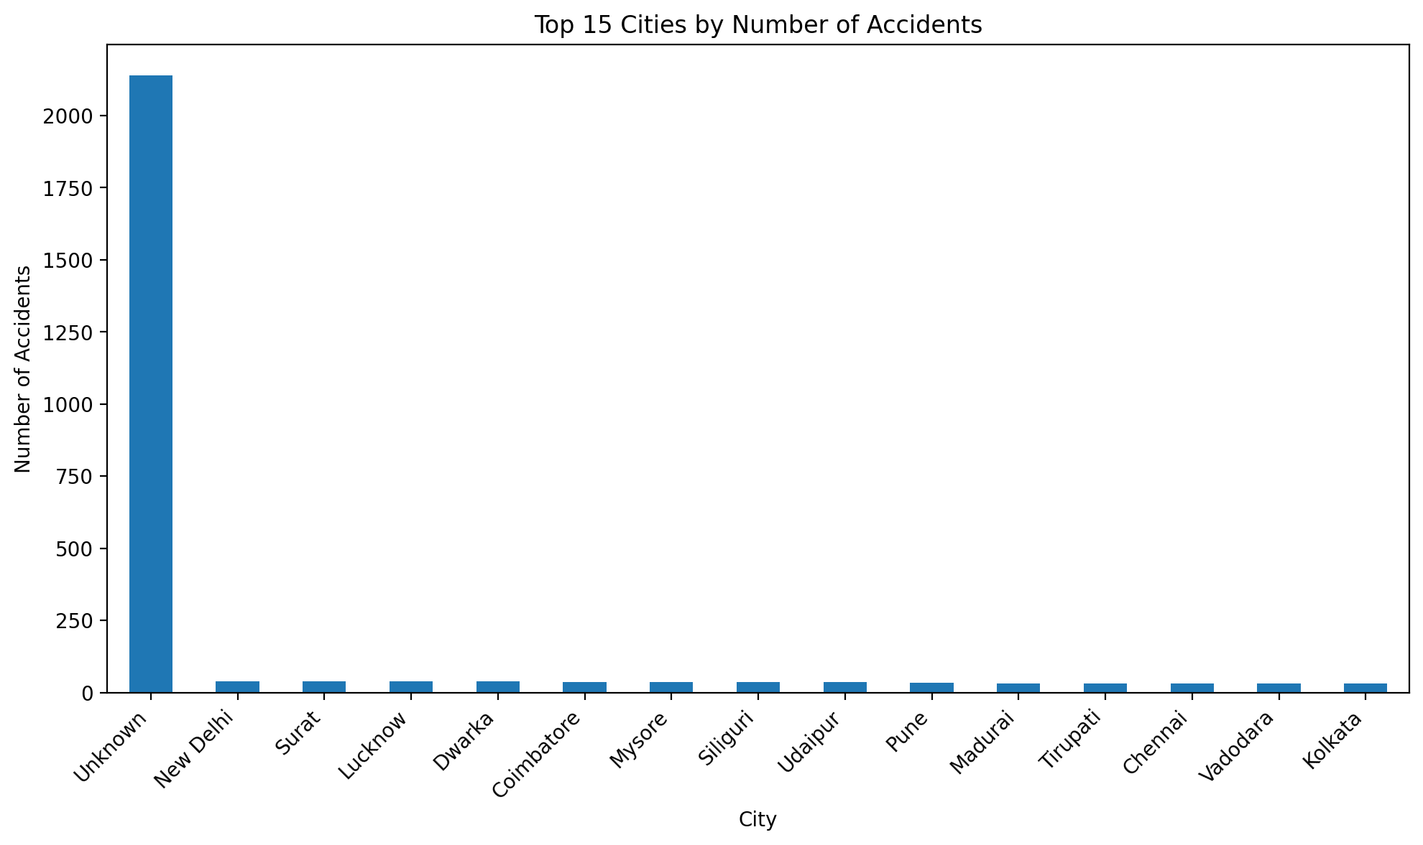

Figure 3: Output generated by the supplied project notebook. This figure is preserved as an experimental visualization; its interpretation should be read together with the EDA discussion in the main report.
Analytical focus: Top cities by accident count. The visualization is one of the 36 graphs reported in the notebook and forms part of the evidence used to understand distributions and relationships before model training.

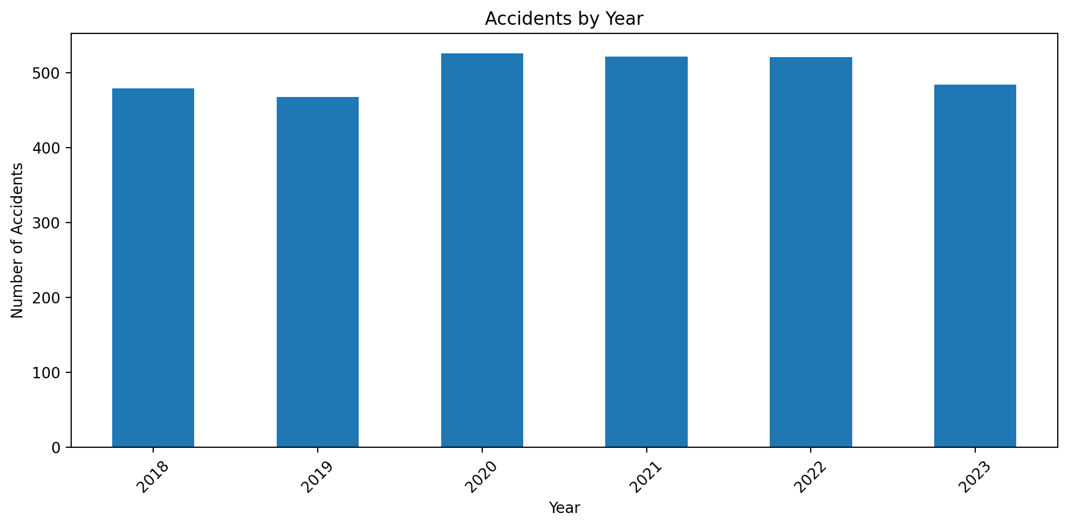

Figure 4: Output generated by the supplied project notebook. This figure is preserved as an experimental visualization; its interpretation should be read together with the EDA discussion in the main report.

Analytical focus: Accidents by year. The visualization is one of the 36 graphs reported in the notebook and forms part of the evidence used to understand distributions and relationships before model training.

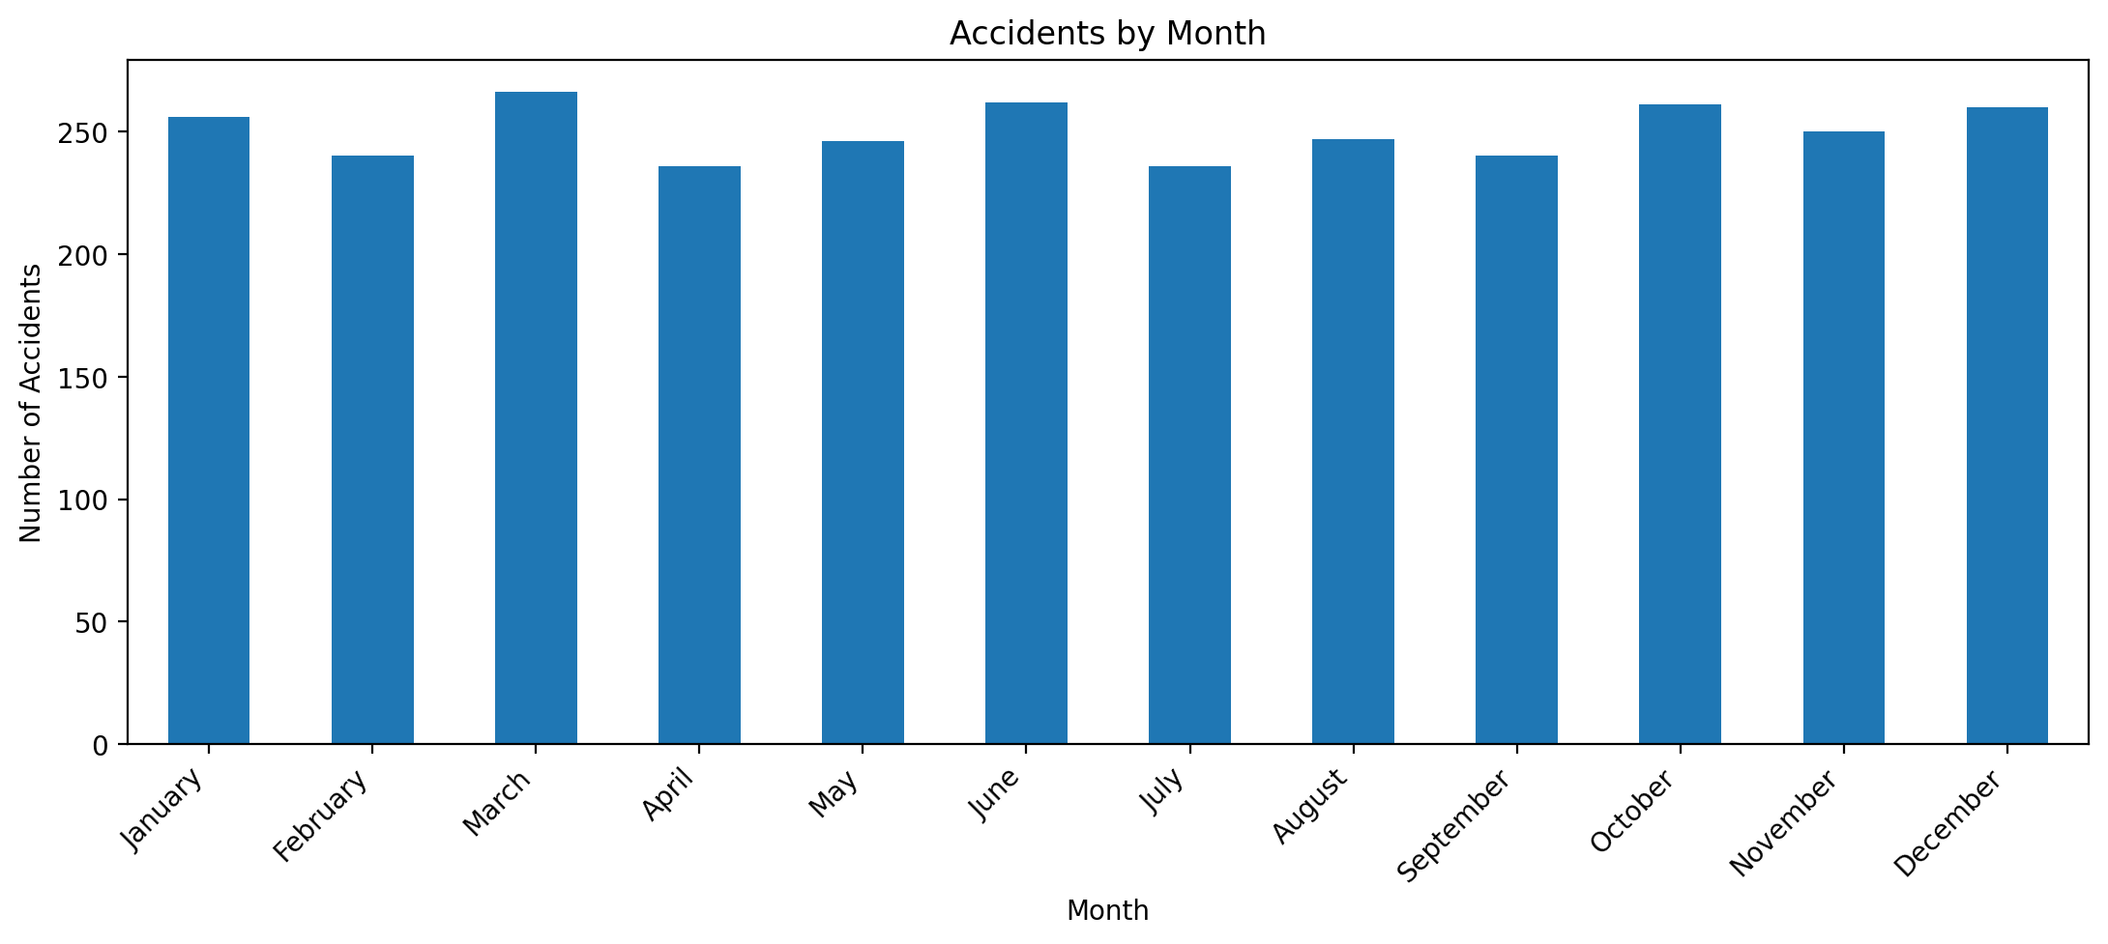

Figure 5: Output generated by the supplied project notebook. This figure is preserved as an experimental visualization; its interpretation should be read together with the EDA discussion in the main report.

Analytical focus: Accidents by month. The visualization is one of the 36 graphs reported in the notebook and forms part of the evidence used to understand distributions and relationships before model training.

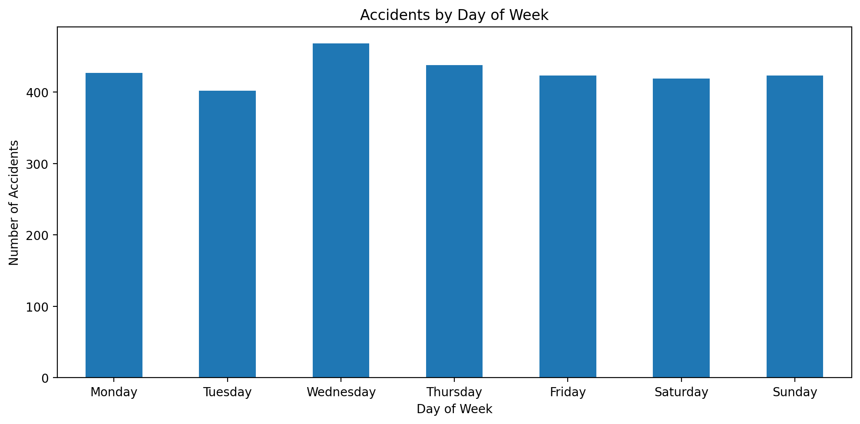

Figure 6: Output generated by the supplied project notebook. This figure is preserved as an experimental visualization; its interpretation should be read together with the EDA discussion in the main report.

Analytical focus: Accidents by day of week. The visualization is one of the 36 graphs reported in the notebook and forms part of the evidence used to understand distributions and relationships before model training.

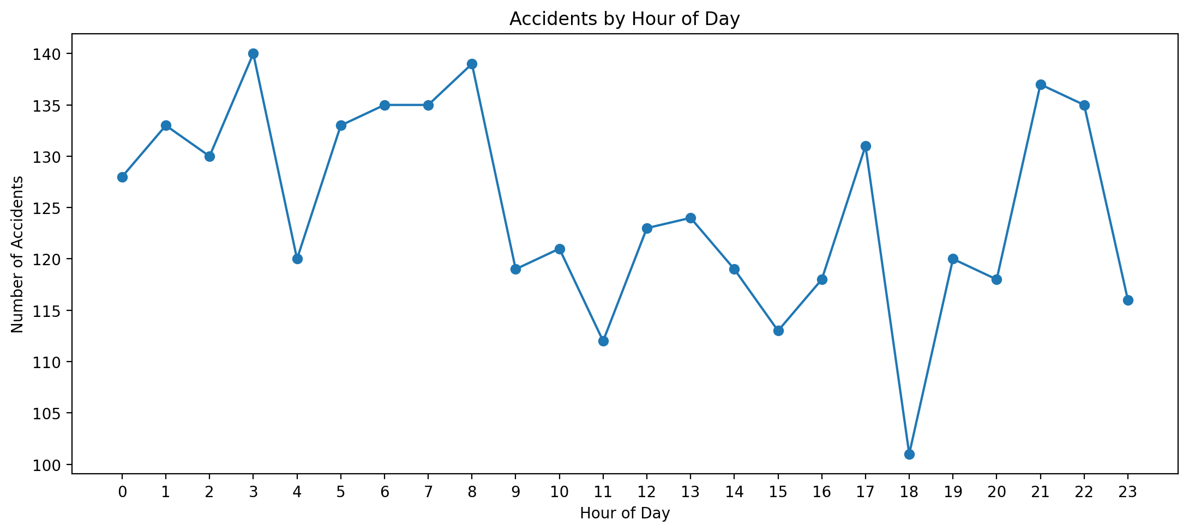

Figure 7: Output generated by the supplied project notebook. This figure is preserved as an experimental visualization; its interpretation should be read together with the EDA discussion in the main report.

Analytical focus: Accidents by hour. The visualization is one of the 36 graphs reported in the notebook and forms part of the evidence used to understand distributions and relationships before model training.

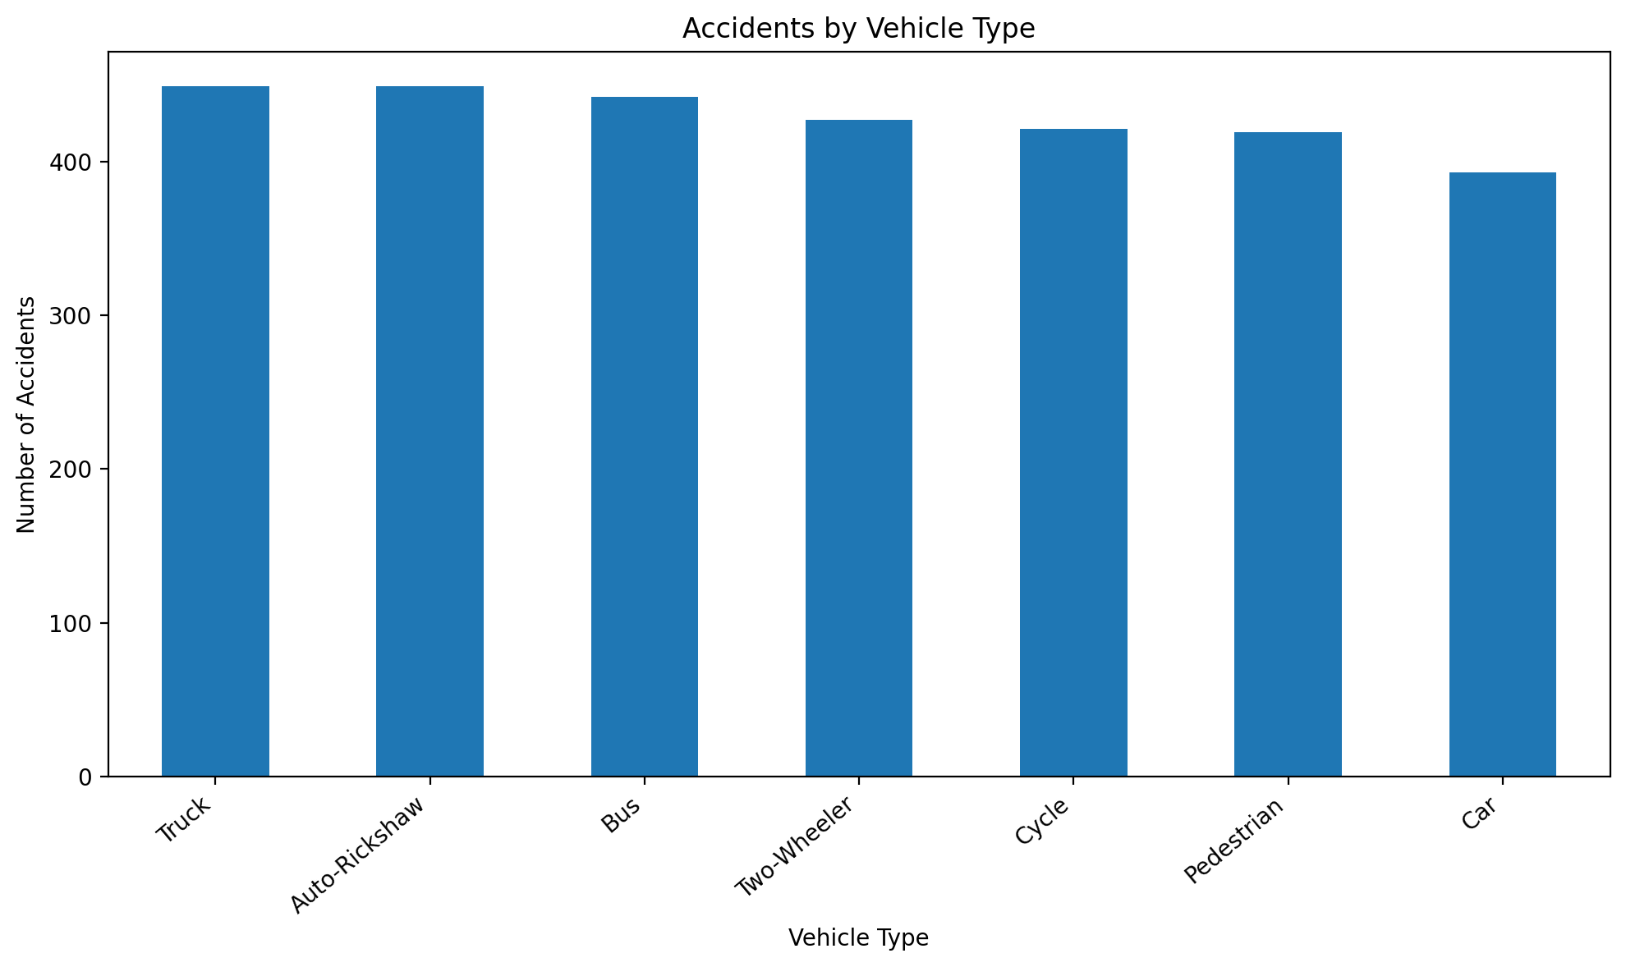

Figure 8: Output generated by the supplied project notebook. This figure is preserved as an experimental visualization; its interpretation should be read together with the EDA discussion in the main report.

Analytical focus: Vehicle type distribution. The visualization is one of the 36 graphs reported in the notebook and forms part of the evidence used to understand distributions and relationships before model training.

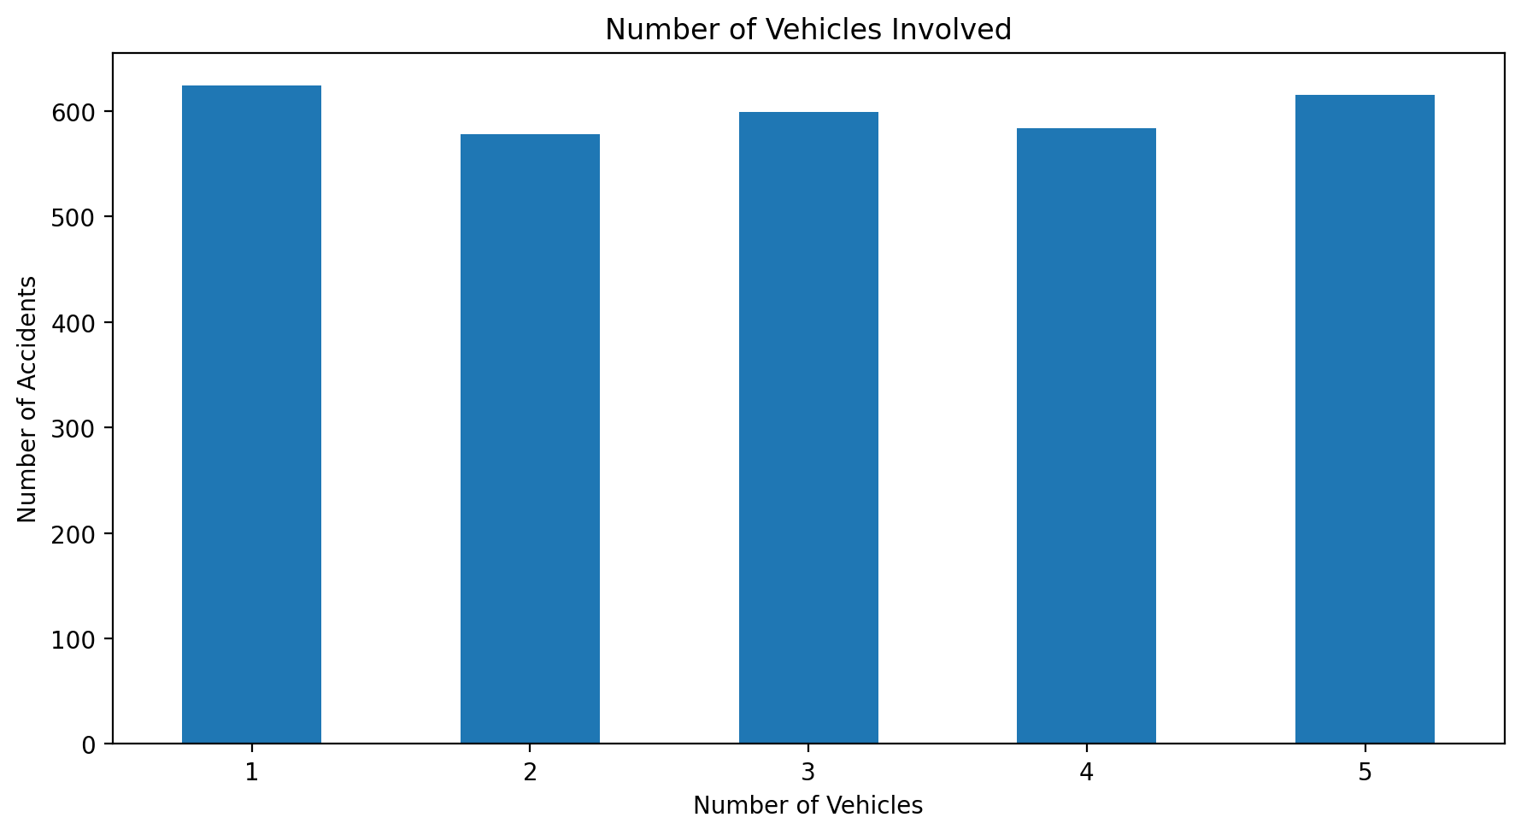

Figure 9: Output generated by the supplied project notebook. This figure is preserved as an experimental visualization; its interpretation should be read together with the EDA discussion in the main report.

Analytical focus: Number of vehicles involved. The visualization is one of the 36 graphs reported in the notebook and forms part of the evidence used to understand distributions and relationships before model training.

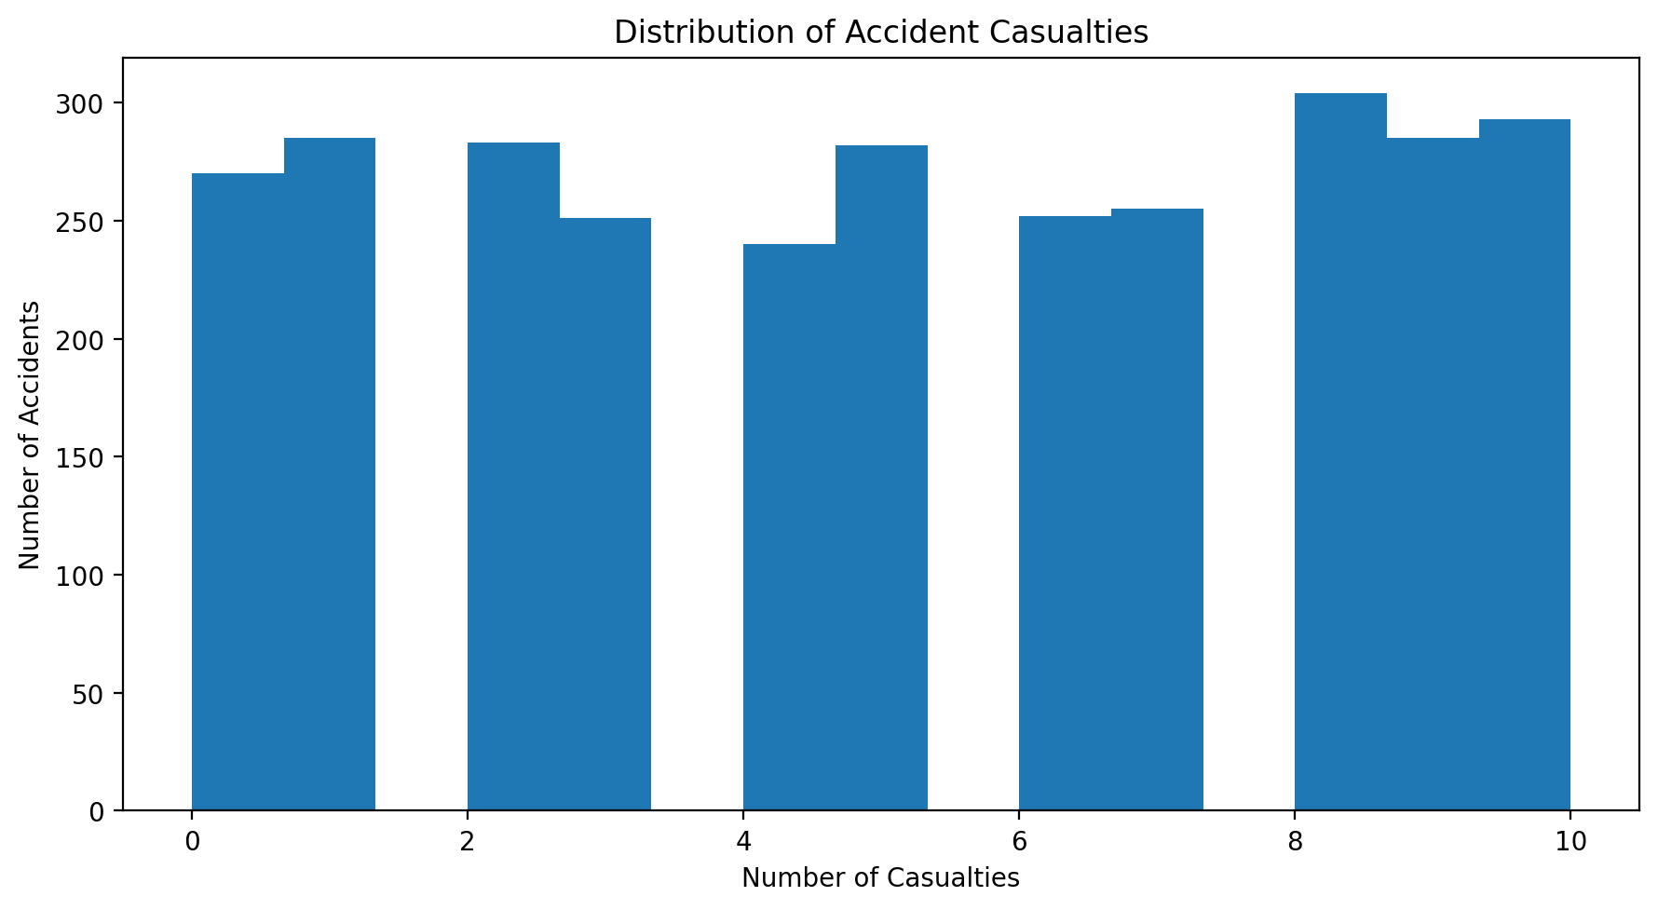

Figure 10: Output generated by the supplied project notebook. This figure is preserved as an experimental visualization; its interpretation should be read together with the EDA discussion in the main report.

Analytical focus: Casualties distribution. The visualization is one of the 36 graphs reported in the notebook and forms part of the evidence used to understand distributions and relationships before model training.

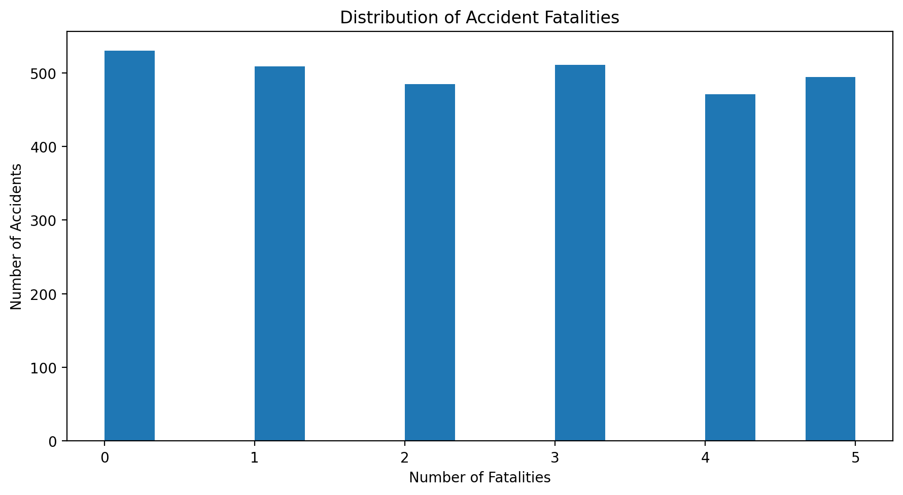

Figure 11: Output generated by the supplied project notebook. This figure is preserved as an experimental visualization; its interpretation should be read together with the EDA discussion in the main report.

Analytical focus: Fatalities distribution. The visualization is one of the 36 graphs reported in the notebook and forms part of the evidence used to understand distributions and relationships before model training.

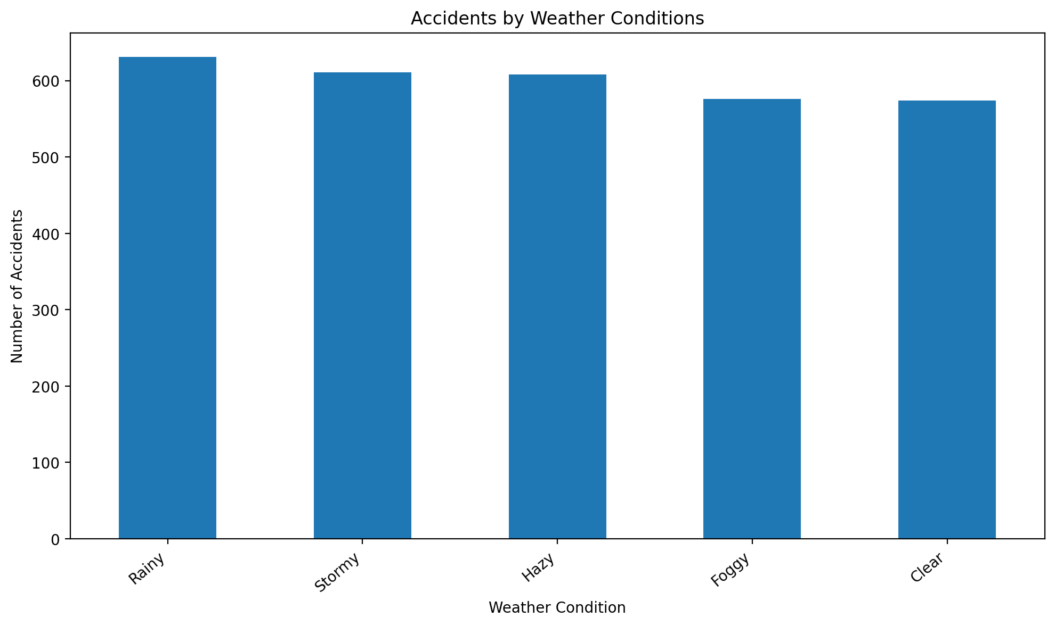

Figure 12: Output generated by the supplied project notebook. This figure is preserved as an experimental visualization; its interpretation should be read together with the EDA discussion in the main report.
Analytical focus: Weather conditions. The visualization is one of the 36 graphs reported in the notebook and forms part of the evidence used to understand distributions and relationships before model training.

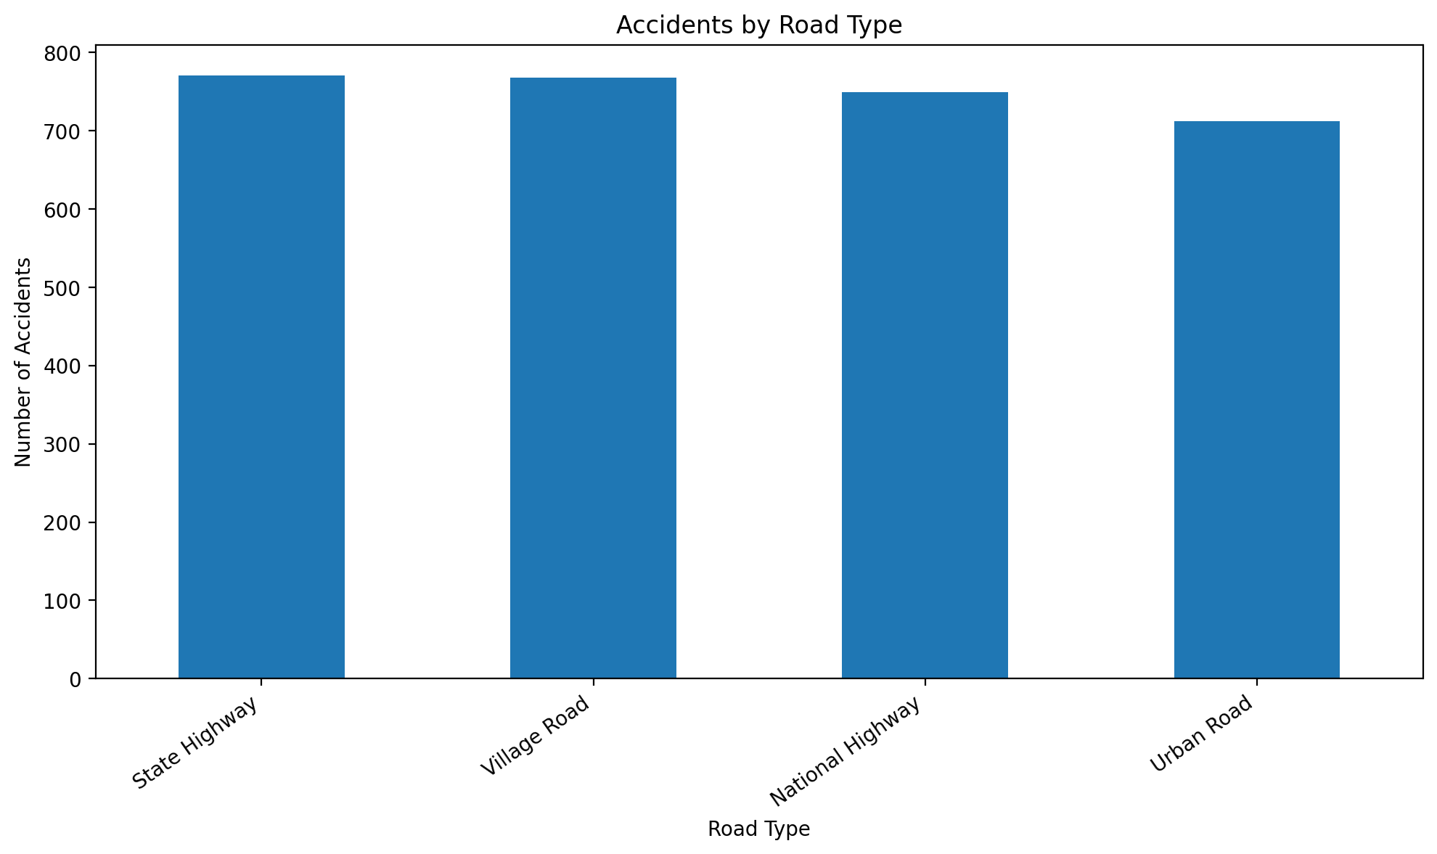

Figure 13: Output generated by the supplied project notebook. This figure is preserved as an experimental visualization; its interpretation should be read together with the EDA discussion in the main report.

Analytical focus: Road type distribution. The visualization is one of the 36 graphs reported in the notebook and forms part of the evidence used to understand distributions and relationships before model training.

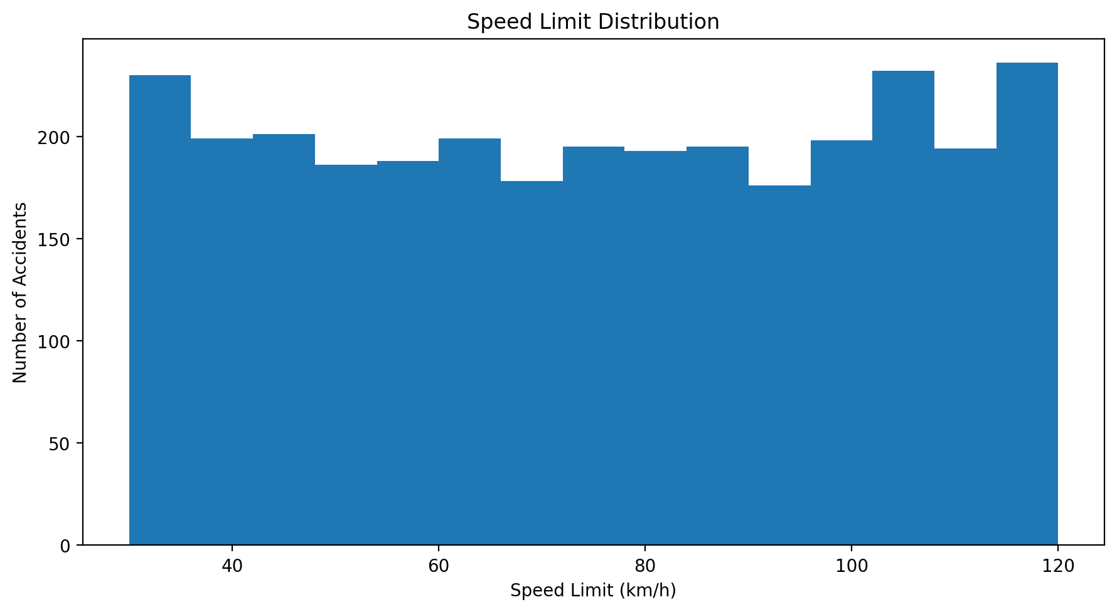

Figure 14: Output generated by the supplied project notebook. This figure is preserved as an experimental visualization; its interpretation should be read together with the EDA discussion in the main report.
Analytical focus: Speed limit distribution. The visualization is one of the 36 graphs reported in the notebook and forms part of the evidence used to understand distributions and relationships before model training.

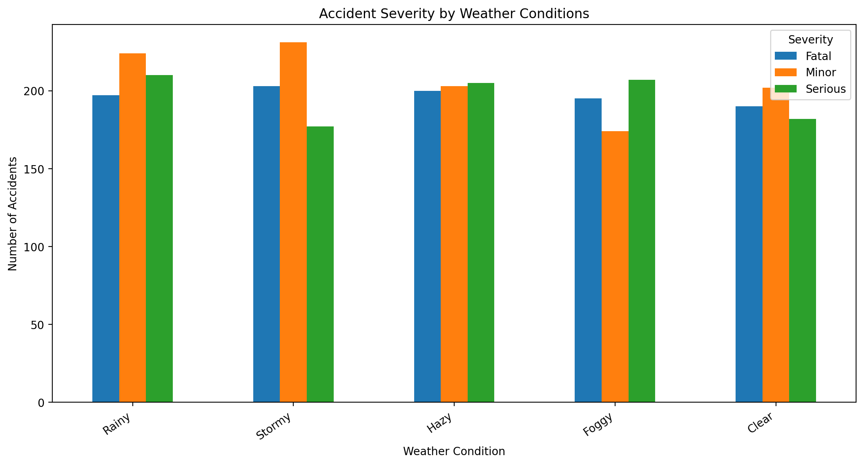

Figure 15: Output generated by the supplied project notebook. This figure is preserved as an experimental visualization; its interpretation should be read together with the EDA discussion in the main report.

Analytical focus: Severity by state. The visualization is one of the 36 graphs reported in the notebook and forms part of the evidence used to understand distributions and relationships before model training.

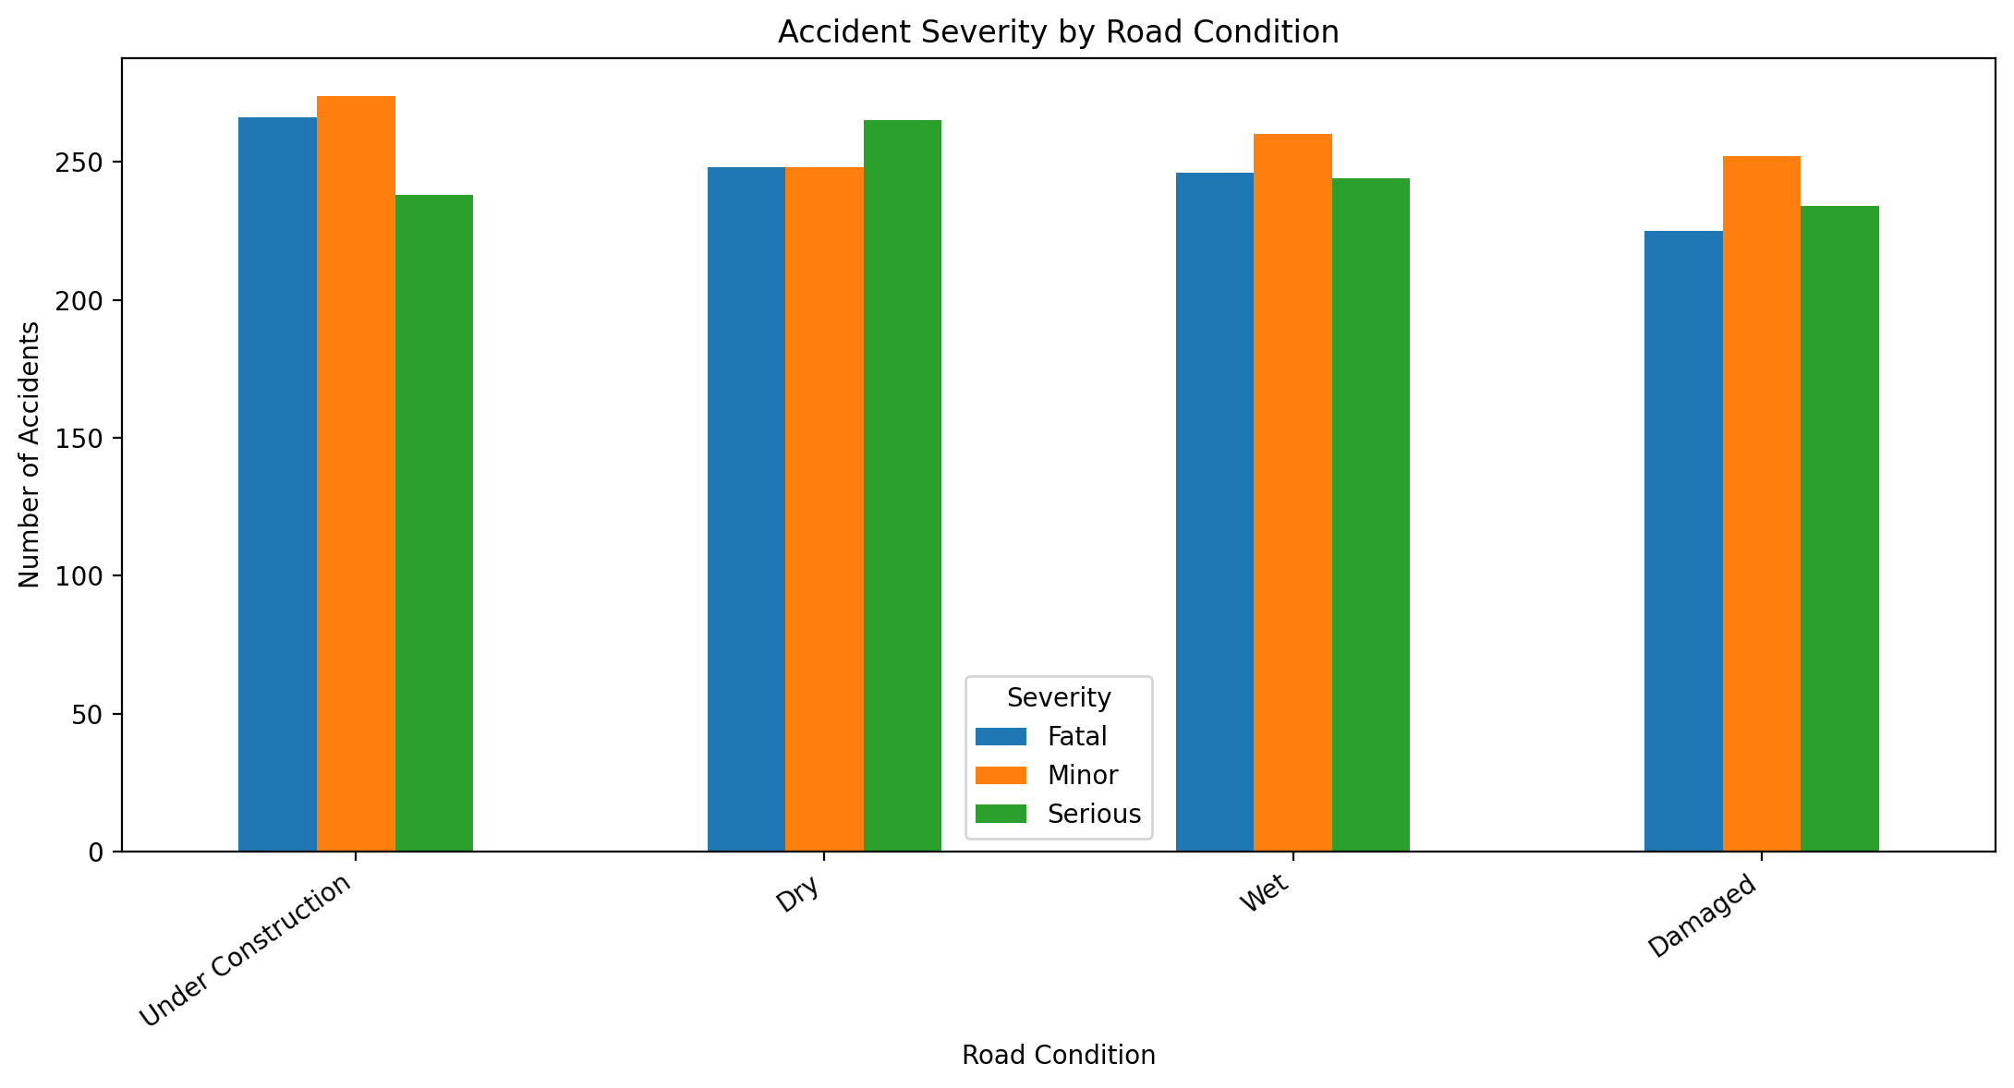

Figure 16: Output generated by the supplied project notebook. This figure is preserved as an experimental visualization; its interpretation should be read together with the EDA discussion in the main report.

Analytical focus: Severity by city. The visualization is one of the 36 graphs reported in the notebook and forms part of the evidence used to understand distributions and relationships before model training.

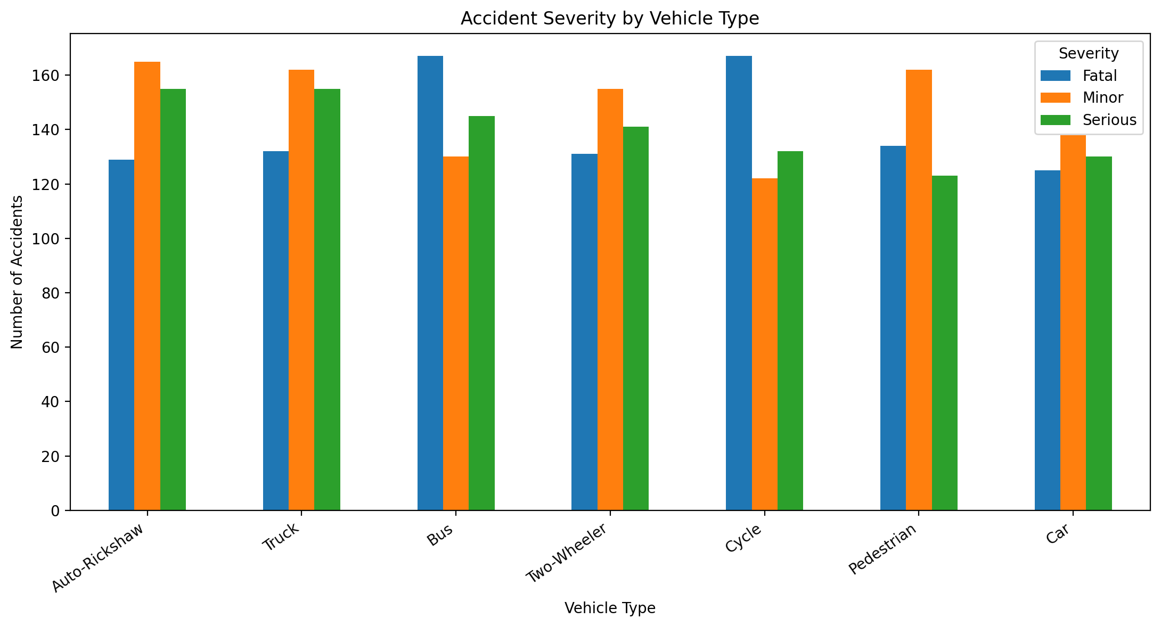

Figure 17: Output generated by the supplied project notebook. This figure is preserved as an experimental visualization; its interpretation should be read together with the EDA discussion in the main report.

Analytical focus: Severity by year. The visualization is one of the 36 graphs reported in the notebook and forms part of the evidence used to understand distributions and relationships before model training.

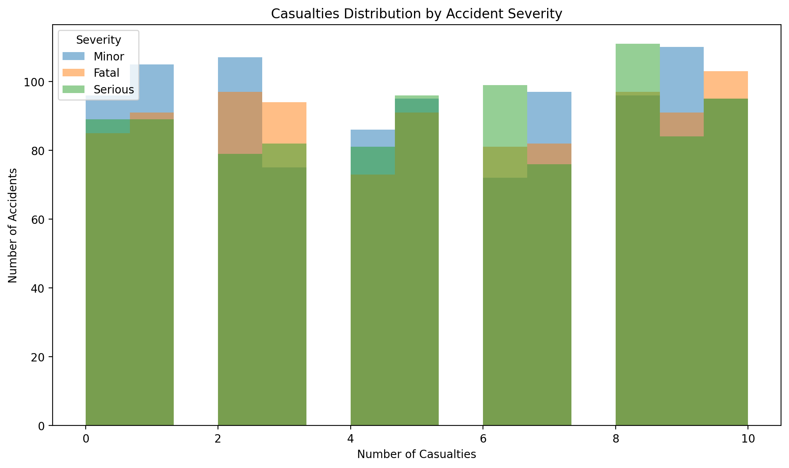

Figure 18: Output generated by the supplied project notebook. This figure is preserved as an experimental visualization; its interpretation should be read together with the EDA discussion in the main report.

Analytical focus: Severity by lighting condition. The visualization is one of the 36 graphs reported in the notebook and forms part of the evidence used to understand distributions and relationships before model training.

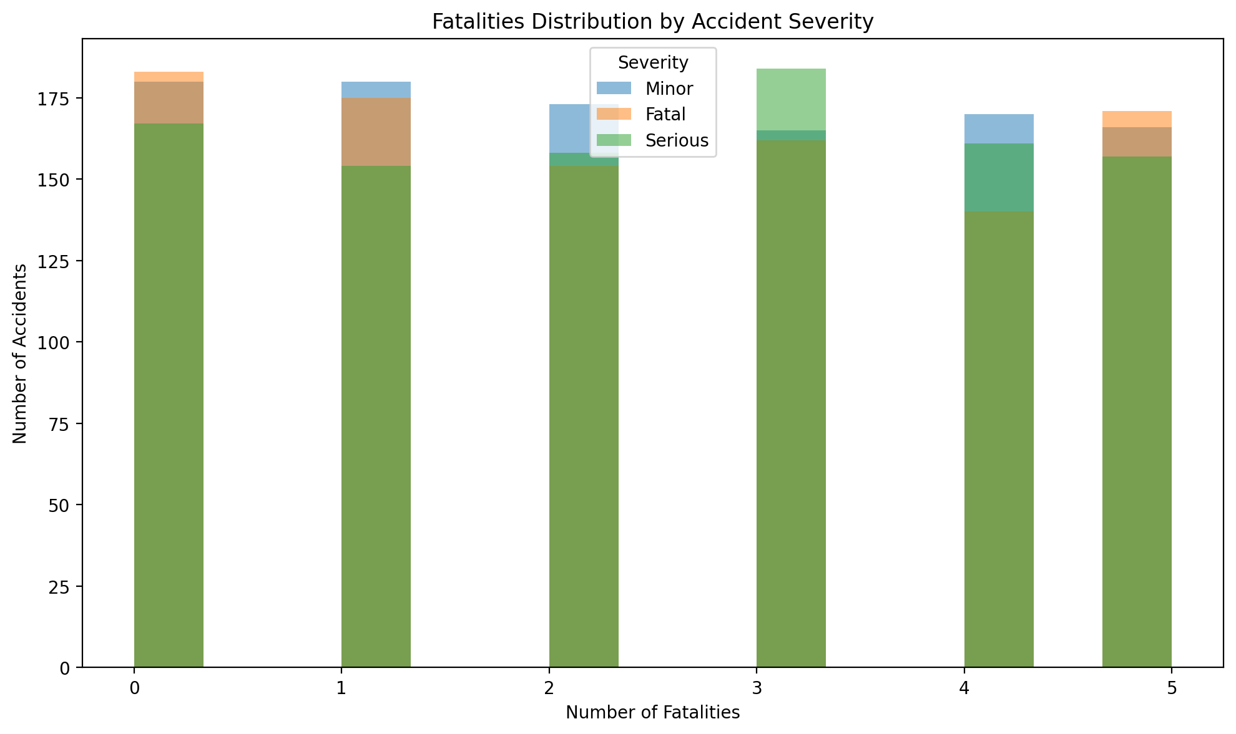

Figure 19: Output generated by the supplied project notebook. This figure is preserved as an experimental visualization; its interpretation should be read together with the EDA discussion in the main report.

Analytical focus: Severity by alcohol involvement. The visualization is one of the 36 graphs reported in the notebook and forms part of the evidence used to understand distributions and relationships before model training.

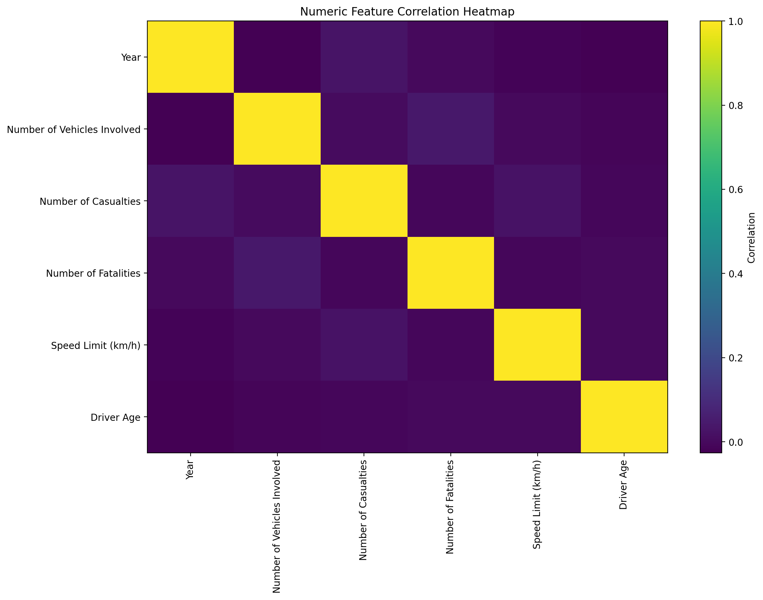

Figure 20: Output generated by the supplied project notebook. This figure is preserved as an experimental visualization; its interpretation should be read together with the EDA discussion in the main report.

Analytical focus: Numeric correlation heatmap. The visualization is one of the 36 graphs reported in the notebook and forms part of the evidence used to understand distributions and relationships before model training.

